HEAD AND NECK
MANIFESTATIONS
OF SYSTEMIC
DISEASE

EDITED BY

JEFFREY P. HARRIS

MICHAEL H. WEISMAN

Informa
healthcare

New York, London.

2007

10

Epstein-Barr, Herpes Simplex, and
Herpes Zoster Infections

Kedar K. Adour
Department of Head and Neck Surgery, Kaiser Permanente Medical Center, Oakland, California, U.S.A.

INTRODUCTION

The three most common types of herpes viruses that infect humans are the Epstein-Barr virus (EBV), herpes simplex virus types 1 (HSV-1) and 2 (HSV-2), and herpes zoster virus (HZV), more properly called the varicella zoster virus (VZV). All three have a DNA genomic core encased in a nucleocapsid surrounded by the viral envelope, but each produces different clinical manifestations. A common feature shared by all three viruses is the ability either to persist in a nonreplicating state in specific cells or to replicate, thereby producing secondary disease or asymptomatic viral shedding.

EPSTEIN-BARR VIRUS

DEFINITION

In 1968 researchers determined that EBV causes heterophile-positive infectious mononucleosis (1). The clinical presentation of mononucleosis includes fever, sore throat, headache, white patches in the oropharynx, swollen neck glands and lethargy.

EPIDEMIOLOGY

EBV is a member of the herpes virus family and is one of the most common viruses. It occurs worldwide and is estimated to have infected as many as 95% of adults in the United States. Afer birth, infants become susceptible when maternal EBV antibody protection disappears. In children, EBV infection is usually mild and indistinguishable from other mild childhood illnesses. EBV infection causes infectious mononucleosis in 35% to 50% of infected adolescents. Mononucleosis is not easily spread and is found in saliva and mucus passed from person to person through intimate contact, the reason for the lay terminology, “kissing disease”. Clinical symptoms of infectious mononucleosis generally develop four to seven weeks after exposure. The condition occurs most commonly in persons between the ages of 15 years and 35 years and rarely recurs (2).

PATHOGENESIS

Like other members of the Herpesvirus family, the EBV DNA viral genome is encased in a nucleocapsid surrounded by the viral envelope. EBV initially infects oropharyngeal epithelial cells; there, the virus replicates and then primarily infects B lymphocytes (B + EBV) and is disassembled. The genome is thus transported in the nucleus in a state of viral latency. Nearly all seropositive persons actively shed virus in the saliva. During primary viral infection, the EBV-infected B cells rapidly proliferate. The infection is usually brought under control by cytotoxic T cells, and the process often results in infectious mononucleosis. After the acute infection resolves, the virus persists in the peripheral B cells without causing disease; however, in males with X-linked lymphoproliferative disorder, the initial B+EBV proliferation is not contained and may result in fatal mononucleosis (1).

CLINICAL MANIFESTATIONS

Classic symptoms of infectious mononucleosis are the triad of fever, pharyngitis, and cervical lymphadenopathy. In addition to fever, systemic symptoms include fatigue and generalized lymphadenopathy. Oral hairy leukoplakia, a collection of hairy corrugated white lesions located on the lateral surface of the tongue, is common. Sometimes splenomegaly or mild hepatitis may develop. Uncommon manifestations include heart problems, jaundice, pneumonitis, blood dyscrasia and cerebritis (2). In patients with HIV infection, infection of epithelial cells by EBV is often represented by oral hairy leukoplakia.

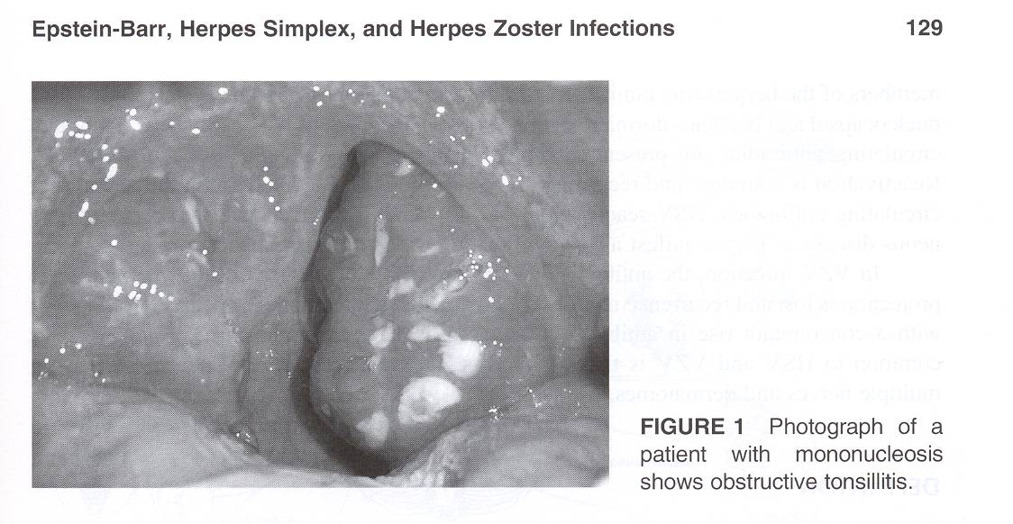

DIAGNOSIS

The diagnosis is suggested by the clinical features. The most frequently used serologic test is the EBV-specific heterophile antibody test (the “monospot test,” “mononucleosis spot test,” or Paul \Bunnel test), which gives a positive result (2). Other abnormal laboratory findings include elevated white blood cell (WBC) count ranging from 1.0 x 10”/L to 1.5 x 10”/L; of these WBCs, 50% or more are “atypical” lymphocytes with oval, kidney-shaped nuclei and vacuolated cytoplasm. Thrombocytopenia is common, and levels of hepatic enzymes may be elevated.
Cytomegalovirus (CMV) can produce symptoms that mimic those of infectious mononucleosis, but give a negative result when subjected to the heterophile antibody test. The diagnosis must be made by isolating the CMV virus. CMV-type mononucleosis usually has both slower onset and slower resolution. Most infected patients recover without sequelae.

TREATMENT

No specific therapy is available to treat infectious mononucleosis. Most practitioners advise bed rest, increased fluid intake, and use of pain relievers such as acetaminophen or ibuprofen. Aspirin should not be given to children younger than 16 years, because doing so may trigger the rare but potentially fatal disorder known as Reye’s syndrome (2). Antibiotic drugs are not given for viral disease but should be given to treat any superimposed streptococcal or sinus infection. Treatment with piperacillin/tazobactam is probably the causative agent in systemic rash. Early reports individually implicated corticosteroid or ampicillin treatment as causing peritonsillar abscess formation, but have since been disproved (3).
Many practitioners believe that for most patients with infectious mononucleosis, no specific therapy is indicated. Because corticosteroid drugs shorten the duration of fever and oropharyngeal symptoms, allowing patients the benefit of such treatment seems prudent. Corticosteroid therapy is used for patients with severe complications such as impending upper-airway obstruction, acute hemolytic anemia, severe cardiac involvement, or neurologic disease.
Acyclovir, which inhibits EBV replication and reduces viral shedding, is effective in treating oral hairy leukoplakia; however, because the immune response prevents acyclovir from having any clinically significant effect on the symptoms of mononucleosis, acyclovir is not recommended for treating this condition (2).

COMPLICATIONS AND PROGNOSIS

Most patients with infectious mononucleosis have the triad of fever, lymphadenopathy, and pharyngitis. The most common complication is swollen tonsils with obstructed breathing (Fig. 1) (3). Splenomegaly, palatal petechiae, and hepatomegaly develop in another 10% of infected patients. The main serious complication is enlarged spleen and its possible rupture. Less common complications include hemolytic anemia, thrombocytopenia, aplastic anemia, myocarditis, hepatitis, rash, and neurologic complications, such as Guillian-Barré syndrome, encephalitis, and meningitis.
Symptoms such as fever and sore throat usually lessen within two to three weeks. Fatigue, enlarged lymph nodes, and swollen spleen may last weeks longer. Most signs and symptoms ease within a few weeks, although two to three months may elapse before patients feel completely normal (4).

SUMMARY

Infectious mononucleosis is caused by ubiquitous EBV virus, which is estimated to infect 80% to 95% of the U.S. population. In infants, the disease is unremarkable and mimics the usual benign diseases of childhood. In adolescents and in young adults under the age of 35 years, primary infection with EBV can cause lymphadenopathy, fever and pharyngitis, a symptom triad often called “mono,” “glandular fever,” or the “kissing disease.” Treatment for symptoms consists of bed rest, increased fluid intake, and use of inflammatory pain relievers. The disease is inflammatory and immune-related, and clinical experience suggests that corticosteroid drugs should be used because they dramatically relieve the symptoms and shorten the duration of fatigue. Corticosteroid drugs should be used also to treat the most common complications of mononucleosis, i.e., respiratory obstruction (from enlarged tonsils) and splenomegaly.
HERPES SIMPLEX VIRUS TYPE 1

INTRODUCTION

All herpes viruses can establish a persistent state after primary infection.
Persons who become infected with a Herpesvirus are susceptible to periodic viral reactivation releasing transmissible virus. The latent sites determine clinical manifestation and are variable. HSV-1, HSV-2 and VZV have structure and propensity similar to all members of the Herpesvirus family. The double-stranded DNA genome is surrounded by a nucleocapsid and becomes dormant in the nucleus of sensory cells. Although circulating antibodies are present in both diseases, HSV antibodies are not protective. Reactivation is common, and recurrence is not accompanied by increase in the quantity of circulating antibodies. HSV reactivation with replication produces secondary neurocutaneous disease or may manifest as symptomatic viral shedding (5,6).
In VZV infection the antibodies remain protective until later in life, when antibody protection is lost and recurrence manifests as segmental neurocutaneous disease (“shingles”) with a concomitant rise in antibodies. VZV rarely recurs a second time. Another factor common to HSV and VZV is that both viruses are responsible for syndromes affecting multiple nerves and dermatomes.

DEFINITION

HSV-1 and HSV-2 are almost identical in structure; however, whereas HSV-1 has been associated with head and neck disease, HSV-2 primarily causes genital infection. As a result of oral-genital sexual encounters, both types of viruses can be isolated from the oral or genital area. The two viruses can cause identical lesions; however, herpetic encephalitis is usually caused by HSV-1 infection, whereas meningitis is usually caused by HSV_2 infection (7). (Discussion of genital herpes is beyond the scope of this chapter).

EPIDEMIOLOGY

HSV-1 is ubiquitous and HSV-1 infection is often acquired in the first decade of life by contact with oral secretions. Presence of antibodies to HSV-1 in a general population increases with age and correlates with socioeconomic status (7). By childhood, 50% of people in the highest social strata are infected, as are 85% of people in lower social strata. Of those who are infected, more than 25% have recurrent episodes, which usually manifest as mucocutaneous herpes labialis. Between symptomatic episodes, HSV-1 can be shed in as many as 10% of healthy persons with a history of cold sores. This shedding spreads the infection. HSV-1 is transmitted chiefly by contact with infected saliva. The mode of transmission is by close personal contact. Aerosol spreading rarely occurs, because the virus is inactivated readily at room temperature and by drying (6). - (* see footnote by H.H.).

- HH: - Other quotes in the literature: By age five years, 60% of children carry the HSV-1 =virus, and by age sixty years, 80% of humans have the HSV-1 virus. ( Fields Virology – 3rd edition, Volume 2 -Lippincott-Raven:

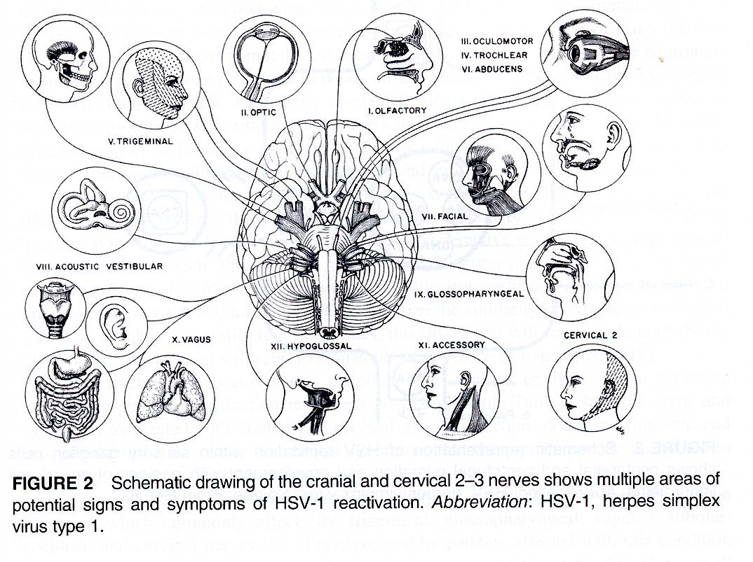

PATHOGENESIS

With the exception of the optic and olfactory nerves, the HSV-1 genome has been detected in all sensory cranial ganglia (Fig.2) and from cervical ganglia 2 and 3. When HSV-1 is injected into the cornea of experimental animals, the virus proceeds to the otic ganglion, then to the trigeminal ganglion, the glossopharyngeal and vagal ganglia, and finally down to the level of the second and third cervical ganglia. The virus also crosses the midline to infect contralateral ganglia.
HSV-1 infection occurs in three stages: the primary disease stage, the dormant (latent) stage, and the recurrent disease stage.
In the primary disease stage, infection is initiated by contact with infected oral secretions or lesions. The virus enters through mucocutaneous membranes or through a break in the skin. In the latent stage, the virus travels up the sensory nerves that reside in the nucleus of the cranial and spinal ganglia, where the virus is protected from circulating antibodies but can be reactivated. Disease recurrence is triggered by multiple factors, including fever, trauma, emotional stress, sunlight, menstruation, and ovulation (5).
Because every replication begins in ganglion cells, every case of recurrent HSV infection starts as ganglionitis (8). When the virus is episodically reactivated in multiple ganglia, it does so as polyganglionitis episodica (PGE). The virus only then passes down the axons to induce radiculitis and finally mucocutaneous disease. The virus also travels up the axon to the brainstem to form a localized arachnoiditis, but usually does not cause generalized encephalitis.
When the virus genome leaves the nucleus, it acquires a nuclear protein coat from the nucleus and thus becomes a nucleocapsid. This nucleocapsid acquires an envelope of lipoprotein from the plasma membrane of the infected cell (Fig. 3). The alteration in the host cell membrane and deposition of neural protein in perineural areas leads to processes T-lymphocyte sensitization and virally induced immune response – that cause demyelinization. The mucocutaneous vesicles caused by the virus invading epithelial cells merely represent the visible perimeter of the infected area. These virally mediated cranial neurologic syndromes include many sensory syndromes as well as motor paralysis (9).

CLINICAL MANIFESTATIONS

The primary episode of HSV-1 infection manifests after the patient is exposed to secretions containing viable HSV-1, which then incubate for three to six days. Mucocutaneous lesions, which can be painful, develop into vesicles that erupt for one to two weeks (Fig. 4). In many cases areas of gingivostomatitis and surrounding skin lesions are prominent and are associated with lymphadenopathy. Systemic symptoms include fever, malaise, myalgia, anorexia, and dysphagia. Painful, shallow ulcers are formed by breakdown of individual vesicles. Skin vesicles persist longer and develop into crusted ulcers that heal in five to seven days (6).

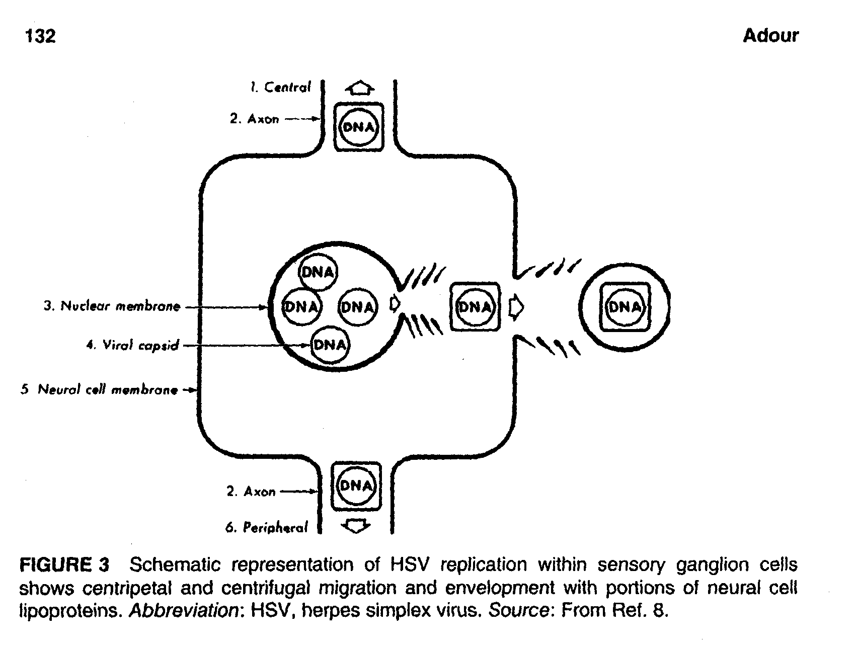

Recurrent infections can be either subclinical (characterized by viral excretion without formation of lesions) or overt (characterized by formation of mucocutaneous lesions). Many affected patients have prodromal dysesthesia, paresthesia, and a burning sensation at the site of impending vesicular lesions. Typical lesions are small, painful, fluid-filled vesicles that form crusts and shallow ulcers within three to five days. Localized lymphadenopathy can occur, unlike primary infection, however, constitutional symptoms are minimal. Recurrent episodes last three to seven days and can be frequent or occur once or twice in a lifetime. Over time, the number of annually recurrent episodes tends to decrease. The neurologic manifestation of recurrent infection depends on the neural ganglia specifically involved in the reactivation. Whereas the sensory component of the peripheral neurologic system is separated from the motor system, motor fibers in the cranial nerves traverse the ganglion in direct contact with sensory ganglion cells. This intimate contact is postulated to lead to virally induced demyelinization of motor fibers and subsequent paralysis or palsy (8).

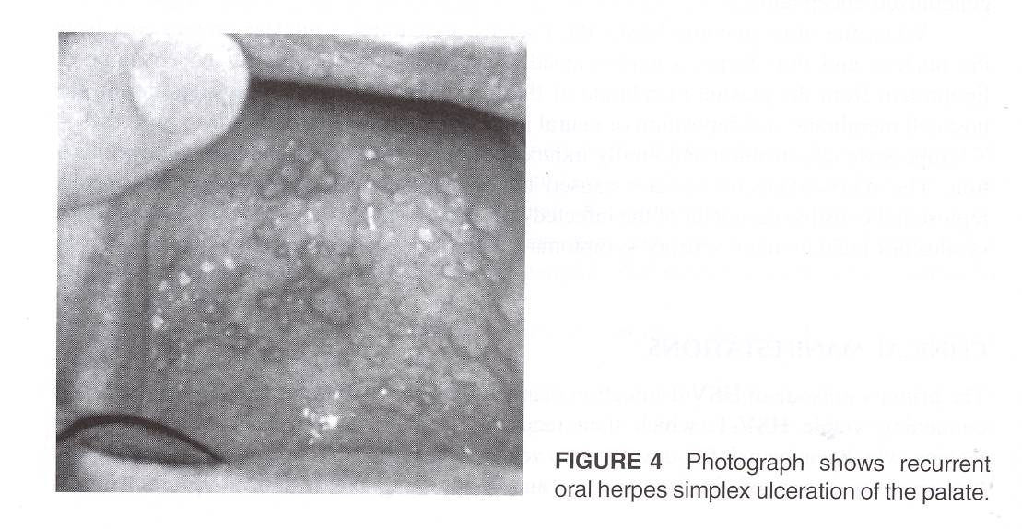

Every sensory system has an inhibitory system, and in the cranial nerves, the inhibitory fibers traverse the ganglion. Decreased function of the ganglion cells causes hypofunction, whereas loss of inhibition creates a hyperactive state such as intolerance to light, sound and touch. Photophobia results from reduction in the number of inhibitory impulses reaching the optic nerve; phonophobia results from reduction in the number of such impulses reaching the auditory nerve. To emphasize the similarity of symptoms associated with loss of inhibition at different nerve sites, this discussion will refer to phonophobia in place of hyperacusis and will refer to somatophobia in place of hyperesthesia (8).
Reactivation can occur in one ganglion or in multiple gangia. When occurring I multiple ganglia, reactivation represents polyganglionitis. Table 1 lists the signs and symptoms associated with cranial and cervical ganglia function, decreased function, and loss of inhibition, as well as clinical syndromes that these processes are postulated to cause (Fig. 5).
The most visible clinical manifestation of herpetic polyganglionitis is Bell’s plasy, a condition which commonly affects the trigeminal, glossopharyngeal, vagal, vestibular-cochlear, and cranial nerves (9). Otherwise healthy patients affected with this condition present with a one-sided facial droop (Fig. 6) and complain of pain behind the ear as well as facial numbness on the affected side. Other symptoms may include dysgeusia and phonophobia (hyperacusis) resulting from loss of inhibitory impulses to the cochlea, probably originating from the olivocochlear bundle of cranial nerve VIII. Results of physical examination confirm numbness of the face (trigeminal nerve) and postauricular area (second and third cervical nerves) (Fig. 7). All patients with Bell’s palsy have unilateral inflammation of the fungiform papillae of the tongue (Fig. 8). Some patients with Bell’s palsy have unilateral inflammation of the circumvallate papillae (Fig. 9)., which are supplied by the glossopharyngeal nerve (8). Other patients may have partial motor paresis of the palate (Fig. 10), which is supplied by the vagus nerve.
The features of migraine headache are not clearly differentiated from those of severe tension headache caused by muscle contraction. Both types of headache are usually unilateral, have a female-to-male predominance of 3:1, are activated by stress and menstruation, and are associated with varying neurologic signs and symptoms. The unilateral nature of the headache is not fully explained by describing the pathophysiology causing both types of headache.
Most physicians agree that a vascular effect is inherent in migraine headache. In addition, the HSV-1 genome has been shown in temporal artery biopsy specimens (12). A common finding in patients with migraine headache is a unilateral increase in somatic sensitivity (somatophobia) of the postauricular and occipital area when the hair is combed, yet astute testing shows numbness (hypesthesia) of that area. This finding is typical of both HSV and herpes zoster. Recurrent herpes simplex PGE explains the prodrome, unilaterality, chronicity, familial incidence, female predominance, age distribution, findings of sterile inflammation, and neurologic dysfunction characteristic of migraine headache.
Temperomandibular joint dysfunction syndrome (formerly called Costen’s syndrome) is a prime example of polyganglionitis (11). Manifestation include occipital headache (cervical nerve 2 and 3), stuffy sensation in the ears (cranial nerve X), tinnitus with hearing loss (cranial nerve VIII, the auditory nerve), earache (cranial nerve V), dizziness with nystagmus (cranial nerve VIII, the vestibular nerve), burning throat (cranial nerve IX) and masseter muscle weakness (cranial nerve V).
Clinical manifestations related to the auditory-vestibular system (cranial nerve VIII) can be traced to either branch of the nerve. Vestibular neuritis or neuronitis describes the vertigo associated with viral reactivation within the vestibular ganglion alone. Acute sudden hearing loss or cochlear Menière’s disease describes the hearing loss, tinnitus, and phonophobia associated with viral replication in the cochlear division. Involvement of both nerves suggests a clinical diagnosis of classical Menière’s disease. Many patients with this diagnosis complain of pharyngeal pain (cranial nerve X) and facial hypesthesia (cranial nerve V), symptoms which further document involvement of multiple nerves (13).

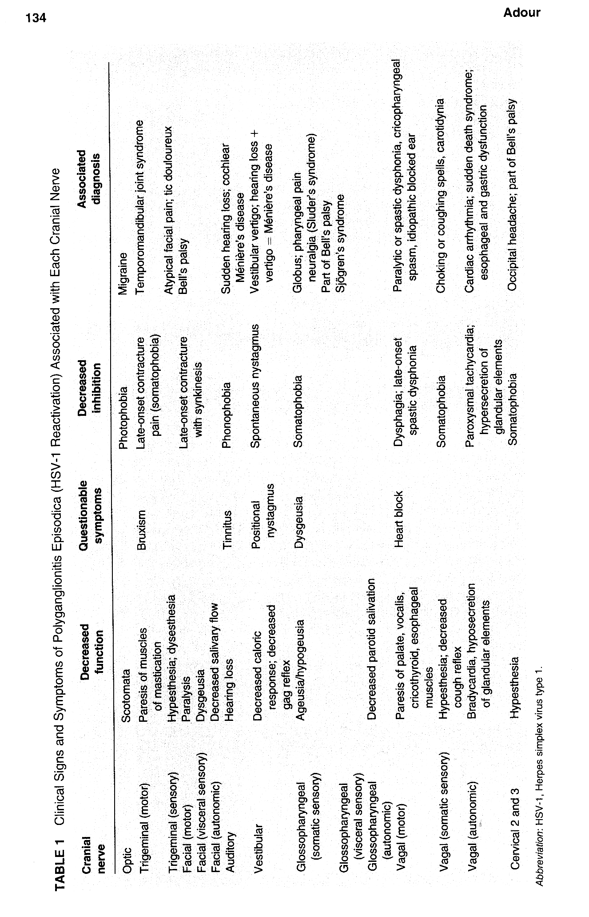

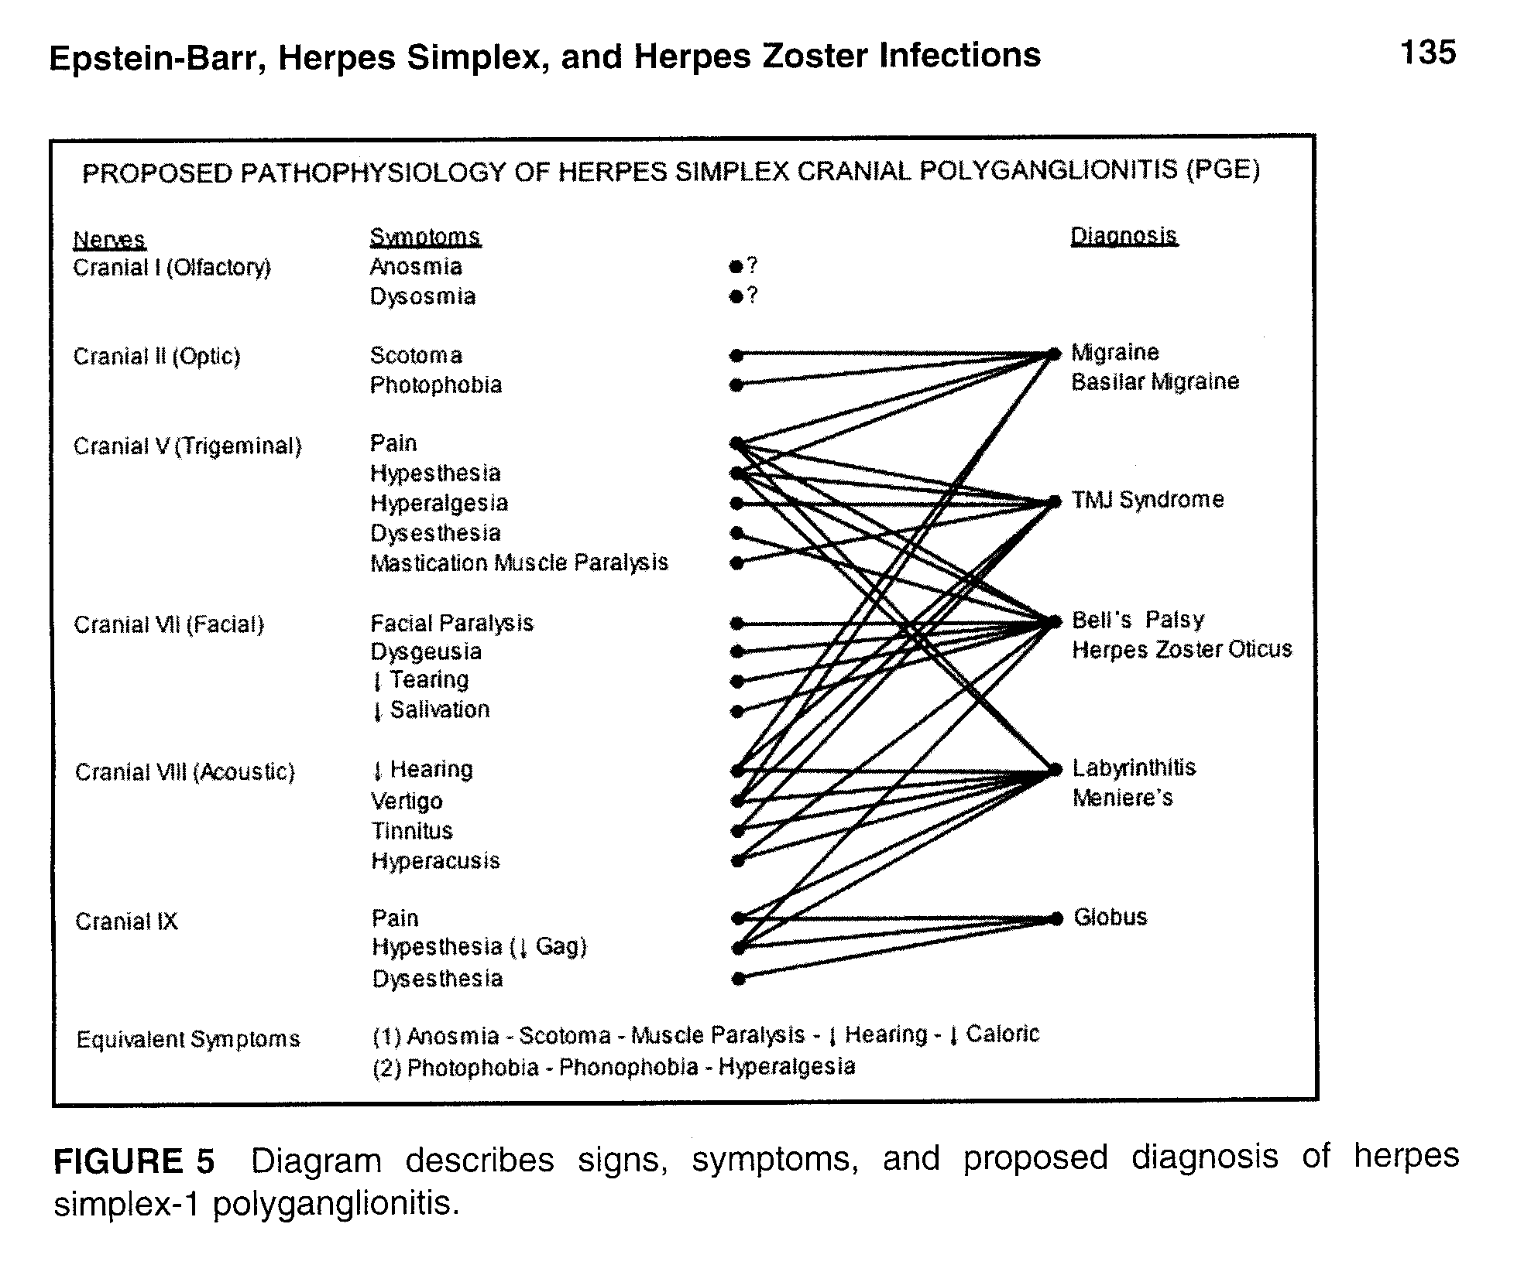
]/

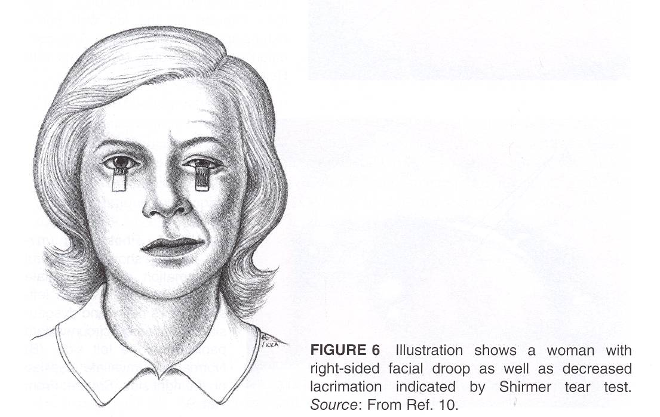

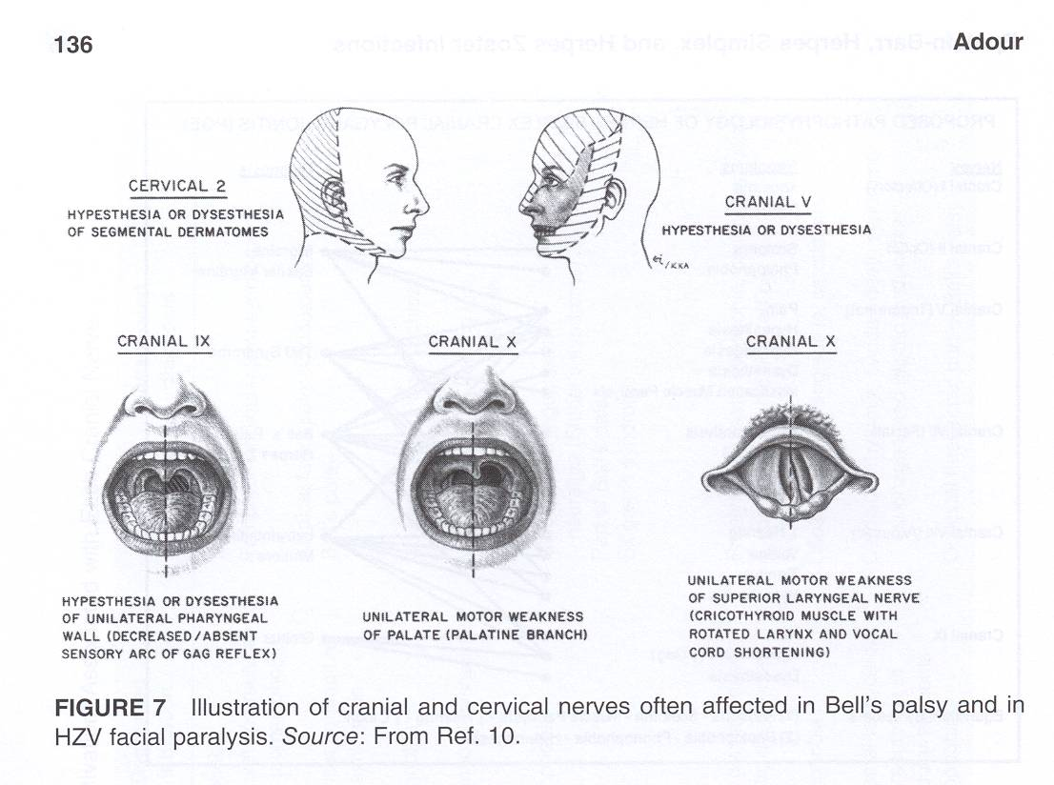

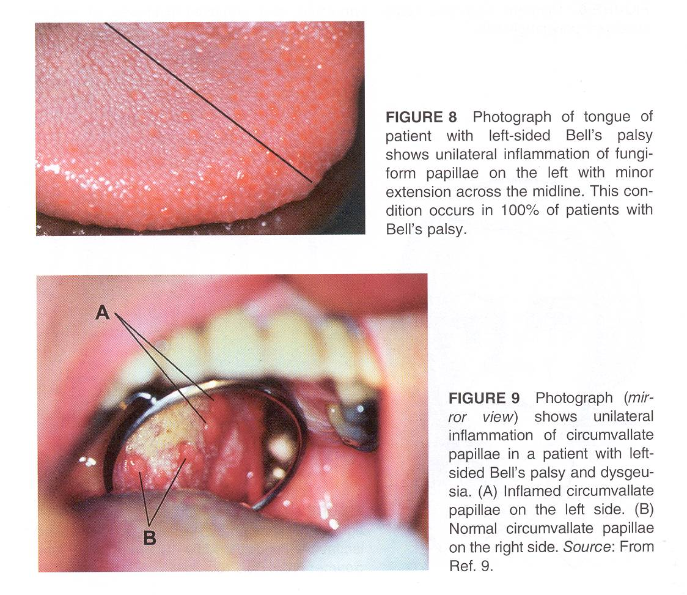

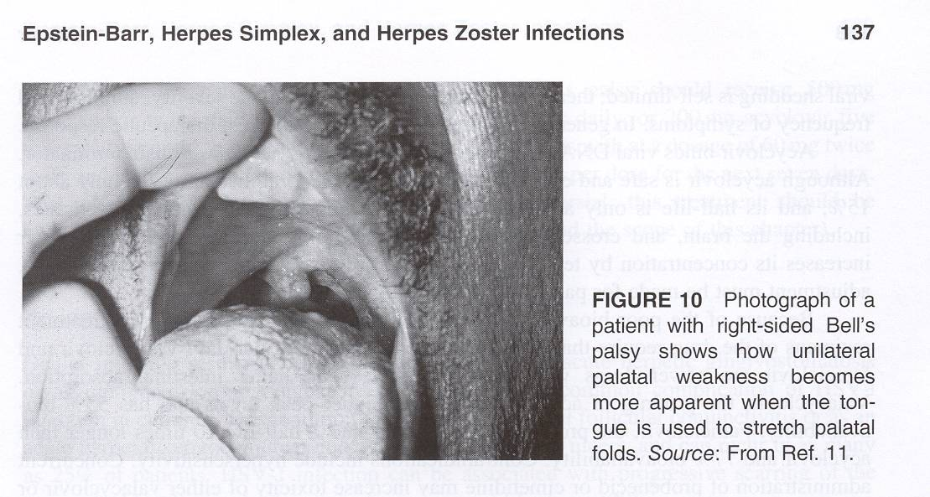

DIAGNOSIS

The diagnosis of HSV-1 infection is best confirmed by isolating the virus in tissue culture. Results of tissue culture are often positive within 48 hours after inoculation, and immunofluorescent staining of the tissue culture cells can enable quick identification of HSV and distinction between HSV types 1 and 2 (7).
Because innumerable cases of recurrent HSV-1 infection occur daily, the method of diagnosis is neither practical nor necessary. Histological diagnosis using scrapings from a mucocutaneous lesion shows multinucleated giant cells as well as epithelial cells that contain eosinophilic inclusion bodies (visible on Tzank smears). Polymerase chain reaction (PCR) techniques can rapidly detect HSV DNA in clinical specimens. Whereas confirmation of HSV encephalitis previously required brain biopsy, PCR study of cerebral spinal fluid is a noninvasive technique as sensitive as brain biopsy (6).
Antibody testing can document seroconversion in patients with primary HSV-1 but has no value for confirming recurrent infection.

TREATMENT

Treatment of primary HSV-1 infection is well established; however treatment of mucocutaneous, recurrent HSV-1 infection is less well defined, and treatment of polyganglionitis is controversial (8). Symptomatic and asymptomatic recurrent disease accompanied by viral shedding is self-limited; therefore. Therapy is designed to reduce severity, duration and frequency of symptoms. In general, early treatment achieves the best therapeutic response.
Acyclovir binds viral DNA and ends viral replication by acting as a chain terminator. Although acyclovir is safe and extremely well tolerated, its oral availability is only about 15% and its half-life is only about 2.5 hours. The drug penetrates most body tissues, including the brain, and crosses the placenta. Intravenous administration of acyclovir increases its concentration by tenfold. Because the drug is excreted through the kidneys, adjustment must be made for patients with renal impairment.
Because of the poor bioavailability and short half-life of acyclovir, oral treatment regimens of the drug require that it be administered five times per day. Valacyclovir and famciclovir are newer drugs with longer half-lives and better intestinal absorption. Valacyclovir, the prodrug of acyclovir, produces higher peak levels and has 55% bioavailability. Famciclovir, the prodrug of penciclovir, has a half-life 10 times longer than acyclovir and 77% bioavailability. Contraindications include hypersensitivity. Concurrent administration of probenecid or cimetidine may increase toxicity of either valacyclovir or famciclovir.
To treat the primary, patients receive a 7- to 10-day regimen of 200 mg acyclovir orally five times daily (0r 400 mg orally three times daily) (14); valacyclovir 1000 mg orally twice daily (15), or famciclovir 250 mg orally three time daily (16). Patients who are immunocompromised or have disseminated disease should receive acyclovir intravenously every eight hours for 5 to 10 days with appropriate adjustment made for the patient’s weight and the severity of disease.
Recurrent mucocutaneous disease is best treated in the prodromal stage or within 48 hours after formation of vesicles. Treatment should consist of 200 mg acyclovir given orally five times per day or 500 mg valacyclovir given orally twice per day or 125 mg famciclovir given orally three times per day for five days. In patients with intact immune systems, adding a regimen of steroid drugs lessens the severity of disease and dries the vesicles but does not shorten the course of the disease. Use of steroid agents in patients with HIV can cause fulminant oral candidiasis.
Patients with HSV-1 ocular infection should receive a double dose of acyclovir. Topical steroid agents are contraindicated for these patients who should receive referral to an ophthalmologist.
For long-term suppression of recurrent episodes, patients should receive 100 mg acyclovir twice daily (14), 500 mg valacyclovir daily (15), or a 125- to 250-mg dos of famciclovir twice daily (16).
Unfortunately, treatment of neurologic symptoms associated with polyganglionitis is determined by the basis of each treating physician’s own philosophy. Because the disease is both inflammatory and a virally induced immune complex, use of steroid drugs is the most effective method of reducing the severity and duration of sensory symptoms (17). Methylprednisolone can reduce symptoms of acute vestibular vertigo (neuritis, neuronitis, and labyrinthitis) within hours after (18). For affected patients who have associated nausea and vomiting, intravenous administration of a single 100-mg bolus of methylprednisolone relieves the vertigo within hours. Adults receive follow-up treatment consisting of 40 to 60 mg generic prednisone given orally for five days. For adults with unilateral parietal-occipital headache and evidence of other cranial nerve involvement, 40 mg prednisone given twice daily for three to four days has proved highly effective.
Now that Bell’s palsy has been recognized as a form of polyganglionitis, treatment with steroid agents and acyclovir has become an accepted form of therapy (19). As with any herpetic disease, the most effective treatment is given early, i.e., within three days after the onset of the palsy. Patients diagnosed with Bell’s palsy should receive 500 mg valacyclovir twice daily, 250 mg famciclovir three times daily, or 200 mg acyclovir five times daily. For these patients, prednisone treatment begins with a dosage of 60 mg twice daily and is then tapered downwards in increments of 5 mg per dose for the next seven days. The role of surgical decompression remains controversial: this treatment should be undertaken only under strict guidelines (which are beyond the scope of this chapter).

COMPLICATIONS AND PROGNOSIS.

Ocular infection resulting from autoinoculation during acute herpetic gingivostomatitis or asymptomatic oropharyngeal infection is not an uncommon complication of HSV-1 infection in children. The condition manifests as unilateral follicular conjunctivitis or as an acute herpetic keratoconjunctivitis with dendritic corneal ulcers, and can recur in as many as 25% of patients. HSV-1 infection can be associated with progressive scarring of the cornea and has been a leading infectious cause of blindness (20).
Types of skin infection complicating HSV-1 infection include eczema herpeticum, herpetic whitlow, and herpes gladiatorum. Eczema herpeticum occurs in patients with underlying dermatitis, skin breakdown (such as occurs with burns), and pemphigus. Herpetic whitlow is an infection of the fingers at or near the cuticle or at a break in the skin. The condition is associated with exposure to saliva and is observed most commonly in health-care workers and in children. Herpes gladiatorum manifests as scattered skin lesions, and is most often observed in wrestlers exposed to infectious saliva.
Visceral infection resulting from viremia with and without skin lesions can infect many organs to cause esophagitis, adrenal necrosis, interstitional pneumonitis, cystitis, arthritis and hepatitis. Hepatitis is often associated with blood dyscrasia that produces intravascular coagulation.
Herpes simplex encephalitis accounts for 10% to 20% of all cases of acute necrotizing encephalitis in the United States. The condition most often occurs after primary infection and, as has been suggested, by reinfection with a different strain of HSV-1. Herpes simplex encephalitis produces nonspecific findings, headache, meningeal irritation, altered mental status, and seizures. In affected patients, magnetic resonance imaging (MRI) often shows focal necrosis of the temporal and orbital frontal region. This necrosis causes symptoms of anosmia, memory loss, and olfactory hallucinations. PCR imaging is the most sensitive noninvasive method of showing HSV-1 DNA. Untreated patients have an estimated mortality rate of 70%. Even with treatment, patients with herpes simplex encephalitis have a high incidence of neurological sequelae (6).
Complications associated with cranial polyganglionitis vary widely according to the nerve or nerves affected. Corneal ulceration is not uncommon in patients with Bell’s palsy. Late complications of Bell’s palsy include mid-face contracture with synkinesis and begin at three to four months after the facial nerve has degenerated and begun to regenerate (9).

HERPES ZOSTER VIRUS

INTRODUCTION

Herpes zoster virus is more properly called VZV because it produces varicella (chickenpox), usually in childhood, and then resides latently in cranial nerve and dorsal root ganglia. Reactivation in adults usually occurs in those aged 50 years and older and manifests either as segmental herpes zoster (shingles) or as central nervous system disease syndrome (21). In many affected patients, reactivation causes postherpetic neuralgia.

EPIDEMIOLOGY

In children, epidemic primary infection with VZV manifests as chickenpox. One suggestion is that every person who has had chickenpox harbors latent virus; molecular analyses of DNA have shown that VZV infection in adults represents reappearance of the childhood virus infection. Of all people who live to be 85 years of age, about half will have an attack of zoster , and about 10% of this affected population will have at least two attacks. One study found 100 cases per 100,000 person-years among people aged between 15 years and 35 years, with an increase in each decade to 450 cases per 100,000 by age 75 years. The proportion of Americans older than 65 years is increasing, so rates of VZV infection and its associated complications will also increase (22). The lifetime risk of VZV infection is estimated at between 10% and 20%. Compared with persons who are seropositive for HIV, persons who are seropositive for HIV have a higher frequency of VZV infection. This higher frequency of VZV infection can be expected for any population with immunodeficiency.

PATHOGENESIS

Like HSV-1, VZV is a double-stranded DNA virus which, in humans, has propensity to reside in a latent, no infective state in sensory neural ganglia; unlike HSV-1, however, VZV cannot be cultured from human ganglion cells. Unlike herpes simplex reactivation, VZV reactivation causes serum antibody levels to rise during virus reactivation. Neurologic damage begins before the characteristic rash appears. Studies using PCR analysis have found the genome in blood vessels and in other types of tissue. The mechanisms causing reactivation of VZV to an active infective state have not been identified (23).

CLINICAL MANIFESTATIONS

Because VZV becomes latent in cranial nerve, dorsal root, and autonomic ganglia along the entire neuroaxis, the virus can manifest anywhere in the body. Typically, the activated virus causes a prodrome consisting of skin sensitivity and mid-to-severe radicular pain, and after five days a rash appears. The pain is associated with itching and dysesthesia. As with HSV-1, VZV infection decreases sensation in the affected dermatome, yet the affected skin is exquisitely sensitive to touch. The rash may continue to produce pustules that lead to crusting and ulceration. In many affected patients, healing is delayed beyond two weeks and is accompanied by increased skin pigmentation and scarring. Lesions can erupt outside the affected dermatome but rarely cross the midline and are not clinically significant. Distribution of 10 or more lesions outside a single dermatome suggests early evidence of viral dissemination. The term “zoster sine herpete” is used to describe VZV that is reactivated without the typical pattern of skin eruption.

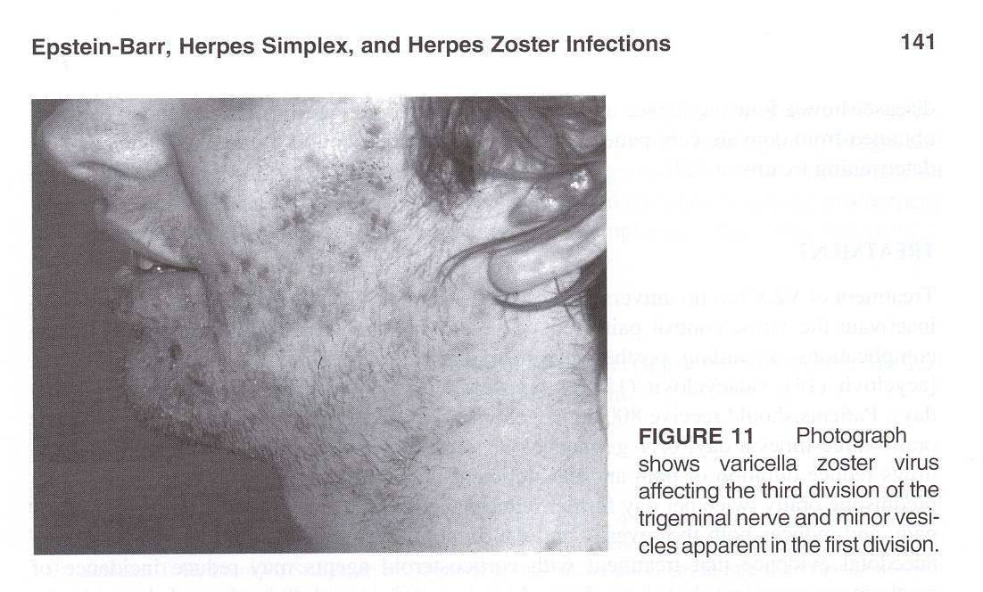
Of the facial nerves, the ophthalmic division of the trigeminal nerve is most frequently affected in herpes zoster (Fig. 11), and this event can cause optic keratitis, a potential cause of blindness. The most visible sign of motor nerve involvement is facial paralysis as seen in Ramsay Hunt syndrome, a condition which is more properly described as herpes zoster cephalicus (Fig. 7). Patients affected with this condition also have palatal and laryngeal paralysis and hearing loss. Acute facial paralysis with pain and hearing loss is pathognomonic of herpes zoster infection. The diverse manifestations of VZV activation are exemplified in Fig. 12, which illustrates VZV affecting a left thoracic dermatome concomitantly with left sided facial palsy. A diagnosis of zoster sine herpete should be considered for patients who have acute facial paralysis accompanied by moderate-to-severe pain and no vesicle formation (23).

DIAGNOSIS

The diagnosis of VZV is generally not difficult if the characteristic dermatomal rash and pain are present. Diagnosis is most difficult during the prodromal phase, when patients have pain but no visible lesions..
In patients who have the characteristic rash, a Tzanck preparation shows presence of multinucleated giant cells and this provides strong supportive evidence of zoster infection. The Tzanck preparation and immunofluorescence have proved superior to viral isolation for diagnosing early lesions. Samples obtained from patients during the acute stage of disease show a fourfold higher level of VZV antibody titer compared with serum samples obtained from convalescent patients, but the observation comes too late to have value for determining treatment (23).

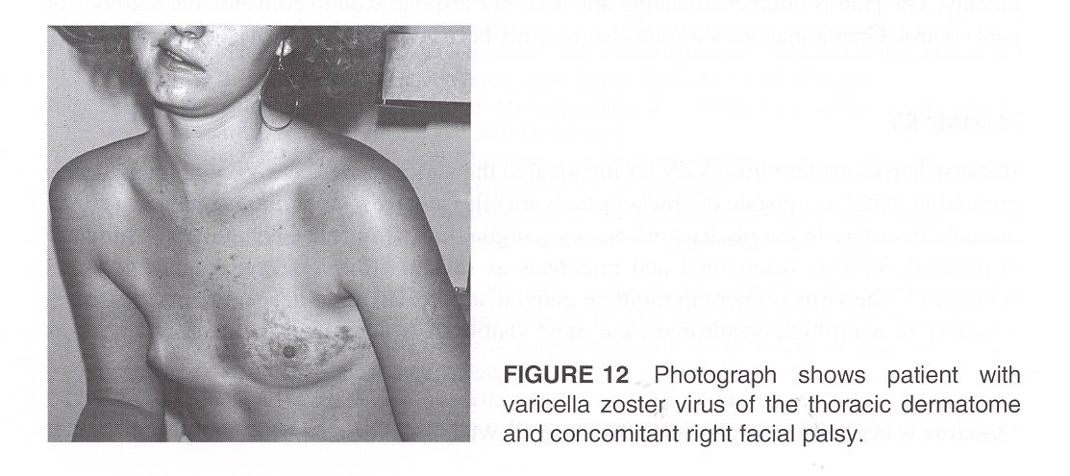
(Error: Left facial palsy)

COMPLICATIONS

About one in eight patients with herpes zoster infection has at least one complication of this condition. Major complications include postherpetic neuralgia, motor deficits, skin infection, and systemic involvement (with manifestations such as meningoencephalitis, pneumonia, deafness or dissemination). Postherpetic neuralgia occurs most frequently in patients older than 50 years of age and can be prolonged and intractable despite early antiviral therapy. The pain is often excruciating and does not respond well to conventional methods of pain control. Granulomatous vasculitis has recently been added to the list of complications (25).

SUMMARY

Because herpes zoster virus (VZV) is identical to the varicella virus the VZV abbreviation is preferable. After an episode of chickenpox (varicella) resolves, the virus subsides to a latent, noninfective state in the nucleus of sensory ganglia. Later in life, when antibody immunity is reduced, VZV is reactivated and manifests as radicular disease, commonly known as “shingles.” The virus is latent in multiple ganglia, and reactivation in specific nerves causes a variety of neurologic syndromes, the most visible of which affect the head and neck as herpes zoster cephalicus (described also as Ramsay Hunt syndrome), or as Costen’s syndrome. In 10% to 20% of affected patients, symptoms include hearing loss, vertigo, and muscle paralysis. Treatment usually consists of antiviral agents and corticosteroid drugs, but this approach is not universally accepted. Despite early and adequate treatment, postherpetic neuralgia develops and persists in many patients as a complication that defies treatment.

ACKNOWLEDGMENTS
Editorial assistance was provided by the medical editing service of the Permanente Medical Group Physician Education and Development Department.

