Bell's Palsy - 1
The Ear Nose and Throat Institute

of

Johannesburg
------------------------

Bell’s Palsy
and

Related Conditions

by

Herman Hamersma
M.B., Ch.B. (Pretoria), M.D. (Amsterdam)

Otology and Neurotology
Flora Clinic, Roodepoort, South Africa.

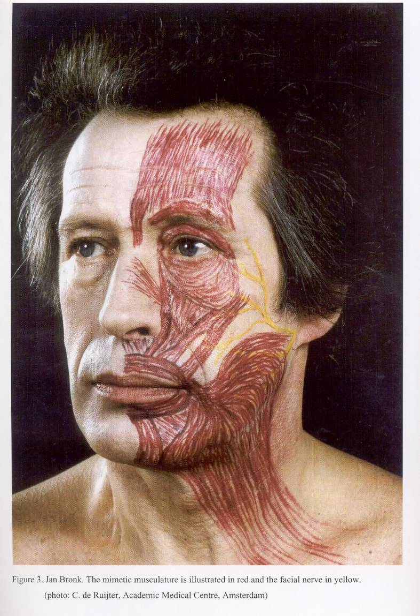

During a visit to South Africa in 1995, Dr Kedar K. Adour of San Francisco, stated

"Bell’s palsy can be looked on as the complete expression of acute benign cranial polyganglionitis affecting the facial nerve. This approach offers explanations for relations between phenomena that appear otherwise unrelated, and provides a basis for rational therapy. This approach equally applies to the eighth nerve, and explains the complex of phenomena which occur in Menière syndrome".
----------------------------------------------------

Bells’ palsy is often called: Idiopathic facial palsy (a diagnosis of exclusion).

Because no other lesions and no etiology are detected, it is assumed that an unknown pathological process confined to the temporal bone causes the palsy, but THIS IS NOT TRUE. A proper history (always ask about a taste disturbance) and clinical examination, often detect involvement of other nerves, indicating that the condition is a polyneuritis, caused by the Herpes Simplex-1 virus (the cold sore virus), which is carried by 80% of the population. Herpetic eruptions around the pinna, on the cheek, and inside the mouth and throat, often occur in Bell’s palsy, very similar to the eruptions of herpes zoster, but associated with less pain than in the case of zoster. These eruptions are missed if the physician does not deliberately look for them!

In children sclerosing bone dysplasias mimic the acute attacks of Bell’s palsy, and has to be excluded by means of an ordinary X-Ray examination of the skull (not a CT scan). This will demonstrate if the skull base is sclerotic. The extremely rare condition of sclerosteosis occurs especially amongst the Afrikaner population of South Africa, and 69 cases have already been identified in the last four decades. In Holland a similar condition exists, i.e., Van Buchem disease – 25 cases identified.

Bell’s palsy is generally regarded as a Benign facial palsy – benign because, even without treatment, it will always recover fully or partially with 6 months, but THIS IS NOT TRUE.

Facial paralysis is frightening to the patient and to the physician. This fear often leads to unnecessary, expensive tests, and, at times, to inappropriate treatment.

Without steroid treatment, 25% of patients with total paralysis will recover after 3 – 5 months but will have sequelae caused by faulty reinnervation to the muscles and loss of central inhibition in the facial nerve nucleus:
Synkinesis (the eye closes when the mouth moves due to faulty reinnervation),
Contractures (stiffness on one half of the face, a true spastic state due to loss of central inhibition),
Involuntary twitching of some muscle bundles,
Gustatory tearing (“crocodile tears”) - (when eating tears run down the face) due to incorrect reinnervation of the nerve supply to the submandibular salivary and lacrimal glands.

Fortunately early treatment wih steroids reduces the number of patients with severe sequelae to less than 10%.

After every attack of palsy, there is a 6% chance of further attacks on the same side or on the other side.

The name of Sir Charles Bell became associated with the facial nerve because he was the first person to demonstrate that the facial nerve was a motor nerve. In 1821 he cut the nerve of his laboratory animal (a jackass) and noticed that the ala of the nose then did not move on respiration. Many scientists then started talking of Bell’s nerve.

Bell’s phenomenon (the eyeballs rotate upwards when an attempt is made to close the eyes, or when falling asleep, or when fainting) was also named after Bell. This is a normal phenomenon especially noticeable in the case of a facial palsy only because the eyelids do not close.

It is to the credit of Antoni (1919) that detailed clinical examinations of patients with so-called idiopathic facial palsy (Bell’s palsy) revealed that other nerves are often involved. Antoni named the condition “acute infectious polyneuritis cerebralis acusticofacialis”, thus indicating an infection as the causative agent.

In 1969 Dr Kedar Adour, Chairman of the Cranial Nerve Research Unit of the Kaiser Permanente Group in San Francisco, confirmed the findings of Antoni, stating that the condition is a cranial polyneuritis, or a mononeuritis multiplex caused by reactivation of the Herpes simplex-1 virus. Adour suggested that the name “Bell’s palsy” should be discarded in favour of either “Herpes simplex facial palsy” or “Antoni’s palsy”.

Noteworthy for clinicians is the way in which Adour became alerted to the polyneuritis phenomenon. A patient with a typical Bell’s palsy mentioned to him that, besides the paralysis, his face was numb. When Adour replied: “I know. That is because your face does not move”, the patient said: “Doctor, you are not listening to me. My face is numb as if it has been injected by a dentist.” On re-examination Adour found hypesthesia of the patient’s cheek! Should we not listen more carefully to our patients? From then on Adour and co-workers examined all patients with Bell’s palsy very thoroughly, and discovered that blisters on the skin and in the mouth and throat occurred quite often.

In 1996 Murakami et al detected HSV-1 genomes in 11 of 14 patients with Bell’s palsy who had undergone surgical decompression, but found none in patients with Ramsay Hunt syndromes or other controls.

In 1997 Adour visited South Africa and stated: “We used the term polyneuritis in the past, but have now changed to polyganglionitis, because with this term we can explain all the signs and symptoms which occur. The disease is primarily in the ganglion, followed by a neuritis. The mucocutaneous manifestation is what we see, but this is only the lip of the volcano. The neuritic manifestations of herpes simplex reactivation are numerous:

Facial palsy, vertigo, acute hearing loss, unilateral headache, unilateral fullness of the ear, unilateral tinnitus, lump in the throat, unilateral neck or tempero-mandibular joint pain, unexplained cough, tendency to recurrent attacks – (see article Polyganglionitis Episodica by H.H.)

.Approximately 80% - 90% of humans carry the herpes simplex virus in the ganglions of cranial and spinal nerves. Our discussions will be confined to the cranial nerves and Cervical 2 and 3. Once the virus gets into the ganglion, it resides in the nucleus of the ganglion and waits there in a latent stage until it is reactivated and then causes a ganglionitis. The virus then migrates down the nerve to cause mucocutaneous vesicles, and up the nerve to cause a localized meningo-encephalitis at the brainstem. When the virus leaves the neural cell membrane, it takes a coat of neurolipoprotein around it, and it deposits that neurolipoprotein in the perineural compartment. This neurolipoprotein causes an immune mediated reaction, which causes demyeilinization in 4 - 5 days and is completed by 8 – 10 days after the disease process has taken place. Therefore, when you see the mucocutaneous vesicle, this is the lip of the volcano, i.e., this superficial sign indicates what is going on deeper, i.e., inside the ganglion. Depending on which nerve the virus reactivates in, signs and symptoms develop which have been described as various disease entities, e.g., Bell’s palsy, Menière disease, etc.. Herpes simplex is the big masquerader. It causes the inflammatory ganglionitis, which then causes a viral induced immunological response, not autoimmune. In addition a metabolic response is invoked by local changes, and the virus can also cause vasospasm.

In 1998 Pyykkö et al (Stockholm) reported circulating autoimmune antibodies in patients with Menière disease. They concluded that a viral infection breaks the labyrinthine barrier and triggers an autoimmune-like reaction. The herpes group of viruses is primary candidates.

Regarding Herpes simplex-1 virus infection of the cornea, Biswell (1998) stated that ‘antigenic particles of the viruses remain in the cornea long after the live infection has passed”, sensitized lymphocytes attack cells with virus particles attached, with resultant cell wall lysis and necrosis. Infiltration and edema ensues. AAC-mediated (Antigen-antibody-complement) Immune Complex Disease may be equally important.

Therefore, what happens in the inner ear in Menière syndrome may very well be described as

Antigen-Antibody-Complement (AAC) Immune
Complex Disease.

Fortunately these responses can be influenced by prednisone treatment, but unfortunately we do not have an antiviral agent to destroy the virus. We can only suppress its activity by means of acyclovir given in the acute stage. However, daily doses of acyclovir for long periods (up to one year) are already recommended to suppress eruptions of genital herpes.”

Dr Adour continued: “The structure of cranial ganglion need to be considered also. Ganglions contain bipolar sensory cells and in the cranial nerves there is a relationship with motor and inhibitory fibres which is unique. In the cranial nerves the motor and inhibitory fibres pas through the ganglion and any disease affecting the sensory nuclei will also affect the motor and inhibitory fibres. Unlike the motor fibres in the peripheral systems (which are separated from the sensory ganglion), the motor fibres of the cranial nerves traverse the ganglion. So, any process which takes place inside the ganglion is going to affect the motor cells – they become involved as innocent bystanders. What people forget is that any sensory system has an inhibitory system, and those inhibitory fibres must traverse the ganglion. When the inhibitory systems are affected this leads to a hyperactive state – see the discussions of every individual cranial nerve in the PGE article.”

Dr Adour concluded: “The proposal for the new syndrome PGE originated from astute clinical observations. The clinical signs were there all the time but were not detected probably due to clinicians not paying enough attention to the patients’ complaints.”

Herpes zoster facial palsy

Tryde (1872) first published on facial paralysis accompanied with herpetic eruption of the auricle. In 1904 Körner coined the term “herpes zoster oticus” for patients with vesicular eruptions of the auricle, facial nerve palsy and hearing loss. In 1907 Ramsay Hunt published in detail on facial paralysis associated with herpetic eruptions of the auricle, and postulated it to be herpetic ganglionitis of the geniculate ganglion of the facial nerve. The causative agent for this condition was later determined as the varicella-zoster virus (HZV) that also causes chicken pox. Although the clinical presentation of the disease is almost identical to that of Bell’s palsy, the patients have more pain, recovery is less favourable, and in addition the acoustic and vestibular nerves are affected in about 40% of cases. However, in 8% of patients with Ramsay Hunt syndrome, vesicles do not appear.

In 1967 Blackley et al published histological findings which showed involvement of the facial nerve as well as other nerves and parts of the central nervous system, and suggested that “herpes zoster cephalicus” should replace herpes zoster oticus. A rise in antibody titer to HZV can usually be determined during this condition.

Adour on the Viruses: Herpes simplex and zoster are neurotropic viruses. No other viruses are neurotropic for the ganglion other than herpes zoster and herpes simplex, and therefore polyganglionitis can only be caused by zoster and simplex. The virus Epstein-Barr causes mononucleosis, and this virus is not neurotropic. Because any infection can activate the herpes simplex virus, mononucleosis can be accompanied by a reactivation of herpes simplex virus resulting in a cutaneous herpes simplex at the same time.

The tricky thing about herpes simplex is that it is a DNA virus. When it gets into the cell the cell is confused – the cell does not know which DNA is the viral DNA and which DNA is the DNA of the nuclei. That is the problem with simplex. And when it activates the immune response it is not initiated until the virus leaves the cell membrane. It activates inside the ganglion, and when it leaves the ganglion it picks up a coat of neurolipoprotein which it deposits in the non-neural compartment creating toxic T-lymphocytes which attack the myelin.

Blood tests for HSV-1 and Zoster: The old theory was that to prove an activation of a virus you had to have a fourfold increase in the titre to that virus in acute convalescent serum. Simplex does not do that. The simplex titre does not change, even with a full-blown activation in the face or elsewhere in the body. There is no rise in the antibody titre during reactivation. The diagnosis therefore has to be a clinical one. With herpes zoster there is a marked (4-16 fold) increase in the antibody titer to zoster, but this only starts rising after a week.

Zoster and Chicken Pox: The patients who have zoster must have had chicken pox (varicella) at one time. They develop an immunity to the chicken pox, but over time the immunity to the chicken pox drops down to a non-protective level. Reactivation or re-infection manifests itself as zoster. Two thirds of the zoster cases occur in people over 50 years of age when they have lost their immunity to the varicella virus. In fact, they are doing a study where they are taking a group of older patients and vaccinating them with the varicella in order to build up their immunity to see if they can decrease the incidence of zoster in those patients who have been vaccinated against varicella. With varicella, since you have lost your immunity, the antibody titres are low enough so that the body must now build up new antibodies to the varicella – this take two weeks – whereas in simplex the active disease process is over by 8-10 days. In zoster, when the antibodies reach a critical level, there is a fantastic reaction between the antibodies and the virus. It is at day 14-21 that all the major nerve damage is done in zoster, whereas in simplex it is at day 8-10.

Does Valacyclovir eradicate the virus in the ganglion? No, once the virus is inside the ganglion the valacyclovir does not get into the nerve. That is the problem. The virus is very tricky – it hides inside the nerve compartment so all the antibodies cannot get to the virus inside ganglion to eradicate it, and neither can the valacyclovir get into the ganglion. Valacyclovir is only good when the virus leaves the neural compartment.

Treatment with Valacyclovir: The treatment is for one week. Do not give Valacyclovir to a patient with Bell’s palsy or Menière’s when you see the patient on day 8-10, because it is not going to do any good. Dermatologists prescribe 500 mg Valacyclovir daily for 3 months to one year to patients with genital herpes (HSV-2), and this can be tried in patients with frequent attacks of Menière’s.
Remember that the steroid is equally important because you must deal with two things, i.e., (a) the inflammatory response plus the viral immune reaction, and (b) the etiological agent.

Can steroids activate an acute herpetic viral infection if given when the eruption is already present?
No, I have been doing it for years on hundreds of patients and I have never seen it happen. This falsehood originated years ago when a microbiology journal published about experiments with mumps vaccine in egg yolk. Similarly there were reports of zoster patients who had been put on steroids and they said that a dissemination of the virus occurred because they developed diffuse pocks.
What actually happens is that in the normal course of events of a herpes zoster there is a viremia – it is not a localized dermatome that is involved. If you look closely you will find almost every patient to have some sort of pocks associated with zoster. And in the normal course of events, once the virus shows up in a segmental dermatome, there is a viremia 4-8 days later and the patient have this pocks, whether you give steroids or not.

SYMPTOMATOLOGY

Taking a proper history is the most important step in the diagnosis of a patient with any form of cranial neuritis. One must from the onset look for evidence that one is dealing with a benign disease. The criteria for benignity are acute onset, transient duration, lack of progression, and clinically complete resolution of the inflammation.
The work-up for cranial neuritis should include a general neurologic examination and a thorough ear, nose and throat examination. It is emphasized that nasopharyngeal and otologic examinations are mandatory. The use of a tongue depressor is essential: the diagnosis of Bell’s palsy or zoster can even be called a type of tongue depressor diagnosis (Adour).

Pain: The postauricular pain is due to the 2nd Cervical nerve involvement and occur in 70% of Bell’s palsy. This often precedes the onset of the paralysis with some days. In zoster infection the pain is more severe, occurs in all patients, and is often felt deep inside the ear, indicating involvement of the 9th and 10th cranial nerve. The severe forms of Bell’s palsy can also have severe pain deep inside the ear. Usually the pain decreases after 7 – 10 days, especially if prednisone treatment is given. If the pain recurs, it may be an indication of the disease not being controlled, and then the steroid should be increased again. Post herpes zoster neuritis may persist for months.

The facial nerve supplies the facial muscles, the stapedius, buccinator, platysma, stylohyoid and posterior belly of the digastric muscles. In Bell’s and zoster the paralysis is a lower motor neuron (nuclear or infranuclear) and must be distinguished from an upper motor neuron (supranuclear) paralysis. For the examination of the muscle movement, it is essential to press down on to the forehead, nose and lips to prevent the normal side from moving the affected side bilateral. In Bell’s palsy all branches of the facial nerve are usually affected, but it need not be to the same extent. With the upper motor neuron palsy, the forehead movement is not impaired due to the supranuclear innervation from both sides.

Taste disturbance (dysgeusia), occurs in 60% of Bell’s palsy patients, and is due to involvement of the cell bodies of the chorda tympani in the geniculate ganglion, often starts the first day of the paralysis. This symptom is pathognomonic of a viral infection of the facial nerve, and an MRI investigation is then not necessary.

Herpetic vesicles of the pinna occur most cases of zoster, but also in a small percentage Bell’s palsy cases. Vesicles can also occur in the oral, nasopharyngeal and hypopharyngeal mucosa, as well as the skin of the head and neck, since herpes simplex and herpes zoster vesicles are the cutaneous manifestations of a neurocutaneous disease.

Numbness of the cheek and the tip of the tongue are due to trigeminal involvement.

Somatophobia – hypersensitivity to touch due to decreased function of the inhibitory fibres of the sensory nerves, manifests itself quite often as sensitivity on touching the hair of the occipital region.

A reduced gag reflex due to involvement of the glossopharyngeal nerve can be tested by using a head light, depressing the tongue with one tongue depressor, and with the other tongue depressor touching the posterior wall of the pharynx, first on the one side and then the other. The tongue or anterior pillar should not be touched.

Hyperacusis (hypersensitivity to loud sound) should rather be called dysacousis or phonophobia, and is not related to an absent stapedial reflex but is due to loss of function of the inhibitory fibres of the cochlear nerve (also present in acute Menière’s).

Inflamed fungiform papillae of the tongue can occur on the clinically affected side, but both also on the clinically unaffected side.

Epiphora. Overflow of tears down the cheek (not increased tearing, although this erroneous interpretation is frequently assumed) is a presenting symptom in 70% of patients with Bell’s palsy. It is due, not to an increase in autonomic stimulation, but to punctate keratitis caused by drying of the globe, or to lack of the blink reflex with eversion of the lower eyelid, which prevents tears from being “milked” out of the eye into the lacrimal duct, or to both of these events. The epiphora may persist even after the patient is able to voluntarily close the eye.

Reduced tearing. If tear production is reduced on one side, this can be regarded as a sign of threatening total degeneration of the nerve. Schirmer’s test is recommended during the first 10 days of the disease: coffee filter paper, cut into strips measuring 5 cm long and 1 cm wide are hooked on to the lower eyelid (after any pooled tears are first removed). The paper should become moist within 2 –3 minutes, and it should be equal for the two sides. A bilateral central shutdown of tearing occasionally occurs for the first week, and in the author’s experience this can be regarded as a good sign, while a unilateral dry eye indicates a severe case of viral inflammation of the superficial petrosal nerve (which accompanies the facial nerve as far as the geniculate ganglion before it proceeds to the lacrimal gland).

Vertigo is unusual in Bell’s palsy, but common in cases of zoster, indicating that the vestibular labyrinth is involved. When the hearing is also reduced it is called Ramsay Hunt Syndrome. In zoster the affected balance organ can be severely damaged, but can recover to a certain extent. If the hearing is damaged, it usually does not recover.

Recurrent attacks are rare in case of zoster, but in Bell’s palsy there is a 6% chance of recurrence on the same side or on the alternate side.

Causes of Facial palsy

Various reports in the literature indicate that of all facial palsies approximately 70% are due to Bell’s palsy, 15% caused by trauma (including iatrogenic), and 7% due to herpes zoster infection.

The natural course of untreated Bell’s palsy

Peitersen (Copenhagen) reported on 2255 patients with facial palsy in 1985. Of these 67% had Bell’s palsy (1510) and none were treated with steroids (that only applied to Scandinavia).

Analysis of Peitersen’s 1510 Bell patients:

Incomplete paralysis (paresis) in 453 cases, i.e. in 36% of all Bell’s.
Recovery was 100% in all cases and completed by 4 weeks.
Total paralysis 1057 cases, i.e. in 70% of all Bell’s.
Recovery was 100% in 792 cases, i.e. 75% only and completed by
4-6 weeks without the sequelae mentioned on page 3, but in
265 cases (25% of total paralyses and 17% of all Bell’s) the
paralysis lasted 12 – 16 weeks (i.e. total degeneration of the nerve
axonotmesis) occurred, and they recovered only 70% movement, and all of
them had sequelae.

Prednisone Treatment results: At the same meeting in 1985, Adour et al reported their results in 2000 cases of Bell’s palsy when prednisone treatment was started within 3 days of onset of paralysis. The results in cases with total paralysis were much better, because only 6% had total degeneration. In 1996 the same researchers reported on a small series (99 patients) of Bell’s with total paralysis who were treated with prednisone, but one half received acyclovir as well. Fortunately none of the patients developed total degeneration, and the group who received acyclovir as well as prednisone had a better recovery profile than those receiving prednisone alone.

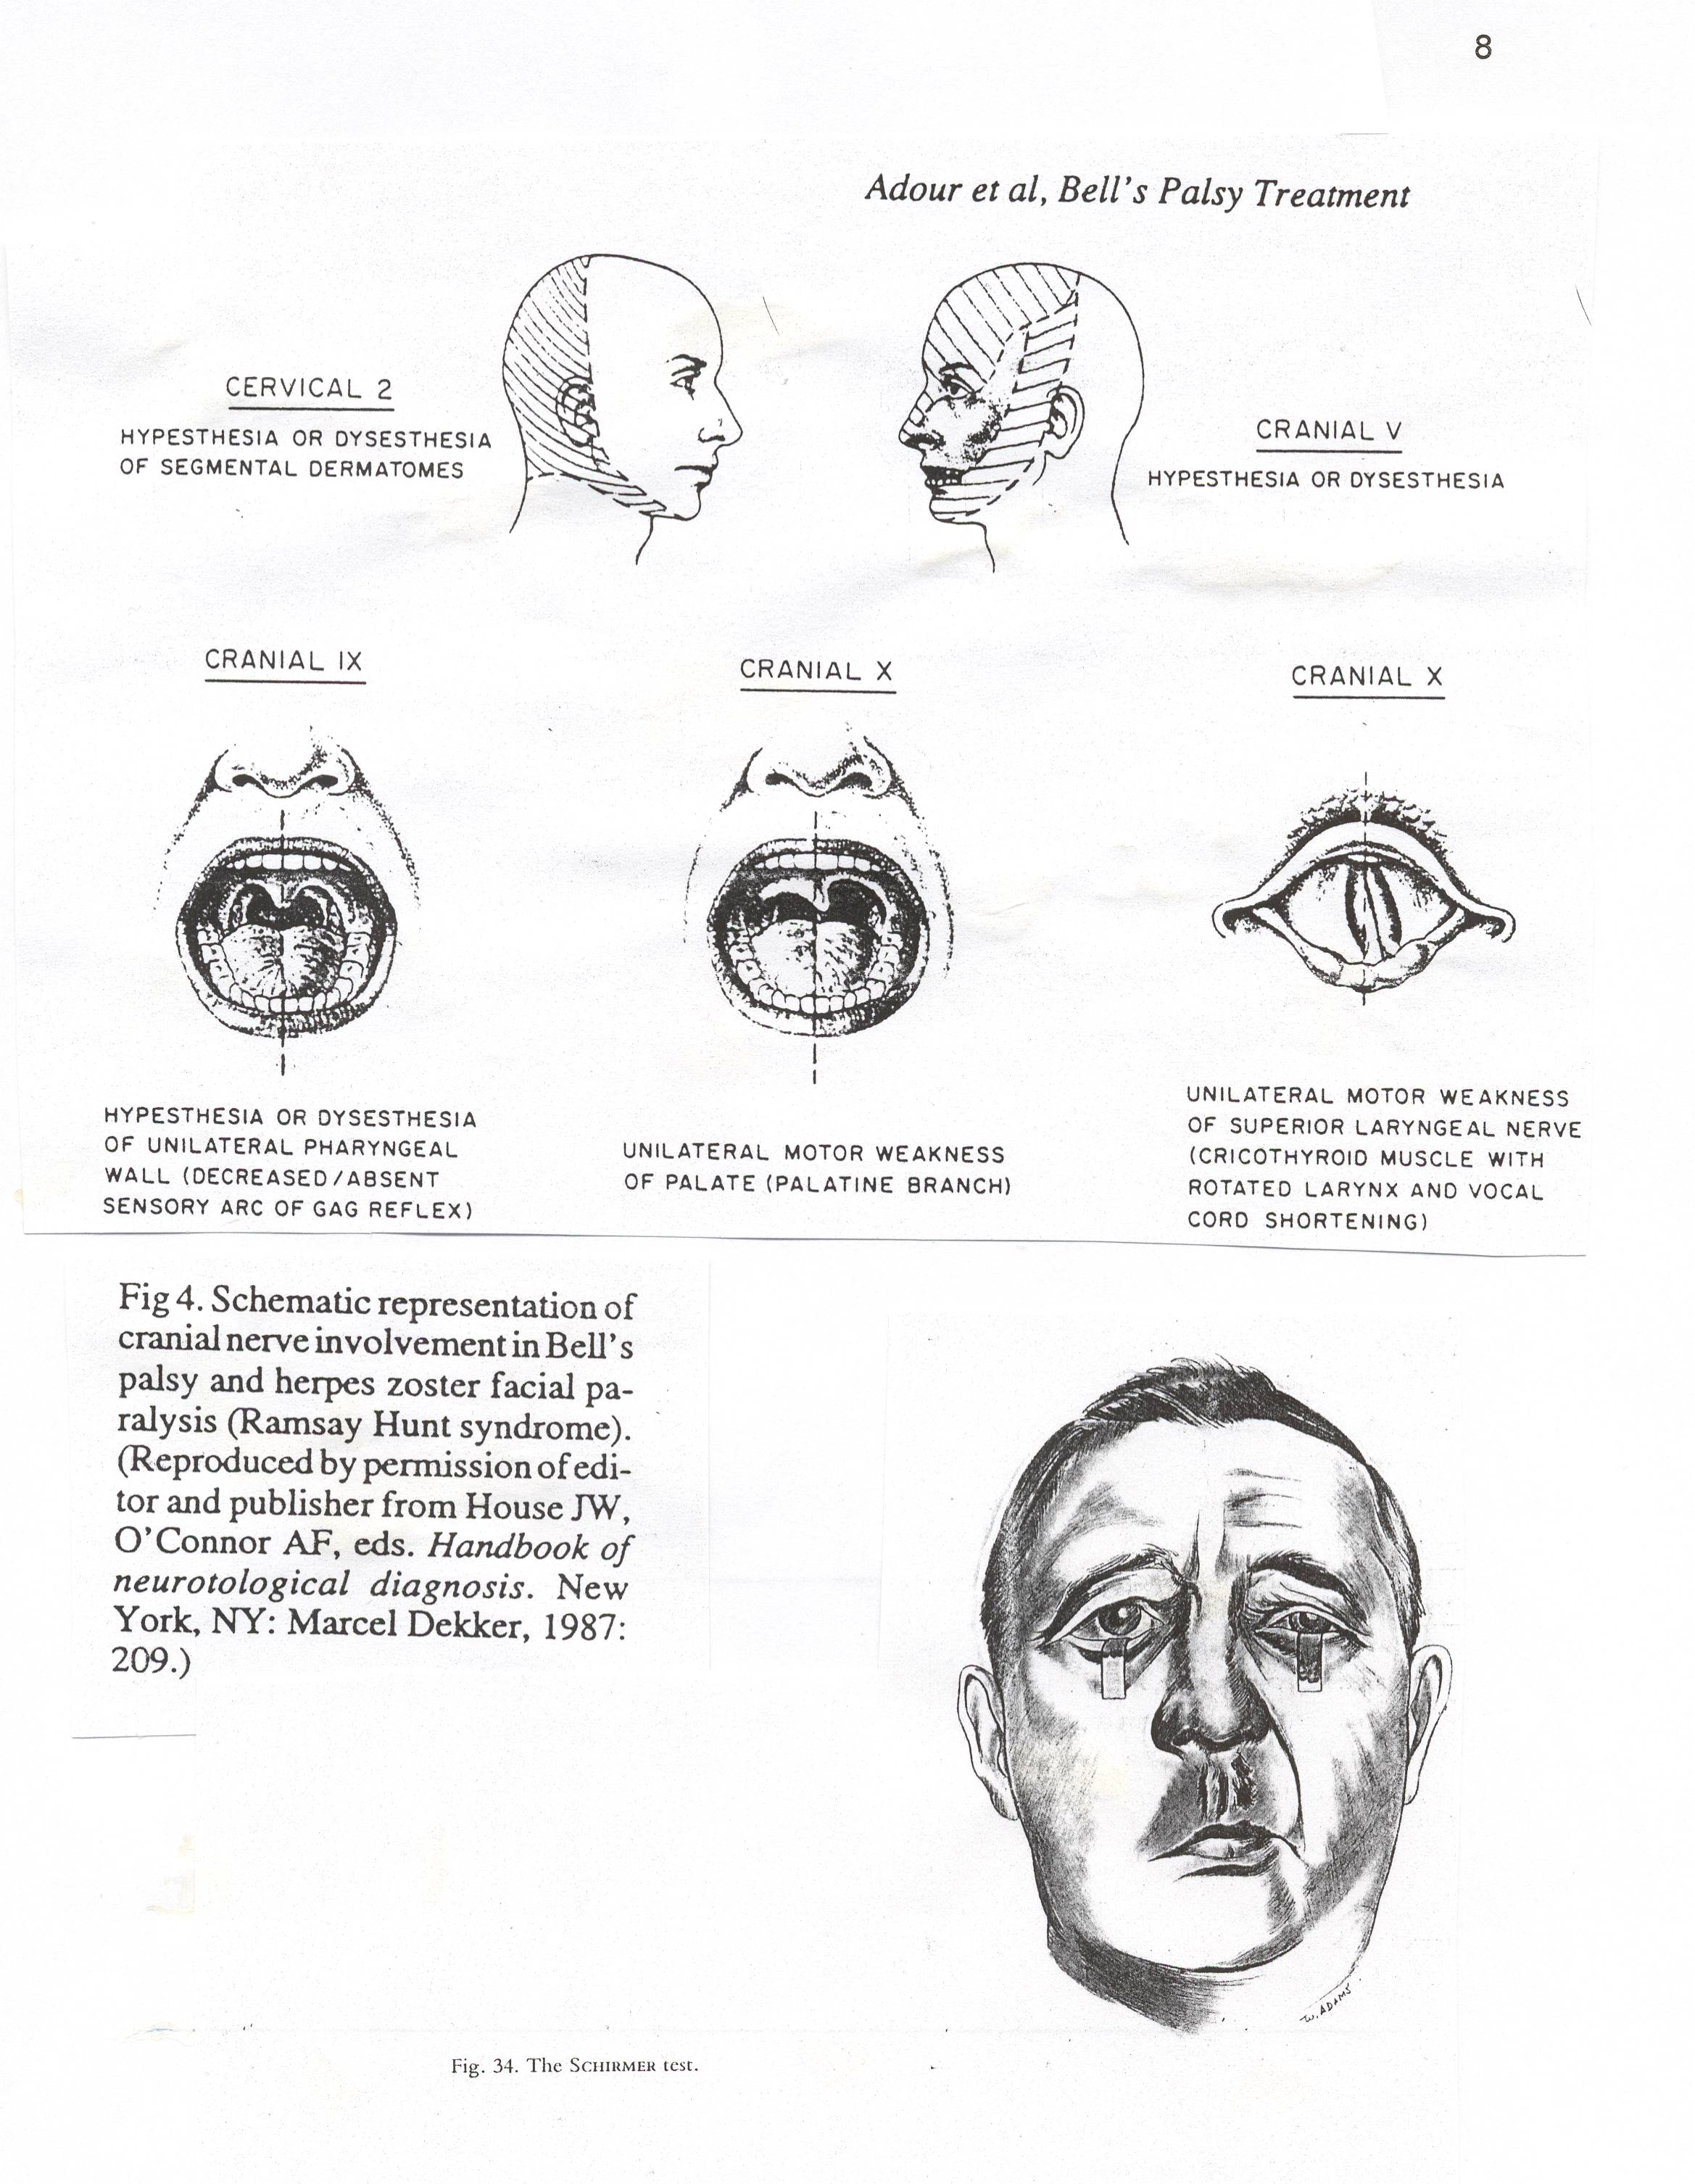

Clinical application of the above findings:

If a partial paralysis (paresis) occurs, it will recover totally and within 3-4 weeks because the nerve then suffers mostly from a neuropraxia only (temporary physiologic block of the nerve impulses).
A total paralysis can recover totally within 4 weeks if not more than 20% of the fibres sustain severe damage (axonotmesis). The damaged fibres will then regrow within 12 – 18 weeks resulting in a very satisfactory recovery with practically no sequelae.
A total paralysis, which persists after 3 – 4 weeks indicate total nerve degeneration (axonotmesis). Regrowth of nerve fibres will occur and the first movements of the face will start 12 –14 weeks after the onset of the paralysis. However, the recovery will be incomplete (about 60 – 70% movement only) and sequelae (see page 3) will always be present to a certain extent.
The treatment of the paralysis is aimed at preventing damage to the neuronal tissue, and we have only antiviral treatment and steroids which influence the pathological process – and not 100% effective at all.

MEDICAL TREATMENT

Every facial palsy should be regarded as an emergency. Prednisone treatment should be started immediately by the referring physician and not delayed until a specialist is seen. When requesting an appointment with a specialist, the urgency should be stressed and the specialist should see the patient within 1 – 2 days.

Prednisone for Bell’s Palsy:
Start with 1 mg per Kg body weight prednisone daily, taken in divided doses morning and evenings for 5 days for both complete and incomplete palsies. Electrical tests are unnecessary if the paralysis is incomplete, but in total paralysis electrical monitoring is recommended starting on Day 3 (because of a built in delay of the tests, it only tells you what the condition of the nerve was the day before – see separate publication on Electrodiagnosis of facial palsy)
.
On Day 6 of the palsy:
If the paralysis remains incomplete (= paresis) the dose is tapered to zero during the next 6 days. Improvement of function usually starts from Day 10-14, and movement should be normal by Day 28. Electrical tests are unnecessary.
If the paralysis is complete the 1 mg/Kg/day is continued up to Day 16, and then tapered to zero during the next 5 days (total 21 days). Prednisone is discontinued after Day 21, even though return of facial function may not yet have taken place. Prednisone should never be stopped abruptly because rebound inflammation can lead to further denervation.
If the nerve does not degenerate totally (as determined by the electrical tests), some function will start from Day 16–18–20, and normal movement is possible by Day 42. If partial movement stops progressing by Day 42, the rest will come by 12 – 14 weeks, and the final result will be good (more than 90% movement) with insignificant synkinesis.

In case of total degeneration (as determined by electrical tests), function will start returning after 12 – 16 weeks, and no more than 70-80% movement can be expected (provided prednisone had been given, otherwise less movement can be expected). However, sequelae (see page 3) will always occur.

Prednisone for Zoster paralysis:

Ramsay Hunt syndrome is more severe than Bell’s palsy and can have late neural degeneration at Day 14-18. Prednisone should therefore be given at the 1 mg/Kg dose for up to Day 21, and then tapered during the next week.

Eye care: Because the eye does not close, natural tears or a tear gel (e.g. Celluvisc) should be prescribed)

Analgesics: Although the prednisone usually helps to reduce the pain, liberal use of analgesics may be necessary, especially in zoster palsy.

Monitoring the paralysis by means of Electrical Stimulation:

A total paralysis cannot be assessed clinically, and only regular electrical stimulation tests can monitor the condition of the nerve. The disease process is active up to day 18 in Bell’s palsy and up to day 21 in zoster.
The small nerve stimulator used by anaesthetists to monitor muscle relaxant dosage during anesthesia suffices for the tests. Electrical monitoring supplies valuable information and the patient’s anxiety will be reduced if regular tests show the nerve is only temporarily inactive. Also, the threat of rapid nerve degeneration can be detected and the possibility of surgical intervention mentioned to the patient (in these times of informed consent it may become mandatory to supply patients with more details of their diseases).

Unfortunately the electrical tests are only accurate during the first 18 days of the disease process.
Antiviral Treatment:

Valacyclovir or Famvir is recommended during the first week of the disease. Although the degree of success of this treatment has not yet been established beyond doubt, we are compelled to prescribe it.
For Bell’s Palsy: Valacyclovir 500 mg. t.i.d. for one week.
For Zoster palsy: Valacyclovir 1000 mg t.i.d. for one week.
In case of a Bell’s palsy with severe pain, give the zoster dose.

Decompression Surgery for Viral Facial Palsy

Considerable difference of opinion still exists regarding surgery. The consensus is that, if surgery is performed, the proximal (labyrinthine segment) of the nerve should be decompressed via a middle fossa approach (craniotomy) by a neuro-otologist trained in skull base surgery. Animal experiments as well as clinical experience have so far indicated that it is impossible to prevent degeneration by means of timely surgery based on serial electrical tests. However, cases have been reported where eventual sequelae were significantly less when they had been decompressed within days after electrical tests showed total degeneration had occurred, provided it is done not later than day 10 – 14. Anxious patients, especially those whose careers require good facial function, e.g., actresses, may insist on this information. Unfortunately the surgery, as is the case in all surgical interventions, carries a small risk of complications.
Physiotherapy

Most facial nerve researchers do not recommend physiotherapy treatment. The argument that muscle atrophy during the time of total paralysis is prevented does not apply to the facial muscles. Experience gained with patients who needed nerve grafts many months after the onset of the paralysis have shown that excellent movements recur even after many months of inactivity of the muscle.

Conclusion

The symptomatology of Bell’s palsy and zoster facial palsy provides the clinician with valuable clues as to the pathological processes in diseases like classic Menière syndrome and vestibulopathies. However, these clues will not be available if the clinician does not deliberately look for them.

Early and sufficient medical treatment usually prevents total degeneration of the facial nerve in most cases of Bell’s palsy, and in the majority of zoster palsy.

Electrical monitoring of total facial paralysis is easy, essential if the paralysis is total, and the equipment available – just look for it on the anaesthetist’s trolley.

Regard each facial palsy as an emergency!
- - - - - - - - - - - - - - - -

Also see the addendum = Bell's palsy - 2

