BPPV - 5

Horizontal canal BPPV:

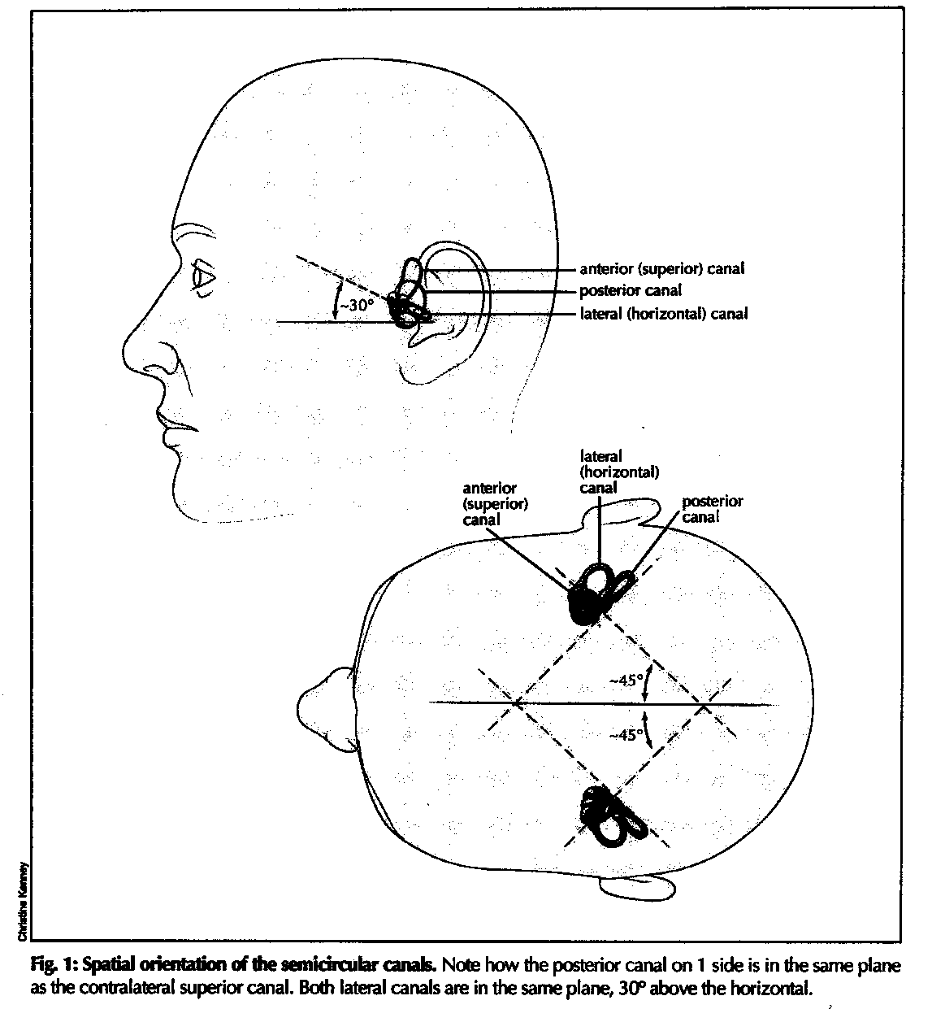

Parnes:
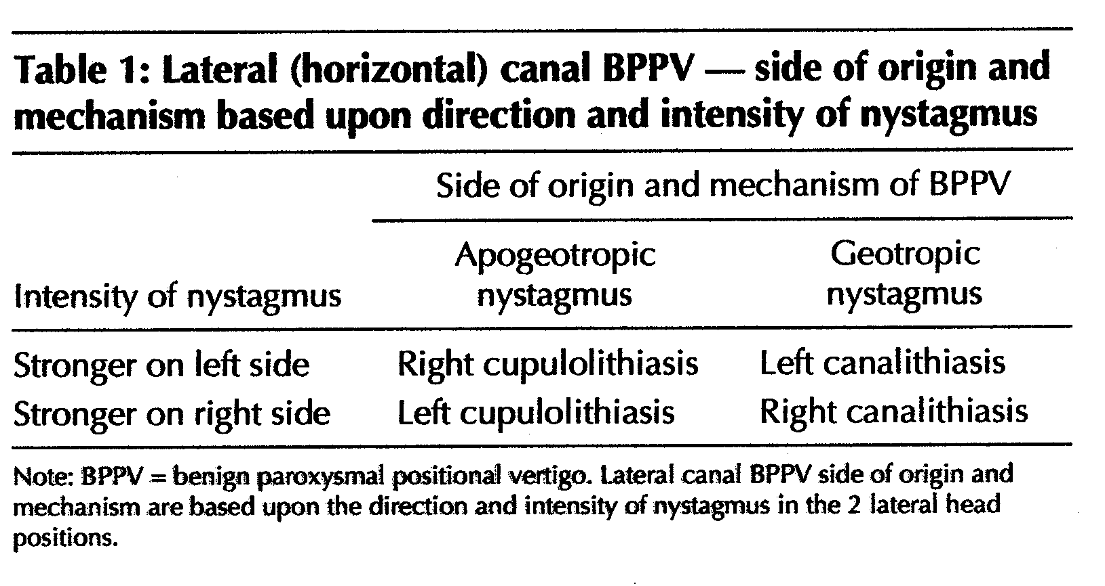

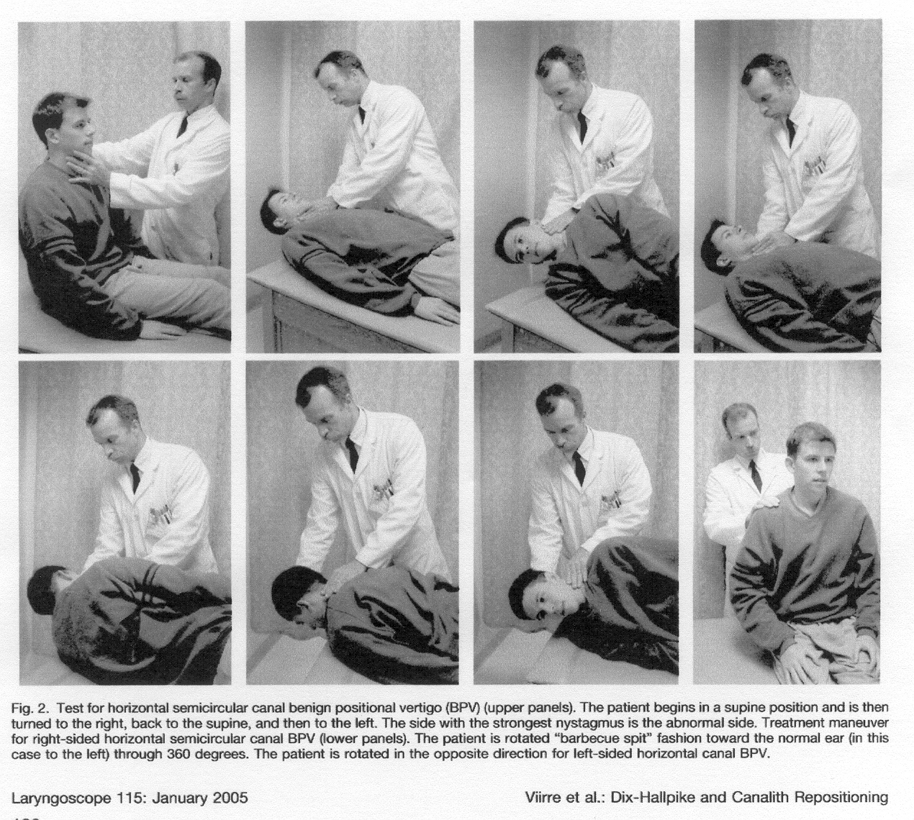

Viirre et al:

If the horizontal canal BPPV test is negative, we then repeat the Dix-Hallpike test. We have often found that typical BPPV nystagmus will be seen on the repeat test even though the original test was negative in 10% to 20% of cases where the history was consistent with BPPV. Presumably, the brief period of lying supine allows the debris that was dispersed throughout the posterior canal to form a clot that is more effective in displacing the cupula. Regardless of the mechanism, this simple procedure of repeating the Dix-Hallpike tests after the horizontal test has increased the number of positive tests.

If the Dix-Halpike test is negative on both sides, we immediately proceed to a test for the horizontal canal variant of BPPV. The horizontal canal variant of BPPV is relatively rare with respect to posterior canal type (less than 1% in our experience). With the patient placed supine (Fig. 2), the head and body are rotated 90 degrees laterally, while reminding the patient to keep the eyes open. We look for a bust of horizontal nystagmus beating toward the ground. \the nystagmus can last as long as 30 to 60 seconds; the affected side has the stronger nystagmus. If there is no vertigo or nystagmus after 30 sconds in each lateral position, the test is deemed negative.

For treatment of the horizontal canal BPPV, beginning with the supine position, the patient is rolled toward the normal side (barbeque-spit fashion) keeping ythe head in line with the long axis of the body. The procedure is best performed on a floor mat (or carpet) that allows a complete 360 degree rotation back to the supine position without stopping. Vibration over the mastoid on the affected side is particularly helpful for horizontal canal CRM.

HH: In the above article no mention is made of the nystagmus being either geotropic or apogeotropic. For further information the publications from Italy (Appiani, Nutti etc) are worth while.

In 2005 Chiou et al published “A Single Therapy for All Subtypes of Horizontal Vertigo” in the Laryngoscope 115:1432-5.

Today the otolith repositioning manoeuvres for posterior and horizontal canal BPPV, or liberatory manoeuvres, are widely used with a success rate of more than 80%. However, refractory cases do occur and for them Parnes & Price-Jones Horizontal canal BPPV:

Parnes:

Viirre et al:

If the horizontal canal BPPV test is negative, we then repeat the Dix-Hallpike test. We have often found that typical BPPV nystagmus will be seen on the repeat test even though the original test was negative in 10% to 20% of cases where the history was consistent with BPPV. Presumably, the brief period of lying supine allows the debris that was dispersed throughout the posterior canal to form a clot that is more effective in displacing the cupula. Regardless of the mechanism, this simple procedure of repeating the Dix-Hallpike tests after the horizontal test has increased the number of positive tests.

If the Dix-Halpike test is negative on both sides, we immediately proceed to a test for the horizontal canal variant of BPPV. The horizontal canal variant of BPPV is relatively rare with respect to posterior canal type (less than 1% in our experience). With the patient placed supine (Fig. 2), the head and body are rotated 90 degrees laterally, while reminding the patient to keep the eyes open. We look for a bust of horizontal nystagmus beating toward the ground. \the nystagmus can last as long as 30 to 60 seconds; the affected side has the stronger nystagmus. If there is no vertigo or nystagmus after 30 sconds in each lateral position, the test is deemed negative.

For treatment of the horizontal canal BPPV, beginning with the supine position, the patient is rolled toward the normal side (barbeque-spit fashion) keeping ythe head in line with the long axis of the body. The procedure is best performed on a floor mat (or carpet) that allows a complete 360 degree rotation back to the supine position without stopping. Vibration over the mastoid on the affected side is particularly helpful for horizontal canal CRM.

HH: In the above article no mention is made of the nystagmus being either geotropic or apogeotropic. For further information the publications from Italy (Appiani, Nutti etc) are worth while.

In 2005 Chiou et al published “A Single Therapy for All Subtypes of Horizontal Vertigo” in the Laryngoscope 115:1432-5.

