The Ear Nose and Throat Institute of Johannesburg
------------------------

Electrodiagnosis of Bell’s Palsy and

Other Facial palsies

by

Herman Hamersma
M.B., Ch.B. (Pretoria), M.D. (Amsterdam)

Otology and Neurotology
Flora Clinic, Roodepoort,South Africa.

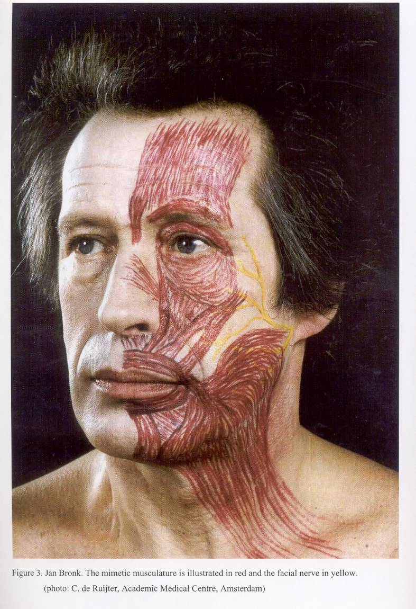

Hamersma Peitersen Devriese Croxon
Florida Copenhagen Amsterdam) Sydney
25 yrs 25yrs 43 yrs 16 yrs

Bell 863 (72%) 1701 (66%) 50% 46%

Zoster 63 (5%} 116 (5%) 6% 12%

Trauma 174 (15%) 95 (4%) 17% 30%

Miscell 101 (8%) 570 (25%) 27% 12%

Recurrences 12% 7% 8% 1%

__________ _____________ ________ __________

Total = 1201 Peitersen 2570 8697 1000

Recurrent palsies:

Recurrences on the same side, new paralyses and recurrences on the contralateral side (also called alternating paralyses) are grouped together as “recurrent”. Kedar Adour (USA) reported recurrences in 9 % of Bells’ palsies.

Partial and Total Paralysis in Bell’s Palsy:
According to Peitersen, 30% of Bell’s palsies present as a partial paralysis (paresis) which do not progress to a total paralysis. 70% Present as a total paraysis, some of them starting as a partial paralysis and then progressing to a total paralysis after a few days, usually within 4 days.

Surgical decompressions for Bell’s palsy done by H.H.:

Surgical decompressions of the labyrinthine portion of the nerve and the geniculate ganglion via the middle fossa approach were performed in 65 cases in 30 years (2 per year). The surgery was done when total degeneration was threatening, or when it had occurred only a few days before. The latest operaton was done by day 14, because even then the recovery of facial movement resulted in less synkinesia and contractures than occurred when these type of patients were not operated at all.

Presented at the Annual Congress of the South African Society of Otolaryngology, Head and Neck Surgery in Bloemfontein, November 2005.

Marble Bone Disease:

55 Cases of sclerosing bone dysplasias (sclerosteosis and osteopetrosis – nickname
= marble bone disease) can be added to the 101 miscellaneous cases of the Florida list, but they are excluded in order to make comparison with international data possible. In these rare conditions, the facial palsies present as acute, recurrent palsies, similar to Bell’s palsy, in early childhood already but the nerve always degenerates totally and recovers partially after 3 – 5 months. Total facial nerve decompressions (in two stages) were performed in 26 children from ages 2 – 12 (many done on both sides).

Assessing the nerve and determining a Prognosis

The peripheral facial palsies should be managed by otologists, because neurologists and internist do not pay enough attention to pathological anatomy, e.g. the possibilty of a benign tumour of the nerve itself (schwannoma) or a tumour in the vicinity of the nerve (adenocystic tumour of the parotid gland), etc..

To assess the condition of the nerve electrodiagnosis is essential. This will determine whether the impaired movement is due to

- Neuropraxia = a temporary block of nerve conduction, - movement will return
- within 2 – 3 weeks),
- or
- A
- Axonotmesis = degeneration,- movement will return after 3 – 4-6 months only),

- or
- Neurotmesis, = . no anatomical continuity (no return of function without grafting).
The elctrodiagnosis will assist to set the prognosis.

The electrodiagnosis should be done by the doctor himself.
The time course of degeneration of the facial nerve must be kept in mind.

- An acute total facial palsy, presumed to be Bell’s palsy, MUST have return of some movement by 4 – 6 months. If no movements return, the diagnosis is wrong, and can be a life threatening disease, e.g. adenocysic carcinoma of the parotid.

- A partial facial palsy, presumed to be Bell’s plasy, must have normal function within 4 weeks, otherwise the diagnosis is wrong, e.g. a tumour of the nerve, or a cholesteatoma, etc.

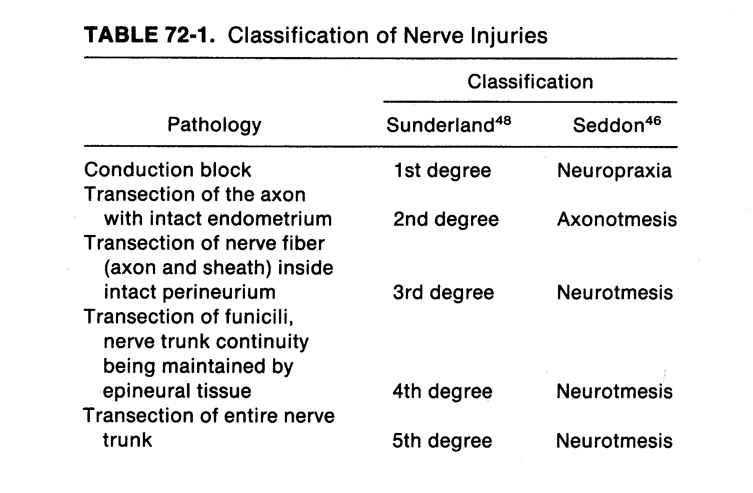-
- - - - - - - - - - - - - - - - - - - - - - - - - - - - - - - - - - - - - - - - - - - - - - - - - - - - - - - - - - -

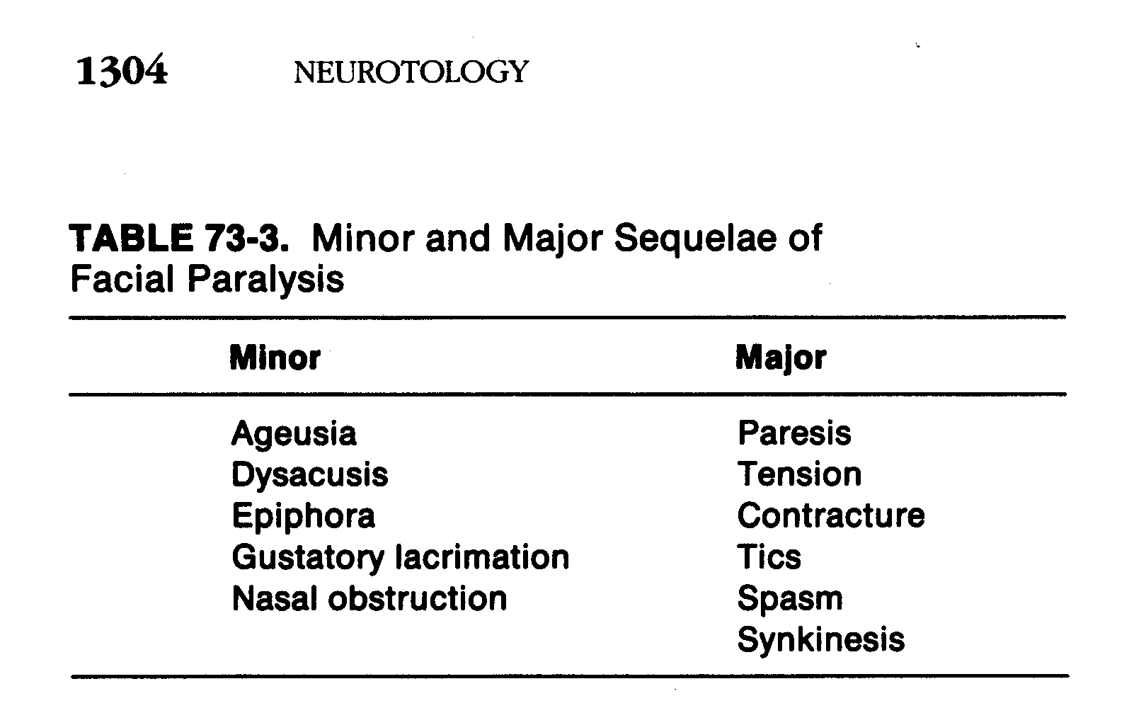

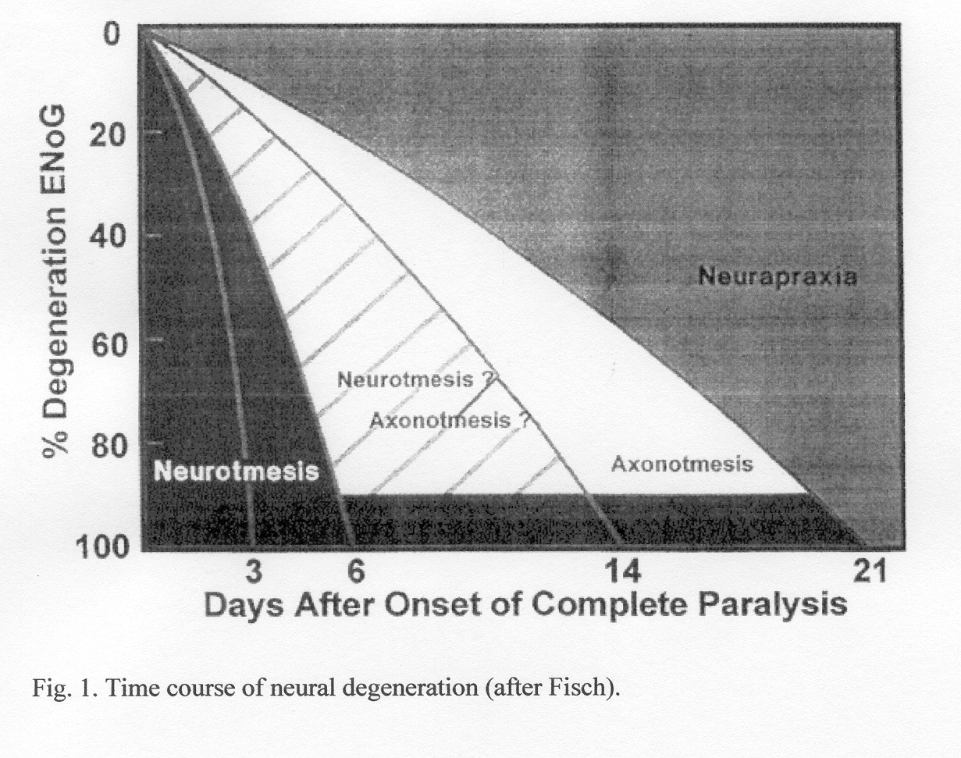

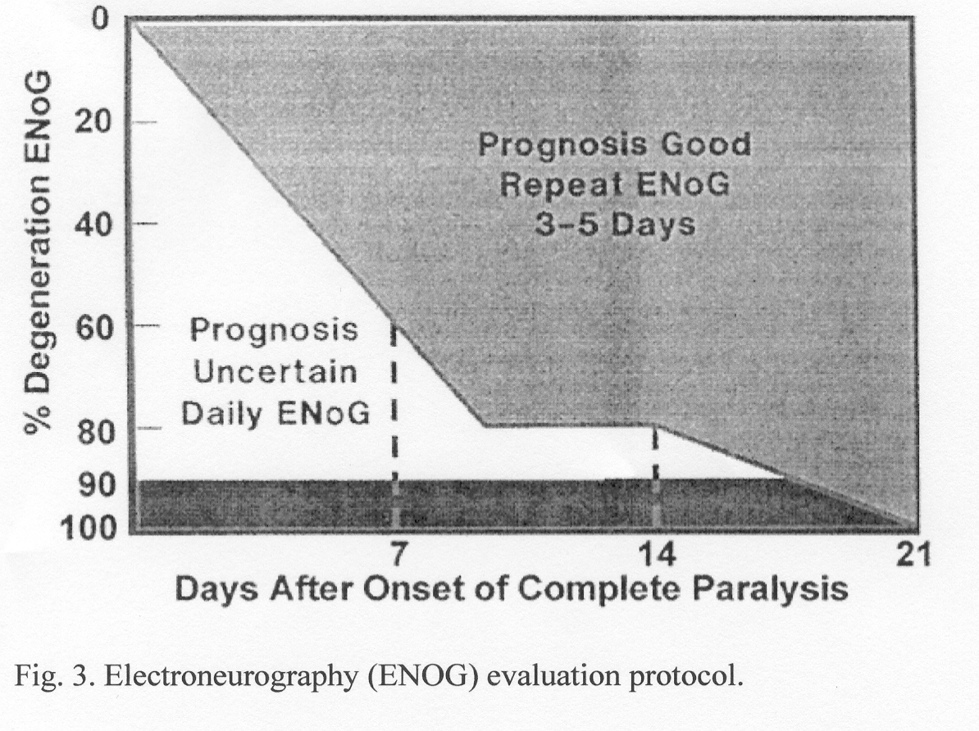

The longer the total paralysis lasts, the bigger the chance of a poor recovery.



