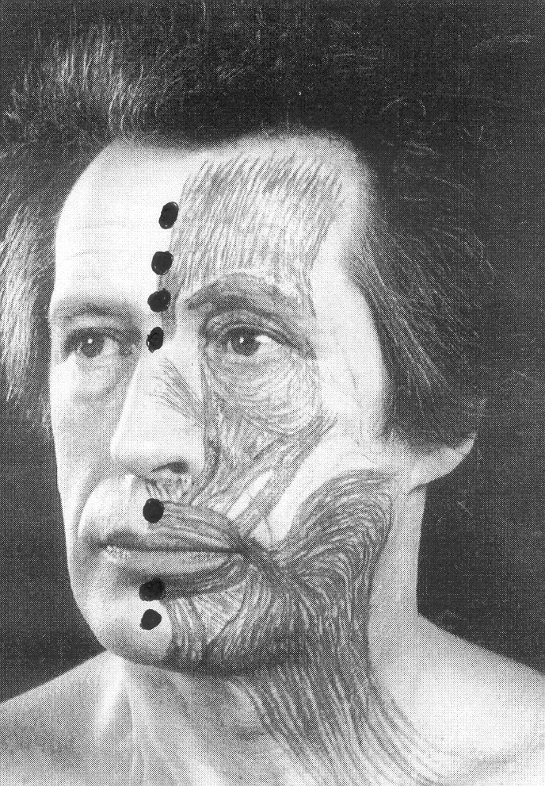

For the forehead the observer should use four fingers on the forehead and the thumb on the nasion (the root of the nose). The same method is used to observe movements to close the eye. For the mouthone or two fingers press on the upper lip against the teeth, and two fingers immobilize the lower lip.

On trying to close the eye, one will observe that the eyeball tilts upwards (Bell’s phenomenon). This tilting of the eyeball must be kept in mind when examining for a return of function of the muscles which close the eye – one should then immobilize the lower eyelid with one finger and ask the patient to close the eye. If there is any real movement of the muscles below the eye, one will feel the muscles moving (advice of Dr Devriese, Amsterdam)..

Example of elctrodiagnosis with VenoG

Observe the voluntary movements of the frontalis, orbicularis oculi, and orbicularis oris, and give it a percentage score (normal if never paralised before, otherwise less if patient had a previous paralysis).

- Do a Schirmer test. Although the topographical value is disputed, a dry eye and
a bilateral shutdown are very important findings.

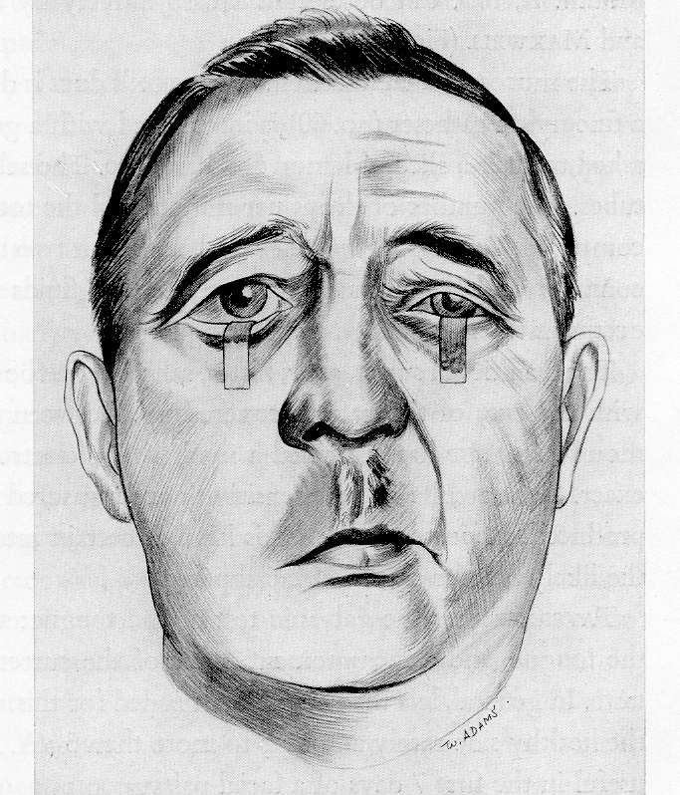

Schirmer test

- Electrodiagnosis: Start with the normal side, and stimulate at the stylomastoid foramen using felt tipped probes.

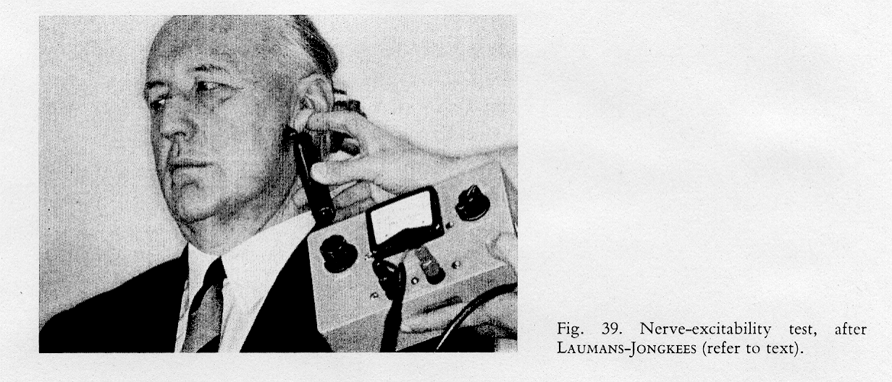

The above picture illustrates stimulation at the stylomastoid foramen and observing
the muscle contractions.

Start with a small stimulation, and then increase to the maximum the patient can tolerate. Do not mistake a contraction of the masseter for a facial nerve response.
If the masseter jerks, move the stimulating electrodes more posteriorly in order to reduce stimulation of the trigeminal nerve. .

Observation of the facial nerve response:

Establish a base line on Day 1 – 3 – (it will always be normal).

Forehead (frontal branch) – give it a percentage score (compare with the normal
side which is 100%).

Eye (zygomatic branch) - dito.

Mouth (buccal branch) - ditto.

Next tests:

Day 4

Day 5

Day 6

Day 7

Day 8

Day 10

Day 12

Day 14

After Day 18 the electrical tests become less accurate.

ENOG:

The author has found that the calculation of the percentage degeneration (in comparison with the normal side) varies too much, and recommends that the absolute values be recorded and taken as important. Thus

Respoinses above 1.0 millivolt – nothing to worry about.

“ betewen 0,5 – 1.0 mV – do daily tests.

“ at 0,5 mv – red Flag!

“ below 0,5 mv - bells ringing!

Example of clinical notes in case of a left sided paralysis:

Day 1: Voluntary movement : Forehead 50%, Eye 50%, Mouth 50%
(as compared with right side).
No electrical tests because they will be normal.

Day 3: Voluntary movement: FH= 0, Eye = 0, Mouth =0%
Schirmer: L= 2 cm, Right 5 cm
VenoG: L = 80% all branches (compared with right side)

Day 5: Voluntary movement – total paralysis left
Schirmer: Left 0,5 cm
VenoG: L = 50% all branches

Day 6: Vol movement: 0%
Schirmer: Dry eye
VenoG: L = 20% all branches. EnoG advised.

Day 7: Vol movement: 0%
Schirmer: Dry eye
Venog: L = 5%
EnoG: Left 0,5 mv, R = 5,0 MV
Advise that decompression may become necessry.

Day 8: Vol: 0%, dry eye.
VenoG: L = 5%
EnoG: Left 0,4 mV

Day 10: Vol 0%, dry eye.
VenoG: L 5%
EnoG = o,4 mv

Day 12: Vol 0%, eye starts tearing
VenoG: 5%
EnoG: 0,4 mv

Day 16: Vol: 5% movement forehead
VenoG: 5%
Day 20: Voluntary movement FH 50%, eye 20%, mouth 20%.
Voila! Both patient and doctor happy because the monitoring of the process
was done in a scientific way with little guesswork. This is the 21st century!

