ENOG:

The author has found that the calculation of the percentage degeneration (in comparison with the normal side) varies too much, and recommends that the absolute values be recorded and taken as important. Thus

Respoinses above 1.0 millivolt – nothing to worry about.

“ betewen 0,5 – 1.0 mV – do daily tests.

“ at 0,5 mv – red Flag!

“ below 0,5 mv - bells ringing!

Example of clinical notes in case of a left sided paralysis:

Day 1: Voluntary movement : Forehead 50%, Eye 50%, Mouth 50%
(as compared with right side).
No electrical tests because they will be normal.

Day 3: Voluntary movement: FH= 0, Eye = 0, Mouth =0%
Schirmer: L= 2 cm, Right 5 cm
VenoG: L = 80% all branches (compared with right side)

Day 5: Voluntary movement – total paralysis left
Schirmer: Left 0,5 cm
VenoG: L = 50% all branches

Day 6: Vol movement: 0%
Schirmer: Dry eye
VenoG: L = 20% all branches. EnoG advised.

Day 7: Vol movement: 0%
Schirmer: Dry eye
Venog: L = 5%
EnoG: Left 0,5 mv, R = 5,0 MV
Advise that decompression may become necessry.

Day 8: Vol: 0%, dry eye.
VenoG: L = 5%
EnoG: Left 0,4 mV

Day 10: Vol 0%, dry eye.
VenoG: L 5%
EnoG = o,4 mv

Day 12: Vol 0%, eye starts tearing
VenoG: 5%
EnoG: 0,4 mv

Day 16: Vol: 5% movement forehead
VenoG: 5%
Day 20: Voluntary movement FH 50%, eye 20%, mouth 20%.
Voila! Both patient and doctor happy because the monitoring of the process
was done in a scientific way with little guesswork. This is the 21st century!

Gantz et al: Surgical management of Bell’s palsy.

Laryngoscope 109 (8) August 1999, pp 1177-1189

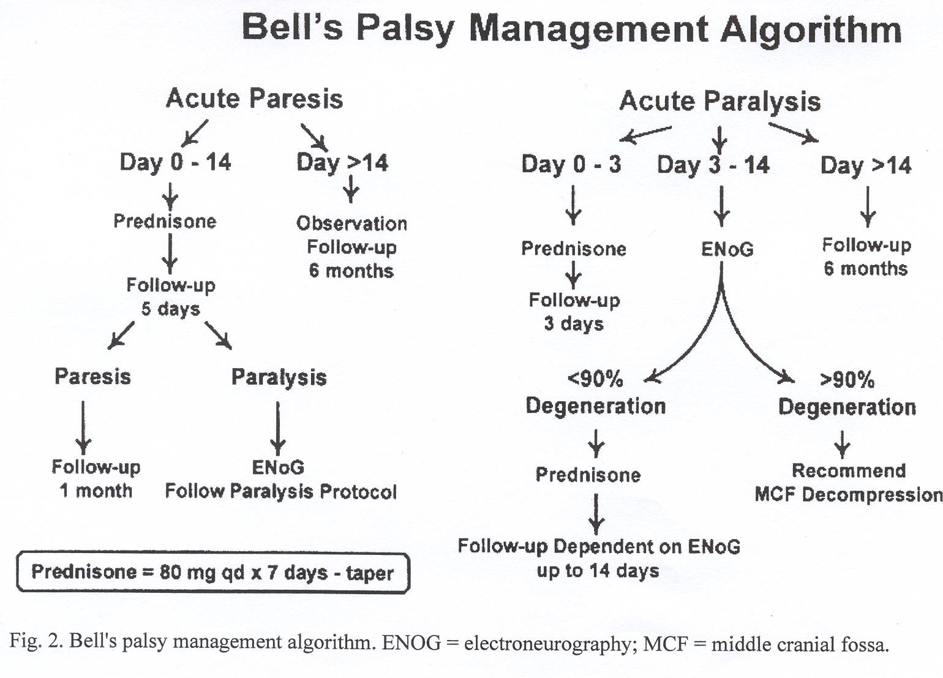

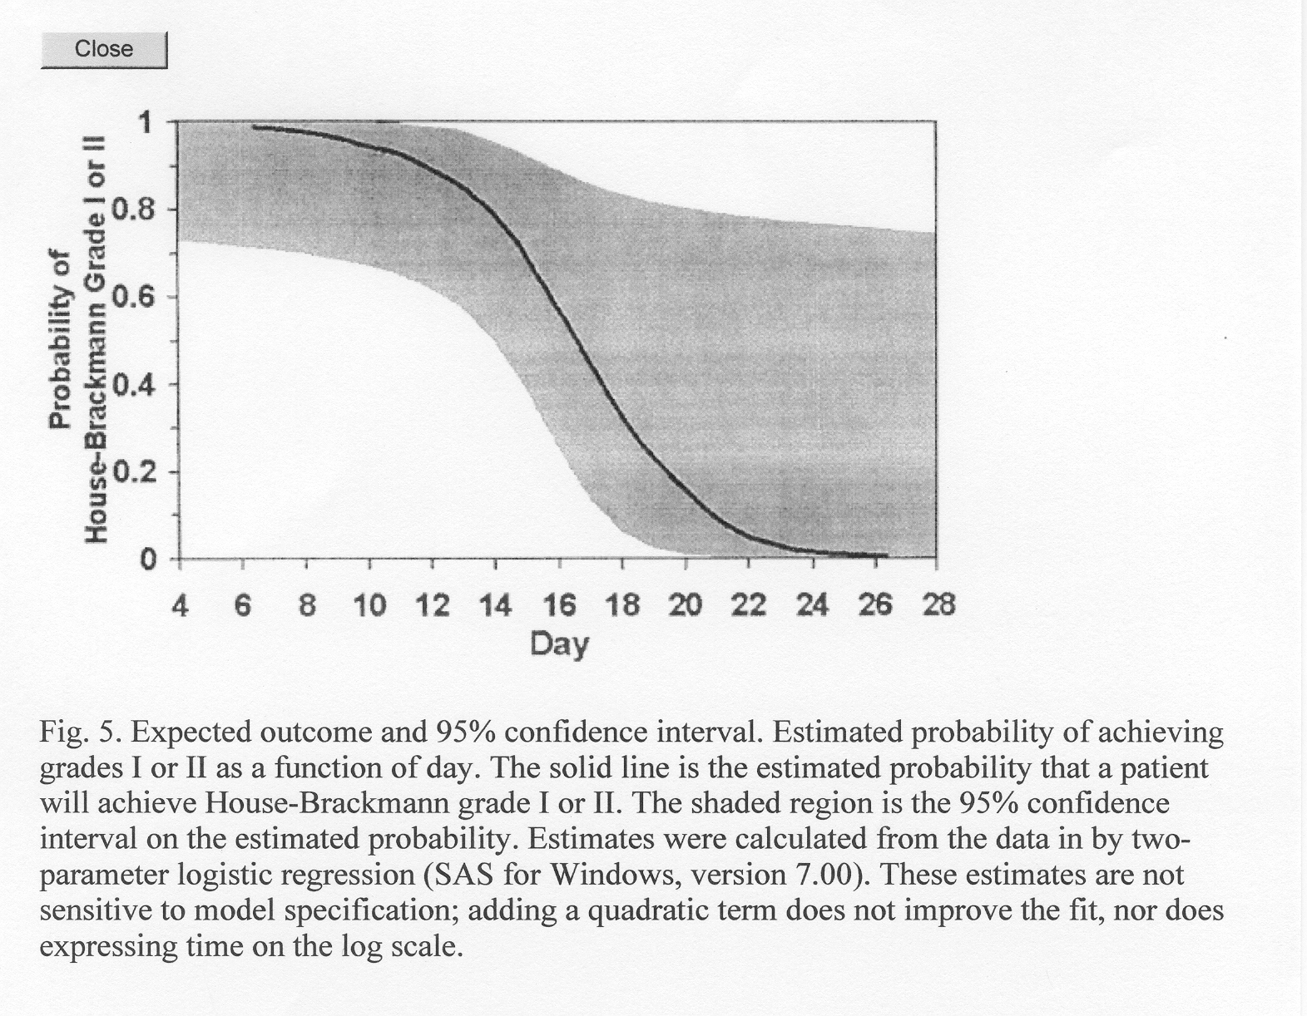

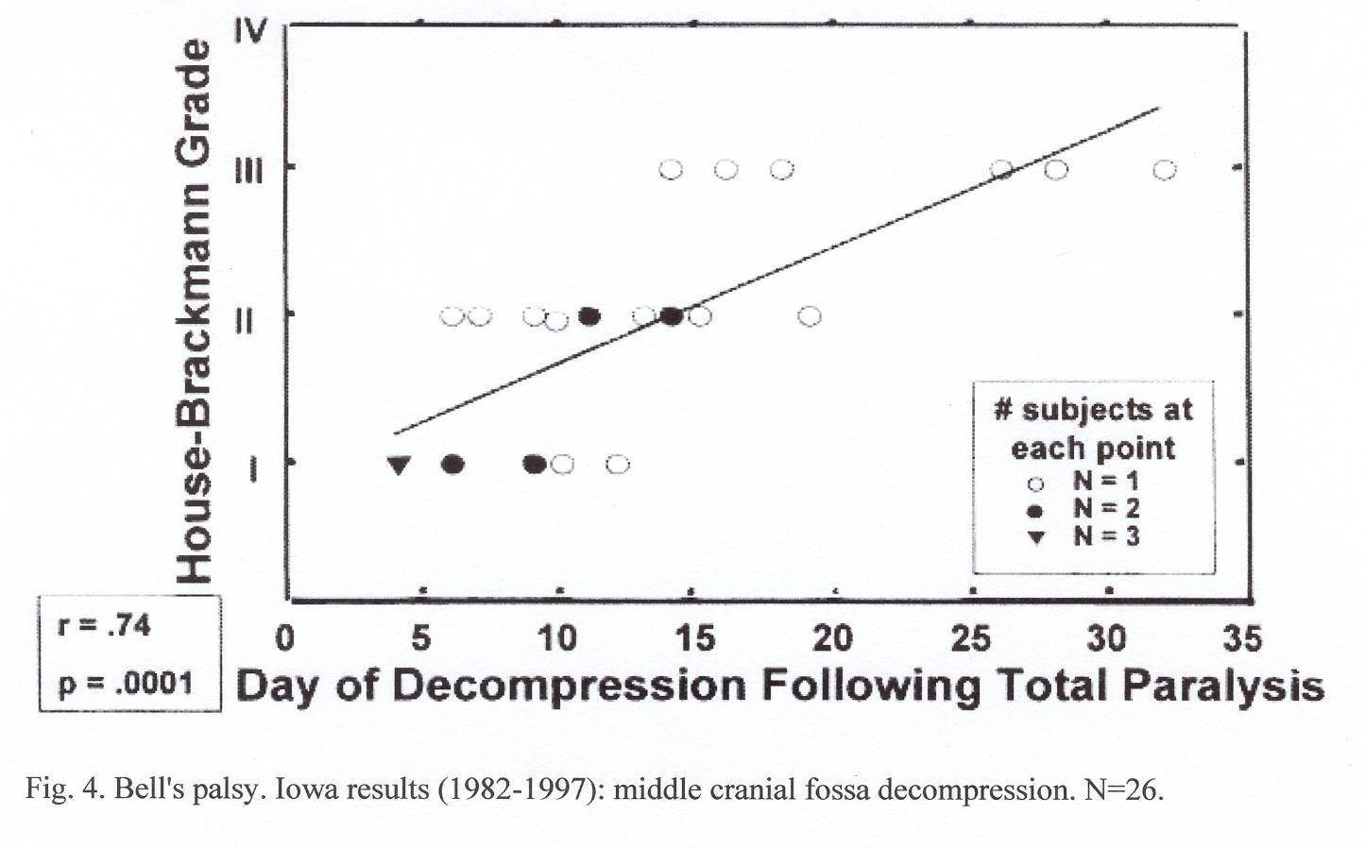

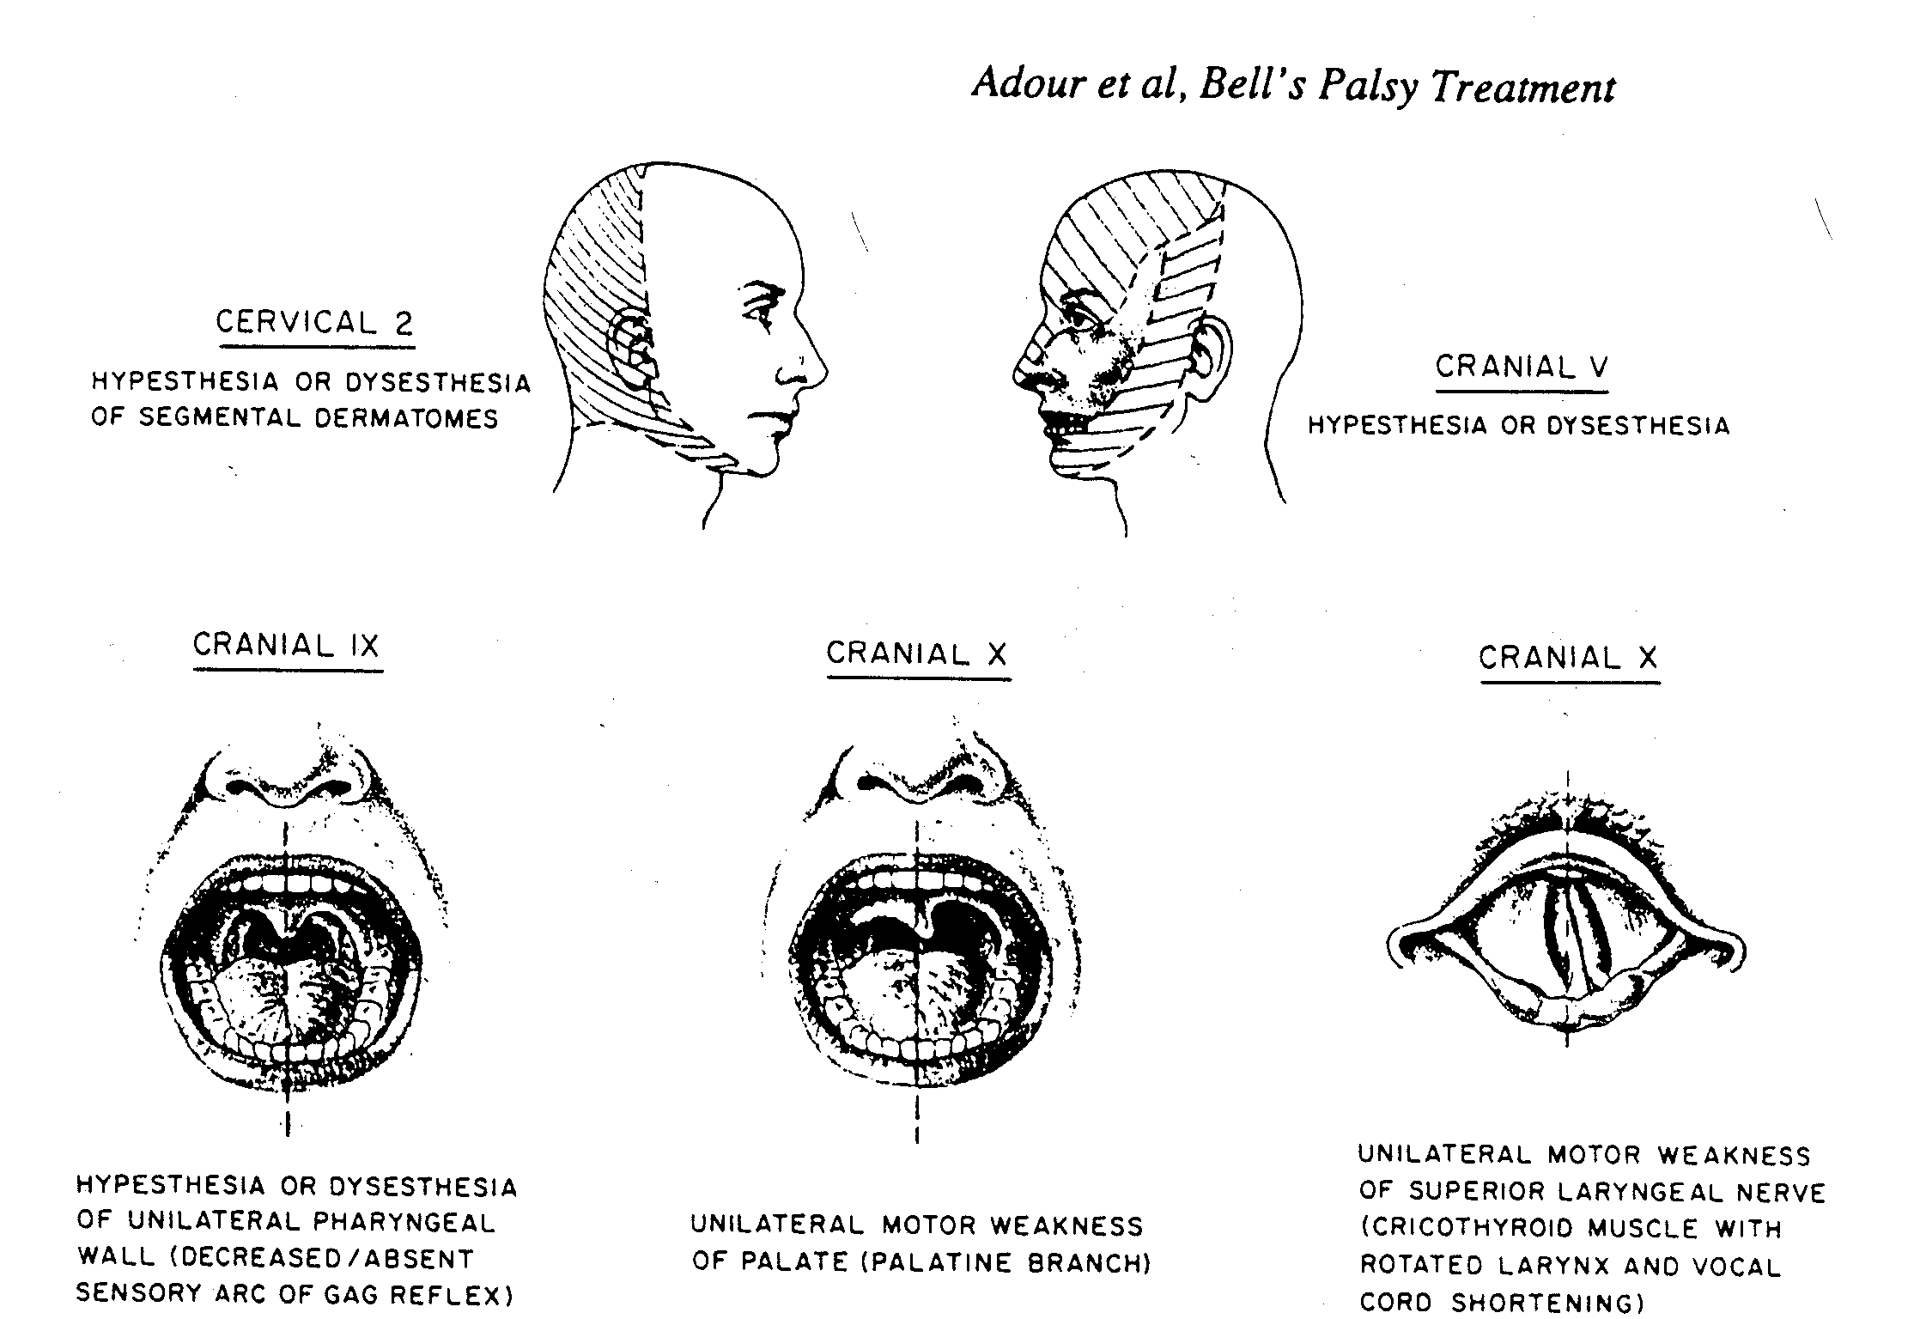

Schematic representation of cranial nerve involvement in Bell’s palsy and herpes zoster facial paralysis (Ramsay Hunt syndrome)

K K Adour in “Handbook of neurotological diagnosis”
Marcel Dekker, New York, 1987: page 209.



