PHYSIOLOGY of EQUILIBRIUM

H.Hamersma, M.D.

(Adapted from publications of the late Prof Brian McCabe, USA
…..

In humans, a highly sophisticated mechanism for maintaining balance has developed, which is dependent upon visual, vestibular proprioceptive (from tendon and joint receptors) and superficial sensory information (e.g. contact between the soles of the feet and the floor). This is integrated in the central nervous system and is modulated by activity arising in the reticular formation, the extrapyramidal system, the cerebellum and the cortex.

Physiologically the vestibular labyrinth transduces mechanical energy into electrical activity (nerve action potentials), which is interpreted by the brain to allow conscious awareness of the position of the head and body in space, and enables reflex control of eye movement, posture and body motion. The mechanical sensors are inside the bony labyrinth (inner ear). The cochlea is anterior and the semicircular canals posterior. The two join at the vestibule, which contains the utricle and saccule (the oval window is lateral to the structures). The sensors are inside a delicate tube containing endolymph, which has a high potassium value. Between the endolymphatic tube and the walls of the bony labyrinth another fluid, perilymph, circulates. The perilymphatic space is in continuity with the subarachnoid space and perilymph is practically the same as cerebrospinal (low potassium value). Leaking of the high potassium endolymph into the perilymph causes irritation of the nerve endings and results in vertigo attacks (as can happen in Menière’s disease).

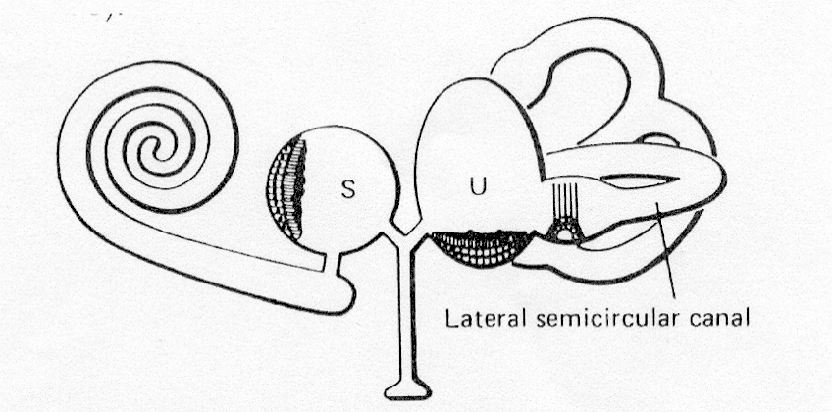
Schematic drawing of the left inner ear: S = saccule, U = utricle

The mechanical sensors of the vestibular labyrinth are

- The utricle and saccule which contain flat sensory areas = the maculae (less than 1 square millimetre) overlayed by a gelatinous coat studded with calcium crystals, otoliths. The utricle is situated horizontally and the saccule vertically. The otoconia, under the influence of gravity, stimulate the hair cells of the maculae, i.e. positive or negative acceleration (e.g. going up in an elevator). They monitor linear acceleration.

- Three semicircular canals (one horizontal and two vertical canals, at right angles to each other) in both temporal bones which are therefore arranged in the three dimensions space. Each canal forms two-thirds of a circle, with a diameter of 6,5 mm and a cross-sectional diameter 0f 0,4 mm. The receptor organ of the semicircular canals (the crista ampullaris with valve like cupula on top) is situated in the dilated (ampulla) of each canal. The cupula, a gelatinous mass which extends from the surface of the crista to the ceiling on the ampulla, forms a watertight swing-door seal. The semicircular canal is sensitive to angular acceleration of the head (= rotation). Any movement of the head in which there is angular rotation causes a piling up of endolymph on one side of the cupulae of two or more of the semicircular canals (they are orthogonally paired structures) and the brain is signalled.

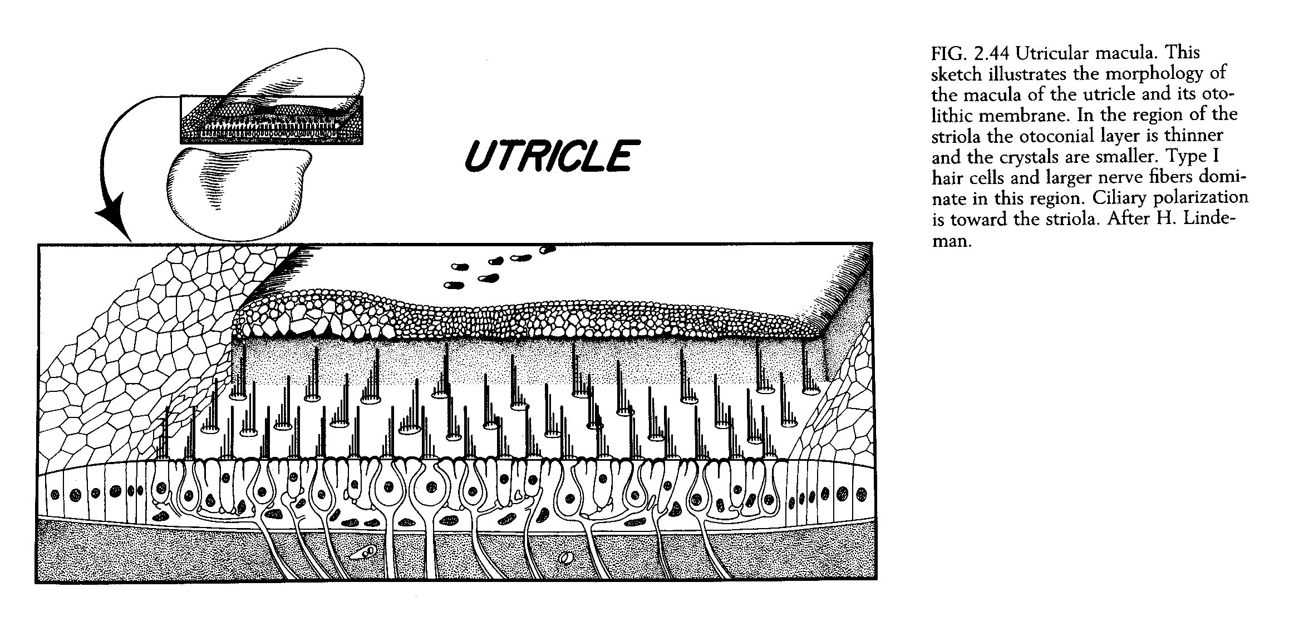

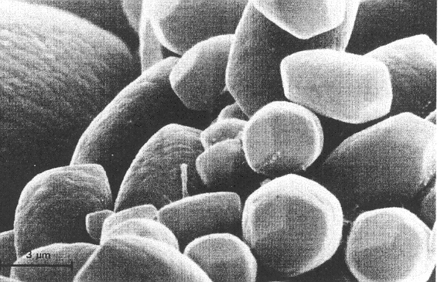

The vestibular end-organs are dynamic structures in three ways
- They respond to linear and radial acceleration,
- They are not silent until stimulated, but constantly discharge a resting pattern of signals to the brain. Acceleration or a change in acceleration deviates the cupula or stimulates the utricle/saccule and produce a change in this pattern or signals to the brain.
- There are two sets of vestibular systems, left and right, constantly signalling. A difference in the signal pattern between them is produced by an acceleration, and it is this difference that is the relevant quantity to the brain.

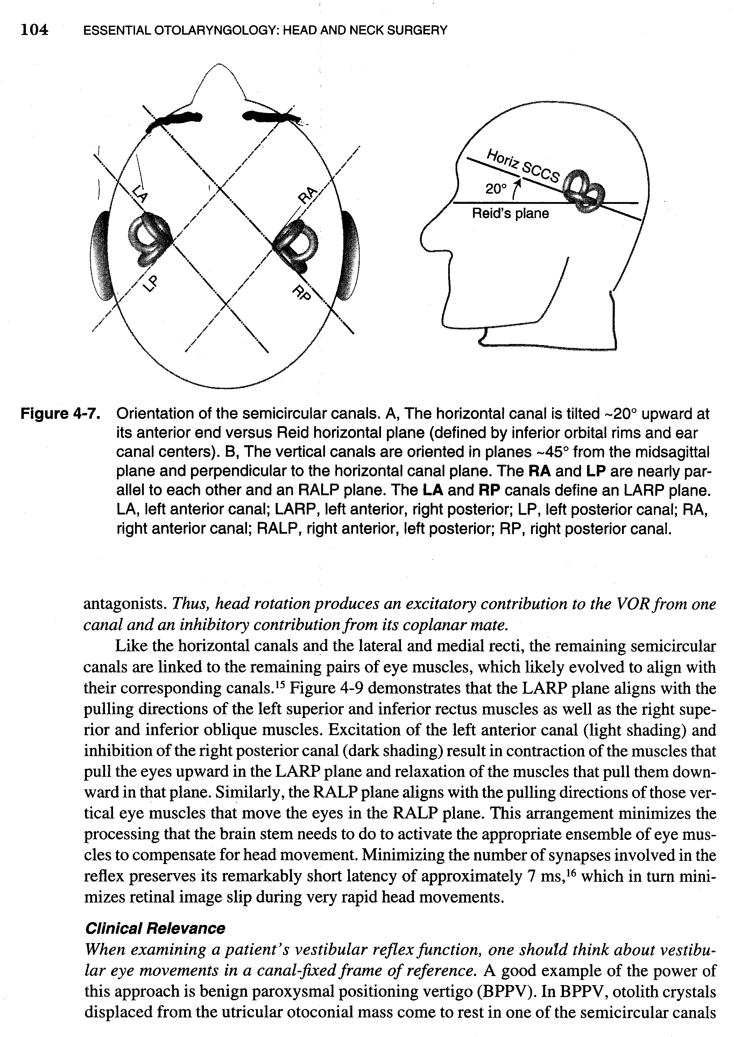

Vestibular function is unique inasmuch as minor derangements frequently produce catastrophic vertigo as, for example in early Menière’s disease, while a gradual total loss of function, as may result from an acoustic neuronal, may produce no significant disequilibrium.

The body position is maintained by means of muscle reflexes which maintain head position in space (vestibulospinal reflexes) and the visual field (vestibule-ocular reflexes). The muscles responsible for these effects are the neck, trunk and limb muscles.

Central Vestibular Connections

The 19,000 vestibular nerve fibres convey the action potentials from the peripheral vestibular labyrinth to the vestibular nuclei in the brain stem. The vestibular ganglion (named after Scarpa) is in the section of the nerve inside the internal auditory canal. This has clinical significance because damage to the peripheral nerve endings of the vestibular nerve does not always result in total atrophy of the ganglion. If the ganglion remains partially active after a total loss of function of the vestibular labyrinth, surgical removal of the ganglion or section of the vestibular nerve medial to the ganglion is sometimes indicated.

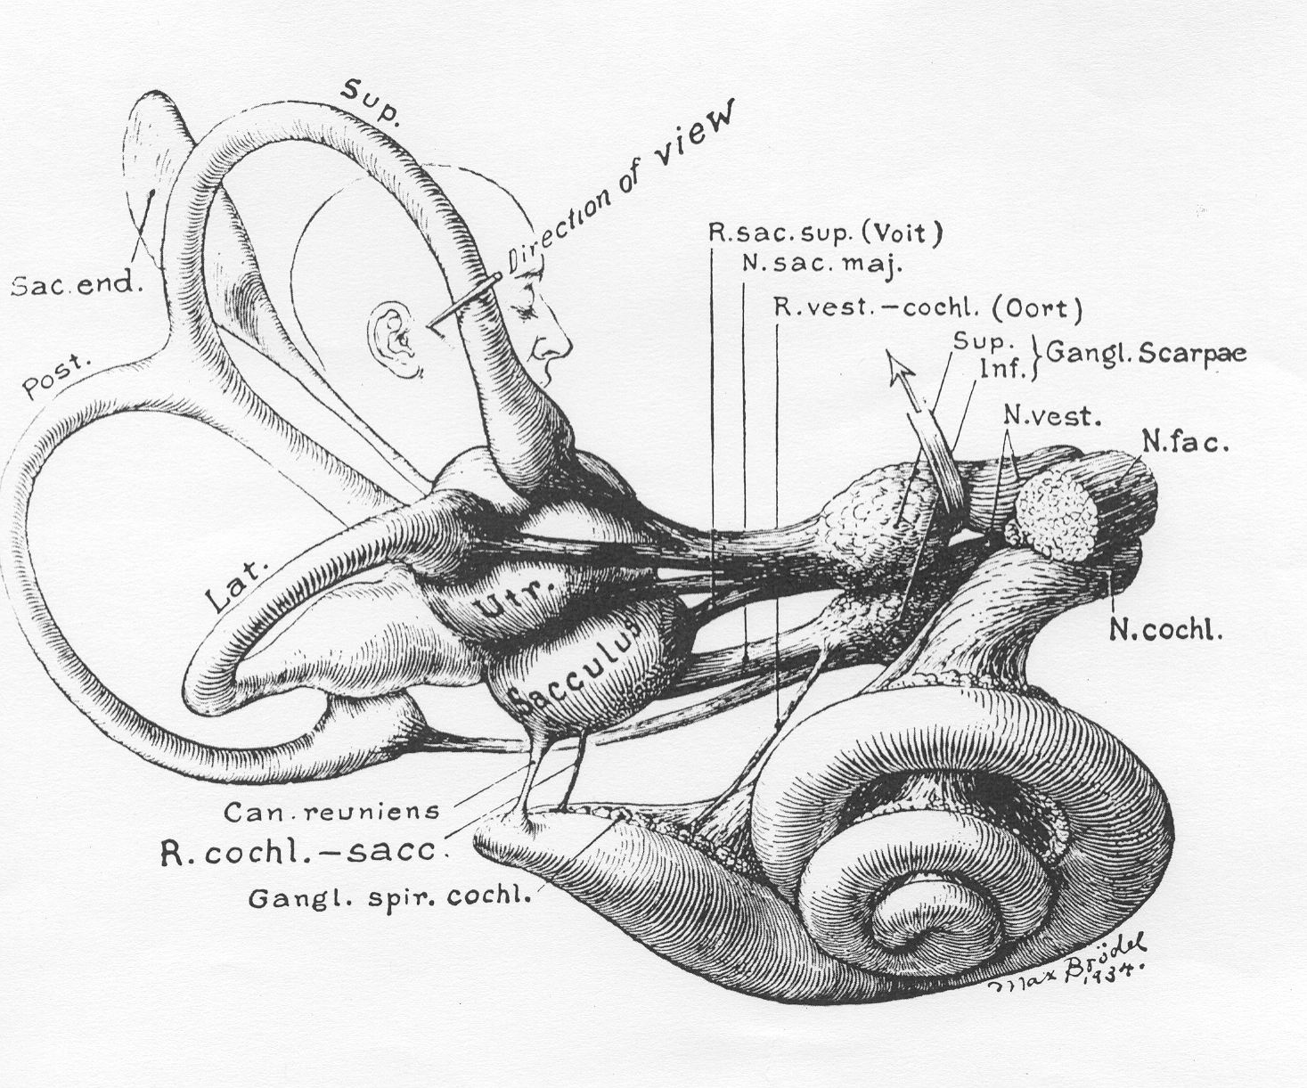

Drawing by Max Brödel shows the membranous labyrinth and its afferent nerve supply.

The vestibular nuclei are intimately connected to other parts of the brain, especially the cerebellum. Important central connections from the vestibular nuclei are the vestibule-ocular connections for maintaining the visual field during movement of the head, the vestibulospinal connections for maintaining posture, and the connections to the autonomic nervous system (in an alarm situation: drop in blood pressure, sweating, nausea, vomiting, diarrhoea).

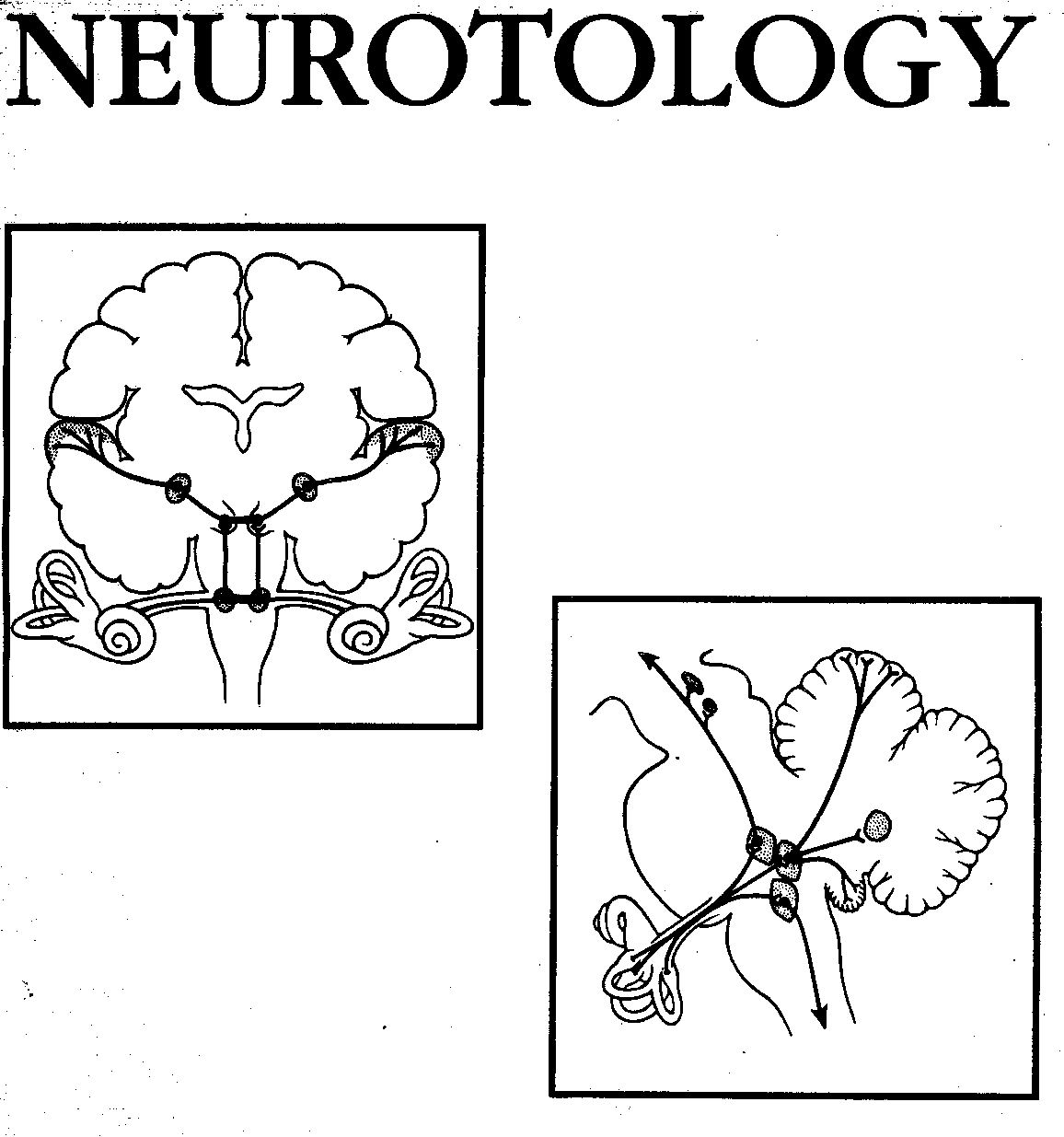

The top diagram shows the neural connections of the cochlea to the brain.
The bottom diagram illustrates the connections of the balance organs to the brain.

Disease Strikes

When a sudden pathologic diminution of function of one vestibular system occurs, as for example in a Menière’s spell of one end-organ, or a serious vestibular neuritis attack, there exists a major imbalance. The involved side is no longer able to deliver its equal and opposite fund of information to the brain, i.e. even at rest the two systems are discharging an unequal intensity, and unequal intensity of discharges has a specific meaning to the brain.

The sequelae of this imbalance are manifestations of a relative hyperfunction of the intact side; thus, uncontrolled and prolonged vestibular reflexes result.

The disparate message arrives at the cerebral cortex, and the cortex interprets this unbalanced information from two sides in the only way it can in the light of past experience. The cortex interprets it as a condition of constant motion – and this is our definition of vertigo. The misinterpretation of the actual state of affairs is a rotatory sensation when the whole end-organ is involved because the six semicircular canals predominate in their overall effects over misinformation from the four otoliths organs alone. It may also have a pitching, yawing or rolling character, but always a rotational nature because of this predominance of innervation.

The same massive imbalance in discharges arrives at the eye muscle nuclei and the reticular formation. The imbalance, interpreted as before in the light of past experience and training, directs the eye muscle nuclei to deviate the eye in the direction of last gaze to retain orientation; the slow component of nystagmus is born. The eyes, however, cannot continue to track indefinitely in any single direction because of their anatomical limitations inside the orbit. Reticular activating neurons direct the ocular muscle nuclei to return the eye balls to the point of gaze at which the slow component began the deviation (across the midline). This second phase of eye deviation is a much faster one because it is a compensatory recovery phase. The quick component of nystagmus is thus generated. The reticular activating neuron, having fired, enters into its refractory period, and the end-organ inflow from the vestibular nuclei resumes its effect upon the eye muscle tracts – the eyeballs are directed again to retain the field of last gaze. This repetitive attempt to retain the last field of gaze by a conjugate movement of the eyes and a rapid reflex return of the eyeballs across the midline in compensation is our definition of vestibular nystagmus, i.e. a rhythmic jerky eye movements with a slow and a quick phase. This is different from, for instance, the rhythmic ocular nystagmus of a person with an under developed fovea centralis (or a blind person) –whose eyes also oscillate rhythmically but with equal speed to both sides.

The same imbalance of information is transmitted from the vestibular nuclei down the spinal cord to anterior horn cells, instructing the postural and locomotors muscles to meet a new situation that never comes, staggering and ataxia result.

The imbalance in impulses also plays upon the dorsal efferent nucleus of X. At first this nucleus effects only a cessation of peristalsis. Gut activity is not needed in an emergent situation. If the imbalance is massive and continuous, however, the nucleus is heavily stimulated, and a reverse peristalsis occurs with resultant nausea and vomiting.

In a matter of minutes the cerebellum imposes a virtual shutdown of electrical activity of the vestibular nuclei by virtue of its profound inhibitory influence on vestibular activity. The nuclear shutdown does not then eliminate the problem, but does serve to render the imbalance at a lower level of magnitude.

The Physiology of Repair and Compensation

The organ then sets about trying to restore the situation. This can be done in three ways.

- Restore to health of the diseased systems, which may take hours to days.
- Central support of the intact side.
- Generation of a new electrical activity in the underdischarging system to balance the normal but now relatively hyperactive side.

In practice it is very likely that all three mechanisms go on at once in varying degrees. For example, in the crisis of Menière’s disease the end-organ heals in a few hours, and a normal or near normal discharge pattern from the end-organ resumes. The cerebellar “clamp” is not needed, or at least only temporarily. Reflexes then revert to normal as equal and opposite reactions are signalled from the two end-organs. Another example would be acute suppurative labyrinthitis. In this disease the end-organ is destroyed and, since it cannot rebuild itself, restoration must be a central process. Very quickly the cerebellum imposes vestibular and nuclear shutdown. For this reason patients in vestibular crisis remain perfectly still, with as little head motion as possible. Motion of the head results in accentuation of the imbalance, and waves of vertigo and vegetative symptoms occur. Then, over a matter of days and possibly weeks a new resting electrical activity is generated in the denervated vestibular nuclei. As this new activity builds, symptoms begin to abate and the cerebellar shutdown is slowly released. When the activity is full and matches the other side, symptoms disappear except for varying degrees of motion intolerance. Motion interpretation involves integration, and this must gradually be built up following regeneration of resting activity in the nuclei.

The speed at which it is brought about is dependent upon the severity of the imbalance stimulating it, and the ability of the central nervous system to respond. This ability is a function of the vigour of the whole organism – age of the patient, availability of neuron arcs, efficiency of the central nervous system vascular supply, and so forth.

Clinical Applications of the Balance Theory

From such a consideration of the balance theory of vestibular function, we arrive at two axioms:

- In vestibular cases of any severity, there will always be labyrinthine nystagmus. The movement of the eyeball is determined by the stimulation in the vestibular labyrinth. In the case of the nystagmus provoked by a caloric test, the horizontal canal is stimulated and a purely horizontal nystagmus results. When all three semicircular canals are stimulated (as in labyrinthitis) the two vertical canals also play a role (the utricle and saccule’s stimuli are much smaller than those of the canals and therefore the canals dominate). The vertical canals produce eye movements in the same anatomical plane which they occupy in the body, i.e. diagonally. Therefore the combination of the three canals results in a horizontal-rotatory movement of the slow phase, with the fast phase purely horizontal (the shortest distance for the eye to travel during the recovery phase).

- If the severe symptoms last continuously for more than two or three weeks, the cause is not vestibular.***

*** HH:
This only applies to the cases when the patient’s eyes are open in daylight, and the observer does not use special equipment to prevent suppression of involuntary visual eye movements by the patient. i.e. this will always happens when the patient’s eyes are open and the room is not totally dark. Frenzel glasses help to reduce visual suppression, but slight nystagmus (which has a speed of the slow phase less than 7°/second) can still be present and not seen by the observer. Electronystagmography (eyes are closed) and infrared videonystagmography (eyes open in total darkness) eliminate suppression of nystagmus caused by visual fixation almost completely , but the patient must be asked not to try and focus (even in the dark).
The method of Toni Haid (Fürth, Germany) to detect slight nystagmus with the aid of Frenzel glasses is recommended Instruct the patient to close the eyes and relax, and after a little while let the patient open the eyes ---very often the eyeball will have deviated to the direction of the slow phase during the time that the eyes were closed. When the eyes open a recovery (fast phase of the nystagmus) will occur once, indicating that there may be a slight nystagmus towards that direction.
Of course suppression of the nystagmus can still occur due to cerebral (brain) suppression, e.g. during emotional stress, and in long standing cases, where the patient has been able to suppress the nystagmus by means of willpower and adaptation. In all cases of examination for spontaneous nystagmus, the patient must be asked to perform mental arithmetic, etc, in order to unblock the patient’s capability to suppress nystagmus and dizziness symptoms.
The HSN (head shake nystagmus test) has been developed to “wake up” any suppressed nystagmus, and is recommended for all investigations for spontaneous nystagmus.

According to Aschan, Bergstedt & Stahle (Uppsala, Sweden, 1956) a resulting
from a unilateral total loss of vestibular function, never disappears totally, and
can always be elicited if “wake up” manoeuvres are carried out and
electronystagmography used.

These axioms can be applied clinically.

The first axiom can be helpful if the patient , while dizzy, can be
observed by the physician or, indeed, any interested person. If a patient in a significant spell does not have spontaneous labyrinthine nystagmus, the disease is not vestibular. The physician may not often have opportunity observe a spell because the patient presents usually between spells. However, the patient’s spouse can often times be a surprisingly good observer once instructed. The physician can instructed the spouse in the office at the initial visit by pointing out carefully the features of nystagmus produced by the minimal caloric test he performs in the course of his workup (irrigation with water at room temperature for 5 -10 seconds), i.e., NOT ICE WATER. (or play a CD of a previously recorded spontaneous nystagmus). Some lay people become surprisingly astute observers after a little instruction.

The second axiom is also helpful in this regard. If on close questioning the patient states that his dizziness has been non-episodic and continuous for, say, two or three months, then his disease need not be from the vestibular labyrinth alone, but can be due to a more centrally situated pathology, e.g. a tumour of the 8th nerve.

Vestibular Function Tests – What can we learn from them?

The goal of vestibular function tests in the present state of the art should be to distinguish a vestibular disease as either end-organ or central and determine which side is diseased. It is frequently an immense relief to a patient to be told that his disease is end-organ and that, whatever follows in the way of symptomatology, his condition will not shorten his life by one day. Even if his disease is not directly treatable, he can be at least assured of eventual relief. If, on the other hand, the disease can be recognized as central, the patient can be put in the hands of the proper specialist until it is diagnosed, or the next months or the emergence of new symptoms make it possible to make the diagnosis. This is where an MRI of the brain is invaluable, provided gadolinium contrast is used, and that a “limited scan” is not done but a proper comprehensive scan.

Practical Anatomy and Physiology of the Vestibular System

Michael C. Schubert
Neil T. Shepard

The saccule and uticle make up the otolith organs of the membranous labyrinth. Sensory hair cells project into a gelatinous material that has calcium carbonate crystals (otoconia) embedded in it, which provide the otolith organs with an inertial mass (Figure 1-4). The presence of the otoconia increases the specific gravity above that of the endolymph. As a result, the maculae (the surfaces of the otolith organs that contain the hair cells)are responsive to linear acceleration , including the force of gravity as the head is placed in different positions. The utricle and the saccule have central regions known as the striola, dividing the otolith organs into two parts. The kinocilia of the utricular hair cells are oriented toward their striola, whereas the kinocilia of the saccular hair cells are oriented away from their striola. Motion towards the kinocilia causes excitation. Utricular excitation occurs during horizontal linear acceleration or static head tilt, and saccular excitation occurs during vertical linear acceleration.

In: Balance Function Assessment and Management – by Jacobson & Shepard, 2008, Chapter 1

--------------------------------------------------------------------------------------------------------------------

How Does the Vestibular Part of the Inner Ear Work?

Stephen M. Highstein

Otolith Afferents

In the maculae of the utricle and saccule, the adequate stimulus is linear acceleration or change in the gravitational force acting on the macula. It is analogous to the canal action, except in this case an otolith is producing the force that pivots the stereocilia and causes either an increase or a decrease in the intracellular receptor potential. An excitatory response would be caused by a head tilt to the side, resulting in pivoting of the sterocilia toward the kinocilium; a head tilt to the opposite side would return the spontaneous activity toward its pretilt rate of discharge. As noted above, the orientation of the macular hair cells results in functional polarization vectors for haircells and their primary afferents. Most mammalian otolithic afferents respond with a maintained discharge when the head is tilted. As Fernandez et al (1972) have noted, there is an approximately 3:1 ration of utricular units that are ipsilaterally/contralaterally directed. Based on their polarization vectors, utricular afferents should be sensitive to head tilts from the upright position and to linear accelerations in the fore and aft plane. On the other hand, saccular afferents should also respond to head tilts and to dorsoventral accelerations.

In: Disorders of the Vestibular System – Edited by Robert W Baloh & G. Michael Halmagyi

---------------------------------------------------------------------------------------------------------------------------------------



