THE EAR NOSE AND THROAT INSTITUTE

OF

JOHANNESBURG

------------------------

Polyganglionitis Episodica (PGE)

The new concept for viral polyganglionitis
of the head and neck

by

Herman Hamersma, M.B., Ch.B. (Pretoria), M.D. (Amsterdam)
Otology and Neurotology,
Florida, South Africa

A new concept called “Polyganglionitis Episodica (PGE)” was proposed by Dr Kedar Adour, chairman of the Cranial Nerve Research Clinic of the Kaiser Permanente Group in San Francisco, when he addressed otolaryngologists and neurologists in Bloemfontein, South Africa, on April 29, 1997. This new concept (syndrome) comprises a group of conditions with the same etiological mechanism, i.e. reactivation of viruses in the ganglia of cranial and/or spinal nerves.

Dr Adour stated: I am here today to imply that herpes simplex is the great masquerader of our generation and the most frequent cause of acute cranial polyganglionitis. We used the term polyneuritis in the past, but have now changed to polyganglionitis, because with this term we can explain all the signs and symptoms which occur. The disease is primarily in the ganglion, followed by a neuritis. The mucocutaneous manifestations are what we see, but this is only the lip of the volcano. The neuritic manifestations are numerous and are seen by general practitioners as well as specialists, especially otolaryngologists, neurologists, dematologists, and internists. The multiple manifestations of herpes simplex reactivation are:

Vertigo, acute hearing loss, unilateral headache, unilateral fullness of the ear, unilateral tinnitus, lump in the throat, unilateral neck or tempero-mandibular joint pain, unexplained cough, tendency to recurrent attacks.

________________________________________________________
The Ear, Nose and Throat Institute of Johannesburg is a non-profit organisation founded by ear, nose and throat specialists. The Institute aims at developing the science, research and teaching of otorhinolaryngology and related areas, supplementary to other institutions in South Africa.

Pathophysiology of Herpes Simplex Reactivation

Approximately 80% of humans carry the herpes simplex virus in the ganglions of cranial and spinal nerves. Our discussion will be confined to the cranial nerves and Cervical 2 and 3. Once the virus gets into the ganglion, it resides in the ganglion and waits there in a latent stage until it is reactivated and then causes a ganglionitis. The virus then migrates down the nerve to cause mucocutaneous vesicles, and up the nerve to cause a localized meningo-encephalitis at the brainstem.

When the virus leaves the neural cell membrane, it takes up a coat of neurolipoprotien around it, and it deposits that neurolipoprotein in the perineural compartment. This neurolipoprotein causes an immune mediated reaction, which causes demyelinization 8 - 10 days after the disease process has taken place. Therefore, when you see the mucocutaneous vesicle, this is the lip of the volcano, i.e. this superficial sign indicates what is going on deeper, i.e. inside the ganglion. Depending on which nerve the virus is reactivates in, signs and symptoms develop which have been described as various disease entities, e.g. Bell’s palsy, Ménière’s disease, etc.. Herpes simplex is the big masquerader. It causes the inflammatory ganglionitis, which then causes a viral induced immunological response, not autoimmune. In addition, a metabolic response is invoked by local changes, and the virus can also cause vasospasm. Fortunately these responses can be influenced by prednisone treatment, but unfortunately we do not have an antiviral agent to destroy the virus. We can only suppress its activity by means of acyclovir given in the acute stage. However, daily doses of acyclovir for long periods (up to one year) are already recommended to suppress eruptions of genital herpes.

Dr Adour continued: The structure of cranial ganglions need to be considered also. Ganglions contain bipolar sensory cells and in the cranial nerves there is a relationship with motor and inhibitory fibres which is unique. In the cranial nerves the motor and inhibitory fibres pass through the ganglion and any disease affecting the sensory nuclei will also affect the motor and inhibitory fibres. Unlike the motor fibres in the peripheral systems (which are separated form the sensory ganglion), the motor fibres of the cranial nerves traverse the ganglion. So, any process which takes place inside the ganglion is going to affect the motor cells - they become involved as innocent bystanders. What people forget is that any sensory system has an inhibitory system, and those inhibitory fibres must traverse the ganglion. What happens if you have inhibitory systems like that which are affected? You are going to get a hyperactive state and we will discuss that with every individual cranial nerve. That becomes very important - remember the inhibitory fibres.

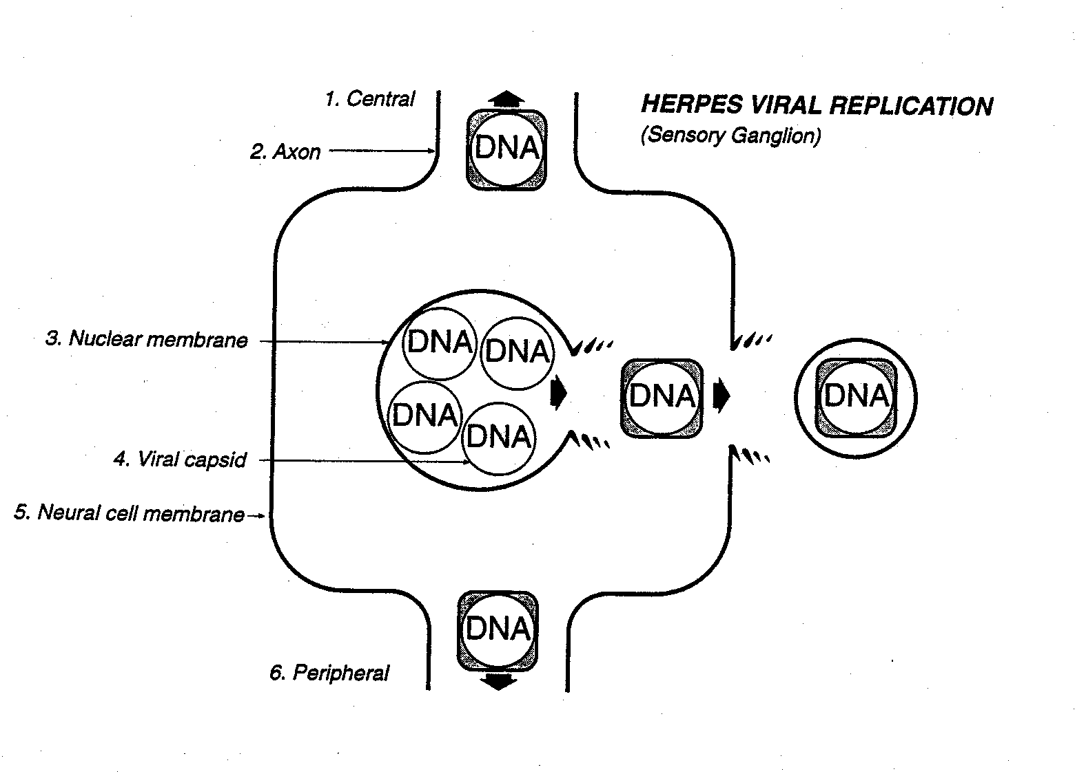

Herpes Viral Replication (Sensory Ganglion) – Adour et al, 1997.

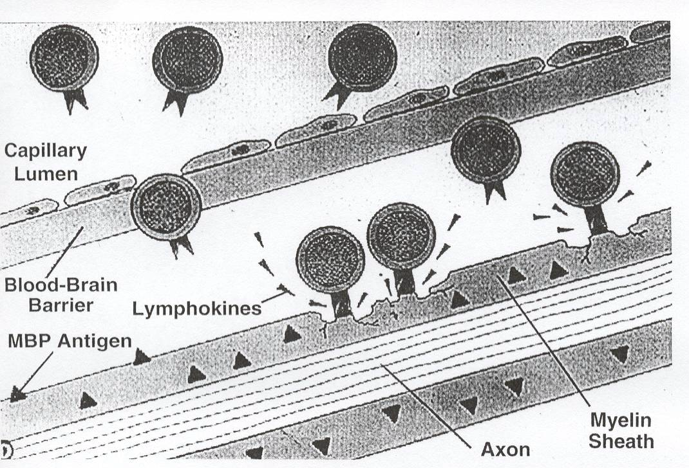

Background to the new concept

Today Bell’s palsy is still called ‘idiopathic facial palsy’. However, in 1919 a publication from Italy by Antoni reported that detailed clinical examination of patients with idiopathic facial palsy revealed that other nerves were often involved. Antoni named the condition “acute infectious polyneuritits cerebralis acusticofacialis”, thus indicating an infection as the causative agent. This report from Antoni was rediscovered by Dr Adour and he then examined his Bell’s palsy patients more thoroughly. Already in 1969 Dr Adour suggested that Bell’s palsy was a polyneuritits probably caused by reactivation of the herpes simplex virus. At that stage it was theory, but in 1996 Murakami et al (Japan) found the HSV-1 genomes in the endoneural fluid from Bell’s palsy patients, who had deompression surgery performed. This was not found in patients with Ramsay Hunt syndrome (herpes zoster oticus) or in other controls.

In 1952 both Furstenberg and Lempert suggested that idiopathic endolymphatic hydrops (Ménière’s disease) had a viral etiology because the vertigo and hearing loss were often accompanied by burning sensation in the pharynx, earache, and numbness of the face. Schuknecht had already stated that the inner ear endolymphatic hydrops in Ménière’s disease could not explain the fluctuating low tone hearing loss which occurred in the early stages of the disease. In 1980 Adour and co-workers suggested that Ménière’s disease was a form of cranial polyganglionitis caused by reactivation of the herpes simplex virus. They reported on other clinical findings which are sometimes present during a Ménière attack, e.g. pain deep inside the ear (due to glossopharyngeal nerve involvement). In 1997 Arnold and Niedermeyer reported the presence of HSV IgG in the perilymph of patients with Ménière’s disease, and concluded that HSV may play an important role in the etiopathogenesis of Ménière’s disease.

The proposal for this new syndrome of PGE originated from astute clinical observations. The clinical signs were there all the time but were not detected probably due to clinicians not paying enough attention to the patient’s complaints. More detailed clinical examination of patients makes sense when they have the conditions which will be described in the rest of this article.

Clinical Manifestations of PGE

The PGE conditions ascribed to Herpes Simplex-1 are Bell’s palsy, Ménière’s disease (idiopathic endolymphatic hydrops), vestibular neuritis, viral cochleitis, viral labyrinthitis, idiopathic sudden hearing loss, carotidynia, blocked ear without detectable abnormality, some cases of otalgia and pain in the throat, hypersensitive scalp, dysphonia, tempero-mandibular joint syndrome (TMJ - also called Costen syndrome), and globus syndrome. A wellknown PGE condition due to the Varicella Zoster virus is Ramsay Hunt syndrome (herpes zoster acustico-facialis).

Trigeminal Nerve

Sensory branches: The pain is due to inflammation of the nerve roots. Hypesthesia or numbness is due to decreased function of the nerve endings. When inhibition is decreased a hypersensitivity to touch takes place. The term ‘photophobia’ indicates intolerance to light, and ‘phonophobia’ indicates intolerance to sound. A new term ‘somatophobia’ is proposed for intolerance to touch, and this is the symptom of hypersensitivity to touch.

Motor branches: When the masseter and pterygoid muscles are affected unilaterally, the jaw shifts to the paralyzed side and there is clicking of the jaw joint. Along with the shift there is a ‘stuffy’ or ‘blocked ear’ due to paralysis of the branches to the anterior belly of the M. tensor veli palatini, and the branches to the M. tensor tympani which moves the ear drum - this used to be called ‘Costen syndrome’. So, if a patient complains of a stuffy ear and the examination shows no abnormality or hearing loss, check the other branches of the trigeminal nerve as well as other cranial nerves for involvement.

Facial Nerve

Motor branches: The facial muscles, stapedius, buccinator, platysma, stylohyoid and digastric muscles are supplied.
Secretomotor fibres: The salivary, lacrimal and nasal glands are supplied.
Special sensory fibres provide taste to the anterior two thirds of the tongue (chorda tympani nerve).

There are no somatic sensory fibres in the facial nerve trunk. Therefore Hunt’s zone of anesthesia of the auricle, or Hitselberger’s sign of anesthesia of the posterior aspect of the external ear canal, does not exist.

In Bell’s palsy the paralysis of the muscles is due to the seventh nerve motor fibres being affected, the numbness and pain in the cheek is due to trigeminal nerve involvement, the post auricular pain is due to the 2nd Cervical nerve involvement. The taste disturbance (dysgeusia) is due to the chorda tympani cell bodies in the geniculate ganglion being involved. The hyperacusis, which is better called dysacousis or phonophobia, is not related to an absent stapedial reflex, but is a function of the cochlear division of the 8th Cranial nerve (see later).

Vestibulo-cochlear nerve (Cr. VIII)

The vestibular and cochlear fibres are well known. Every sensory system has an inhibitory system also and the pathways of the inhibitory fibres of the cochlear nerve are not certain - it is thought that they possibly pass through the olivo-cochlear bundle. Loss of inhibition will result in a complaint of loudness intolerance (phonophobia), a common complaint of patients with Ménière’s disease.

Vertigo can occur alone and is then called vestibular neuritis.

Acute hearing loss which occurs alone is called idiopathic sudden sensorineural hearing loss or viral cochleitis.

Vertigo plus hearing loss occurring once only is called labyrinthitis, and if it is episodic it is called Ménière’s disease or endolymphatic hydrops. However, the virus causes the disease initially (hearing and balance affected but returning to normal after an episode), and the endolymphatic hydrops (chronic stage) is an end stage of the diseased hearing and balance organs. Rather than individual diseases with individual pathophysiology, Dr Adour submitted that the above diseases are a spectrum of the same process, i.e. viral inflammation, probably caused by herpes simplex reactivation.

Glossopharyngeal Nerve

Somatic sensory branches supply the pharynx, tonsils and middle ear. When a patient complains of pain on swallowing and no abnormality can be found - check the nasopharynx for inflammation. For the complaint of ‘a lump in the throat’, check the posterior pharyngeal wall for a loss of sensation - the clue to this finding lies in the phenomenon that a patient always complains of a lump in the throat after the throat has been sprayed with surface anesthetic. Therefore, the ‘globus syndrome’ of a lump in the throat is a true neuritis and not a hysterical condition.

Vagus Nerve

Motor fibres supply the pharynx, larynx, heart, lungs, bronchi and gastrointestinal tract. Somatic sensory fibres accompany the motor fibres and a unique branch to the ear canal is called Arnold’s nerve. Inflammation of the tenth cranial nerve can lead to pain in the throat, ear and carotid artery. Carotidynia (moderate to severe pain with palpation of the carotid artery), is probably due to loss of inhibition to the nerve endings surrounding the carotid sheath. These patients often have a paresis or paralysis of the superior laryngeal nerve (the nerve most often paralysed in the body - Adour). The unilateral loss of sensation in the laryngeal inlet allows mucus and saliva to enter the larynx and a cough results because the swallowing reflex is not initiated in time - the patient complains of a cough, especially when lying on the affected side. The motor fibres of the superior laryngeal nerve stretches the vocal cord, and when affected the patient is unable to sing high notes. On examination the larynx is rotated to the affected side and the vocal cord is shorter.

A feeling of a plugged ear is due to the tensor veli palatini muscle being affected - let the patient put out the tongue and sing a high note - the palate will move asymmetrically.

Herpes particles have been found in the ganglion of the heart of patients who had sudden death syndrome, probably due to arrythmia.

Cervical Nerves

Pain behind the ear and hypesthesia in this area is due to involvement of Cervical nerves 2 and 3. This is a common phenomenon with Bell’s (Antoni’s) palsy and can also occur with acute vestibulo-cochlear symptoms, e.g. Ménière’s disease. Somatophobia of the scalp can occur - patients complain of pain on touching the hair or skin of the scalp.

Conclusion

Dr Adour concluded: “I have presented the pathophysiology of Herpes Simplex Virus, demonstrated the signs and symptoms associated with HSV reactivation, and offered a concept of polyganglionitis which explains what heretofore was unexplained. Take this concept back to your practice and be assured it will be useful. Remember that recurrent Herpes Simplex is the most frequent cause of acute neurological disease.

And above all - THINK POLYGANGLIONITIS.

I would hope it will not be another 25 years before this concept is proven, as was the case with Herpes Simplex-1 facial palsy (Bell’s palsy)”.

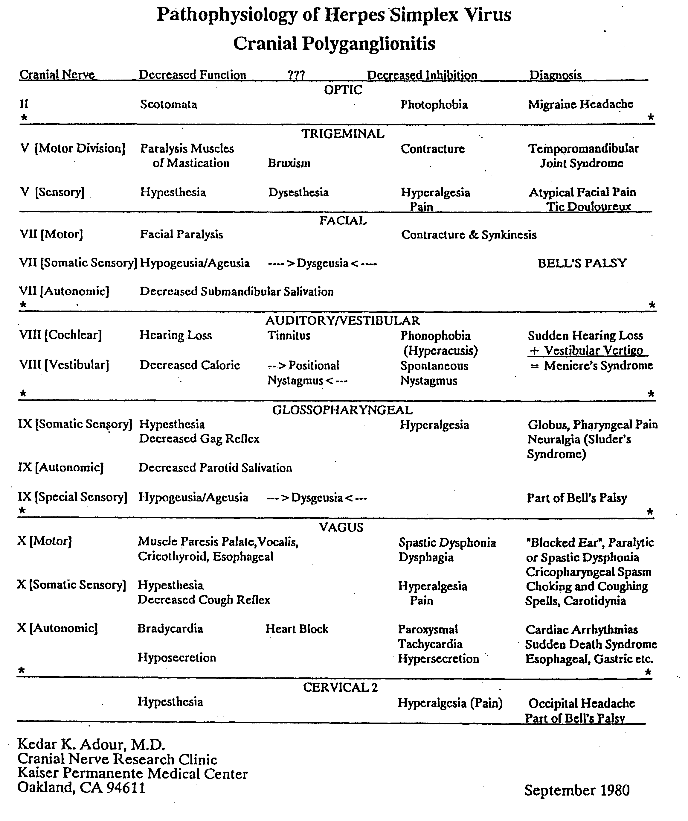

References:

- Adour K.K., Byl F. M., Hilsinger, R.L. & Wilcox, R.D.:
“Ménière’s Disease as a Form of Cranial Polyganglionitis”.
Laryngoscope 90:392-398, 1980.

- Adour K.K.:
“Cranial polyneuritis and Bell’s Palsy”.
Arch Otolaryngol 102:262-264, 1976.

- Murakami et al:
“Bell’s Palsy and Herpes Simplex Virus: Identification of
Viral DNA in Endoneurial Fluid and Muscle”.
Annals of Internal Medicine, 124:27-30, 1996.

- Arnold W., Niedermeyer, H.P.:
“Herpes simplex virus antibodies in the perilymph of patients
with Meniere’s disease”.
Arch Otolaryngol 123:53-56, 1997.

- Adour K.K.:
“Epstein-Barr, Herpes Simplex, and Herpes Zoster Infection”
Chapter 10; “Head and Neck Manifestations of Systemic Disease”
Ed. Jeffrey E Harris and Michael H Weisman, Informa Healthcare,
USA, New York, London, 2007
- - - - - - - - - - - - - - - - - - - - - - - - - - - - - - - - - -- - - - - - - - - - - - - - - - - - - - - - - - - - -

The Er Nose and Throat Institute of Johannesburg
P O Box 5973,
Weltevreden Park
1715.

Secretary: Dr. H. Hamersma
hamersmah@surgeon.co.za

In September 2001 Arbusow et al published in Audiology & Neuro-Otology: “HSV-1 not only in human vestibular ganglia but also in the vestibular labyrinth”.
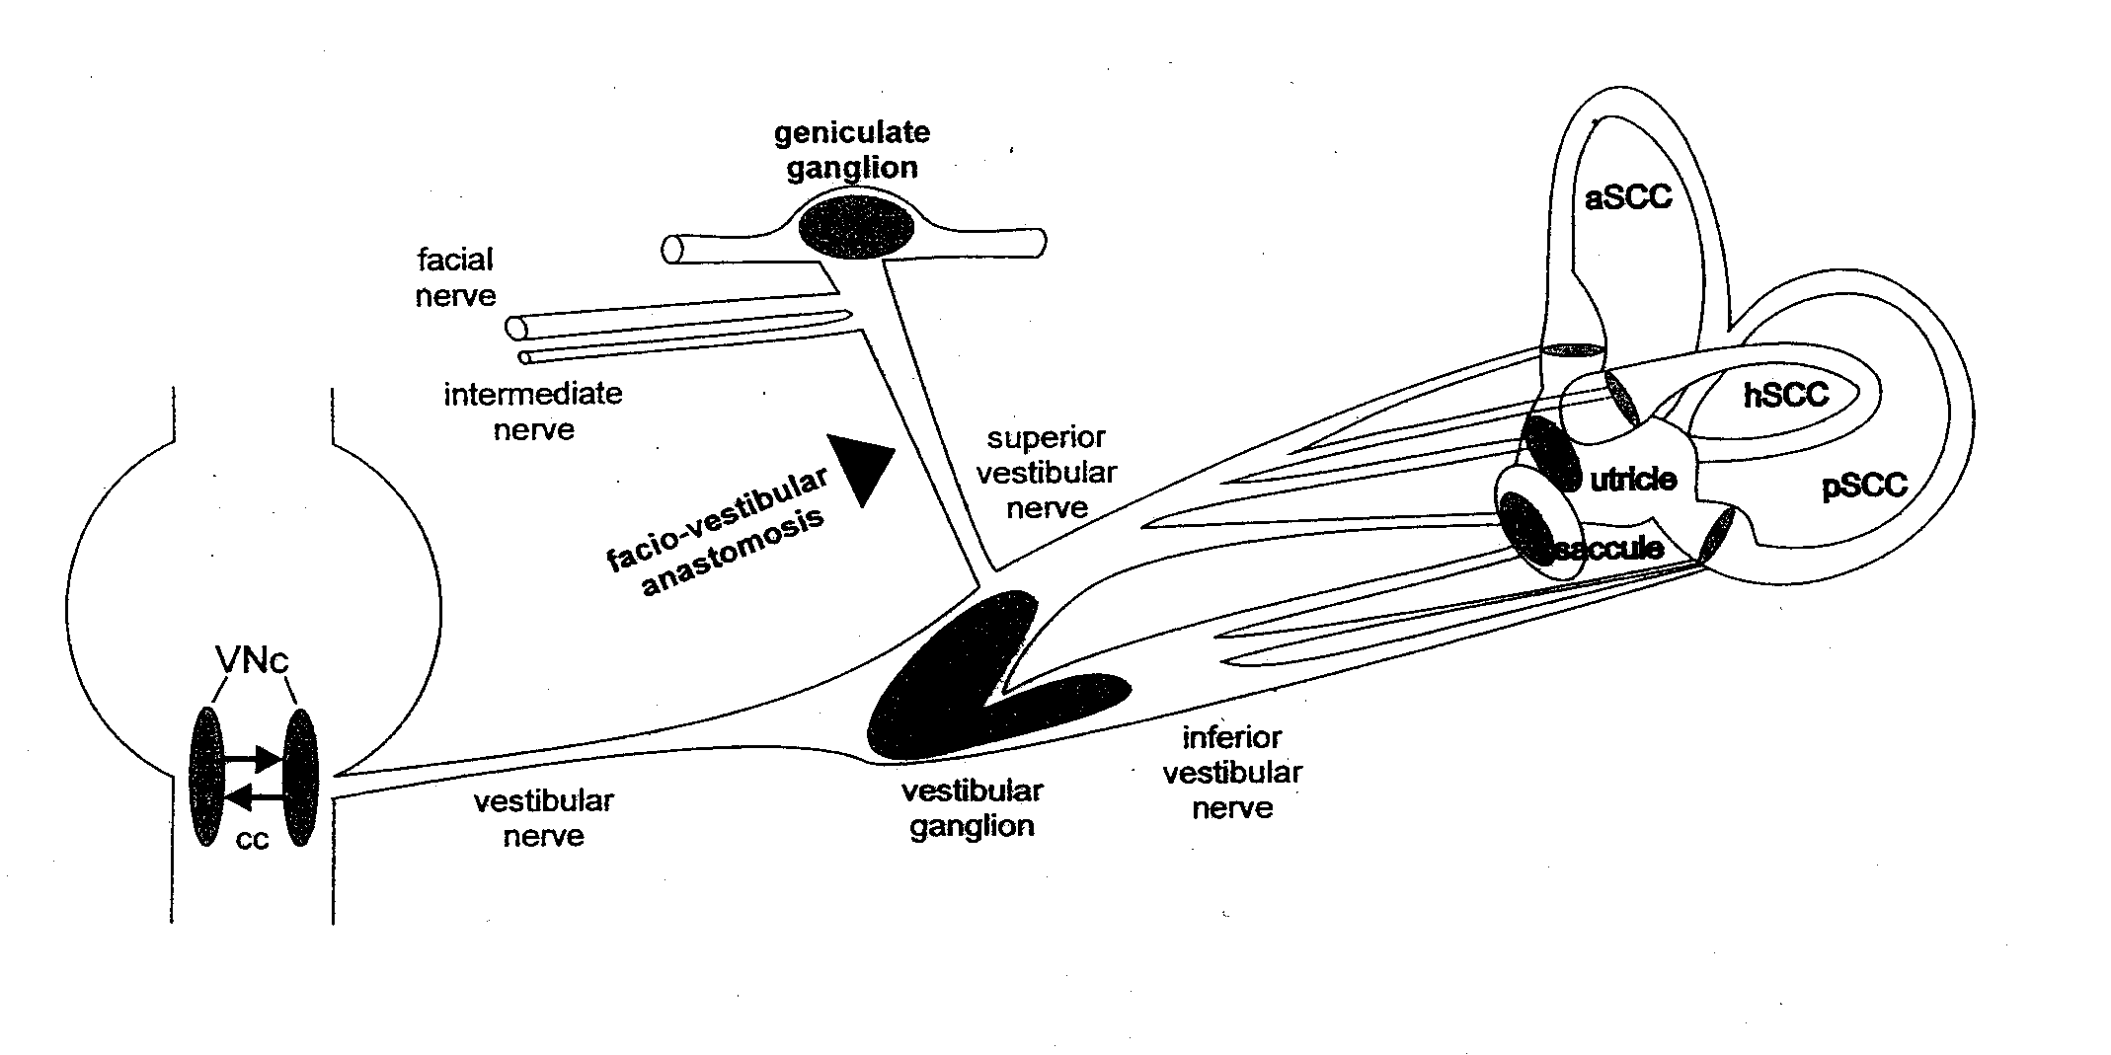
Fig.1. After primary infection (stomatitis herpetica) HSV-1 asecends to the geniculate ganglion (GG) via the chorda tympani**, and via the faciovestibular anastomosis to the vestibular Ganglion (VG). Viral migration to the vestibular nuclei (VNc) and the human labyritnh is possible along the vestibular nerve. aSC, hSC, pSC = Anteriror, horizontal, and posterioir semicircular canals; cc = commissurl connections. Arbusow, Theil, Strupp, Mascolo & Brandt: Audiology & Neuro-Otology 6:259-62, 2001.

Abstract: “ Reactivation of herpes simplex virus type 1 (HSV-1) in the vestibular ganglion is the suspected cause of vestibular neuritis. Recent studies reported the presence of HSV-1 DNA not only in human vestibular ganglia, but also in vestibular nuclei, a finding that indicates the possibility of viral migration to the human vestibular labyrinth. Distribution of HSV-1 DNA was determined in geniculate ganglia, Vestibular ganglia, semicircular canals, and macula organs of 21 randomly obtained human temporal bones by nested PCR (i.e. the patients died from causes not related to cranial nerve dysfunction, and other viral infections were excluded). Viral DNA was detected in 48% of the labyrinths, 62% of the Vestibular ganglia, and 57% of the geniculate ganglia. The potential significance of this finding is twofold: (1) Inflammation in vestibular neuritis could also involve the labyrinth and thereby cause acute unilateral vestibular deafferentation. (2) as benign paroxysmal positional vertigo often occurs in patients who have had vestibular neuritis, it could also be a sequel of viral labyrinthitis.”

The authors stated that this was the first demonstration of HSV-1 DNA in the human semicircular canals and otolith organs. The authors suggested that horizontal rotatory nystagmus (to the non-affected ear) seen in acute vestibular neuritis may be caused not only by viral inflammation of the superior vestibular nerve, but also a sequel of viral inflammation of the peripheral labyrinth. They also hypothesized that this inflammation of the labyrinth could cause loosening of the otoconia leading to the canalolithiasis and benign paroxysmal positional vertigo. These suggestions may lead to using a term such as vestibulo-neuro-labyrinthitis for the clinical symptom complex currently described as vestibular neuritis.

** The chorda tympani nerve is the nerve of taste for the front two thirds of the tongue.

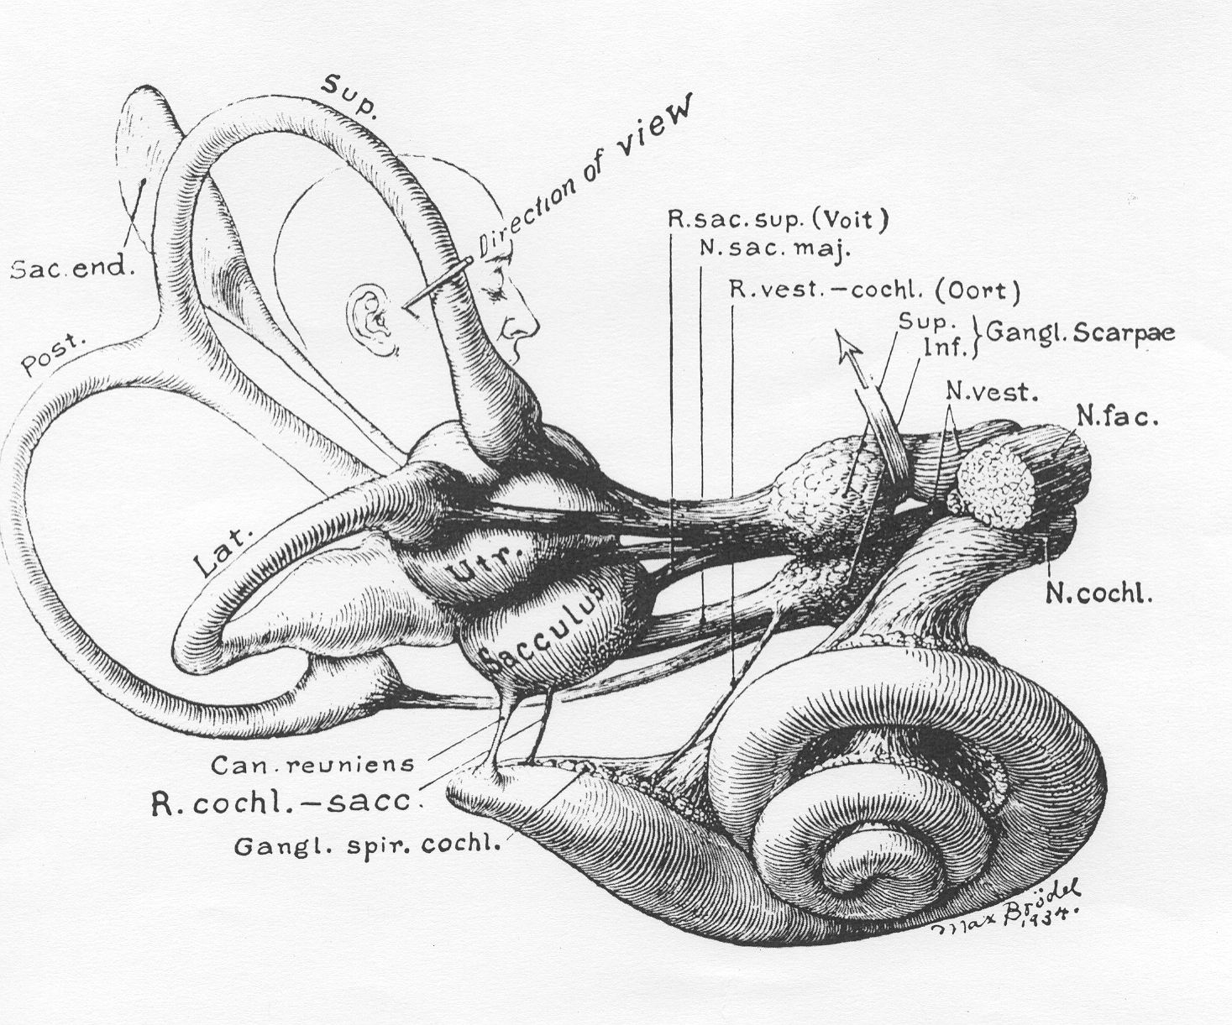

Drawing by Max Brödel shows the membranous labyrinth and its afferent nerve supply.

Note: The vestibular nerve’s two divisions are inside the internal auditory canal, which contain the two vestibular ganglia (Scarpae), in close proximity to the facial nerve (N. fac.) and the cochlear nerve (N. cochl.).
The efferent nerve supply to the cochlea (olivo-cochlear bundle) is in the vestibulo-cochlear anastomosis (Oort).
The three semicircular canals are the superior (sup.), posterior (post.) and horizontal (also named lateral - lat.).

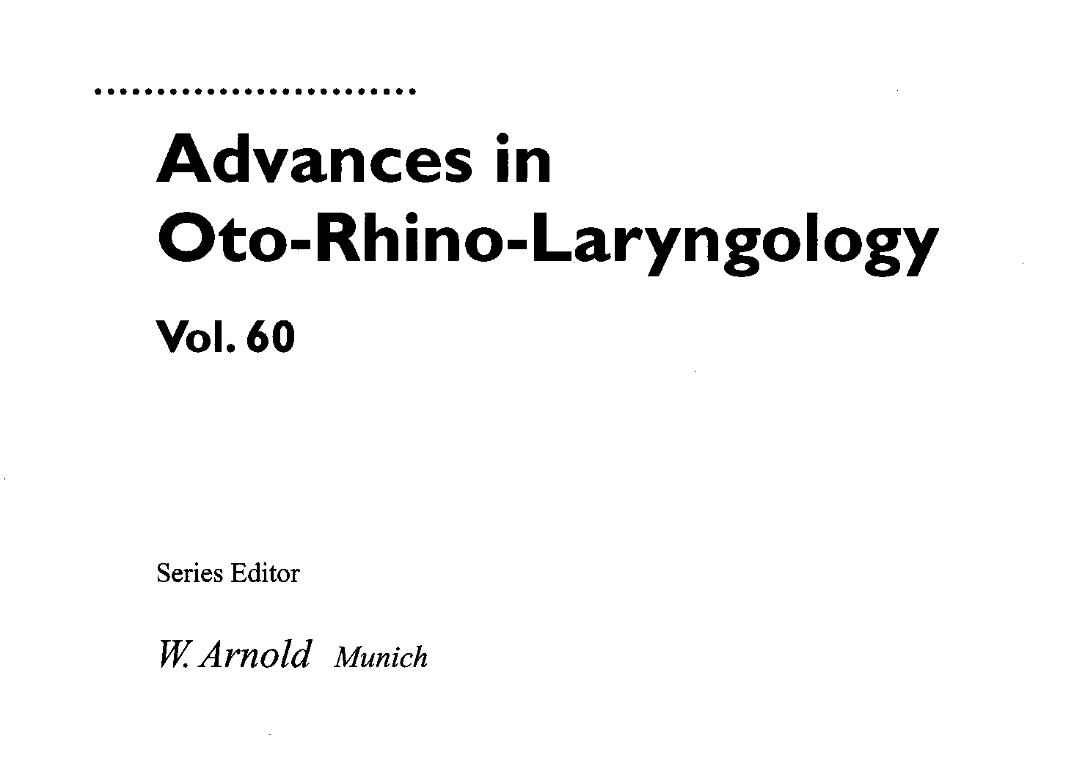
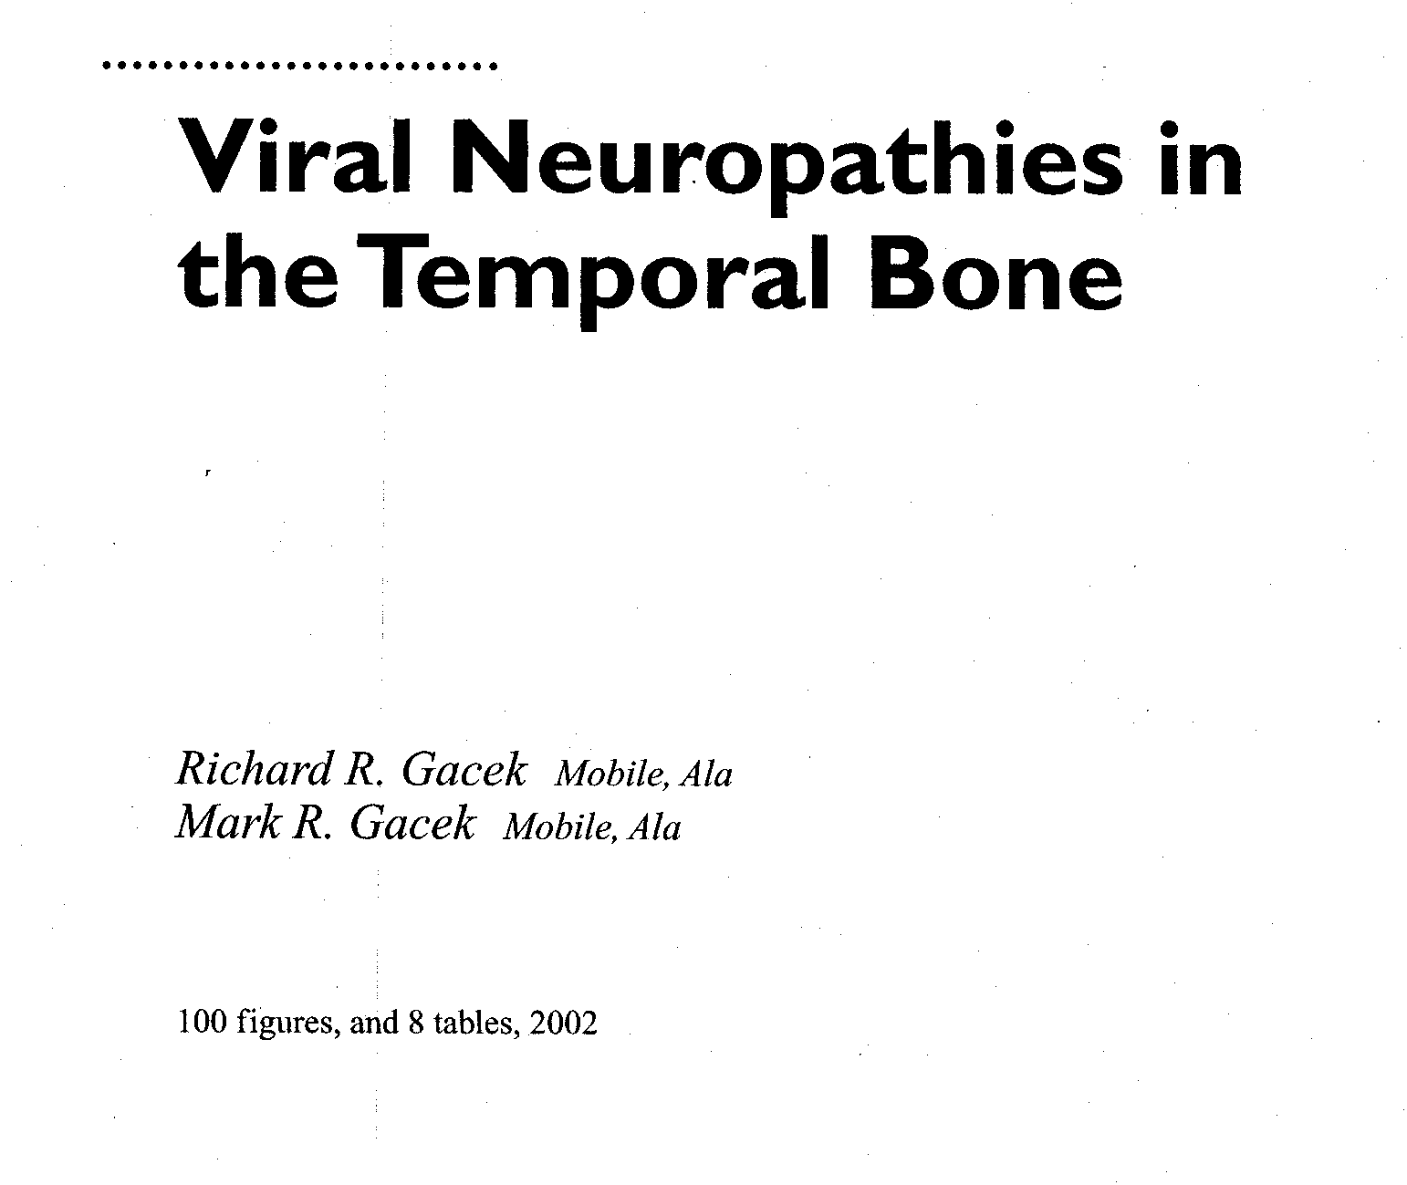

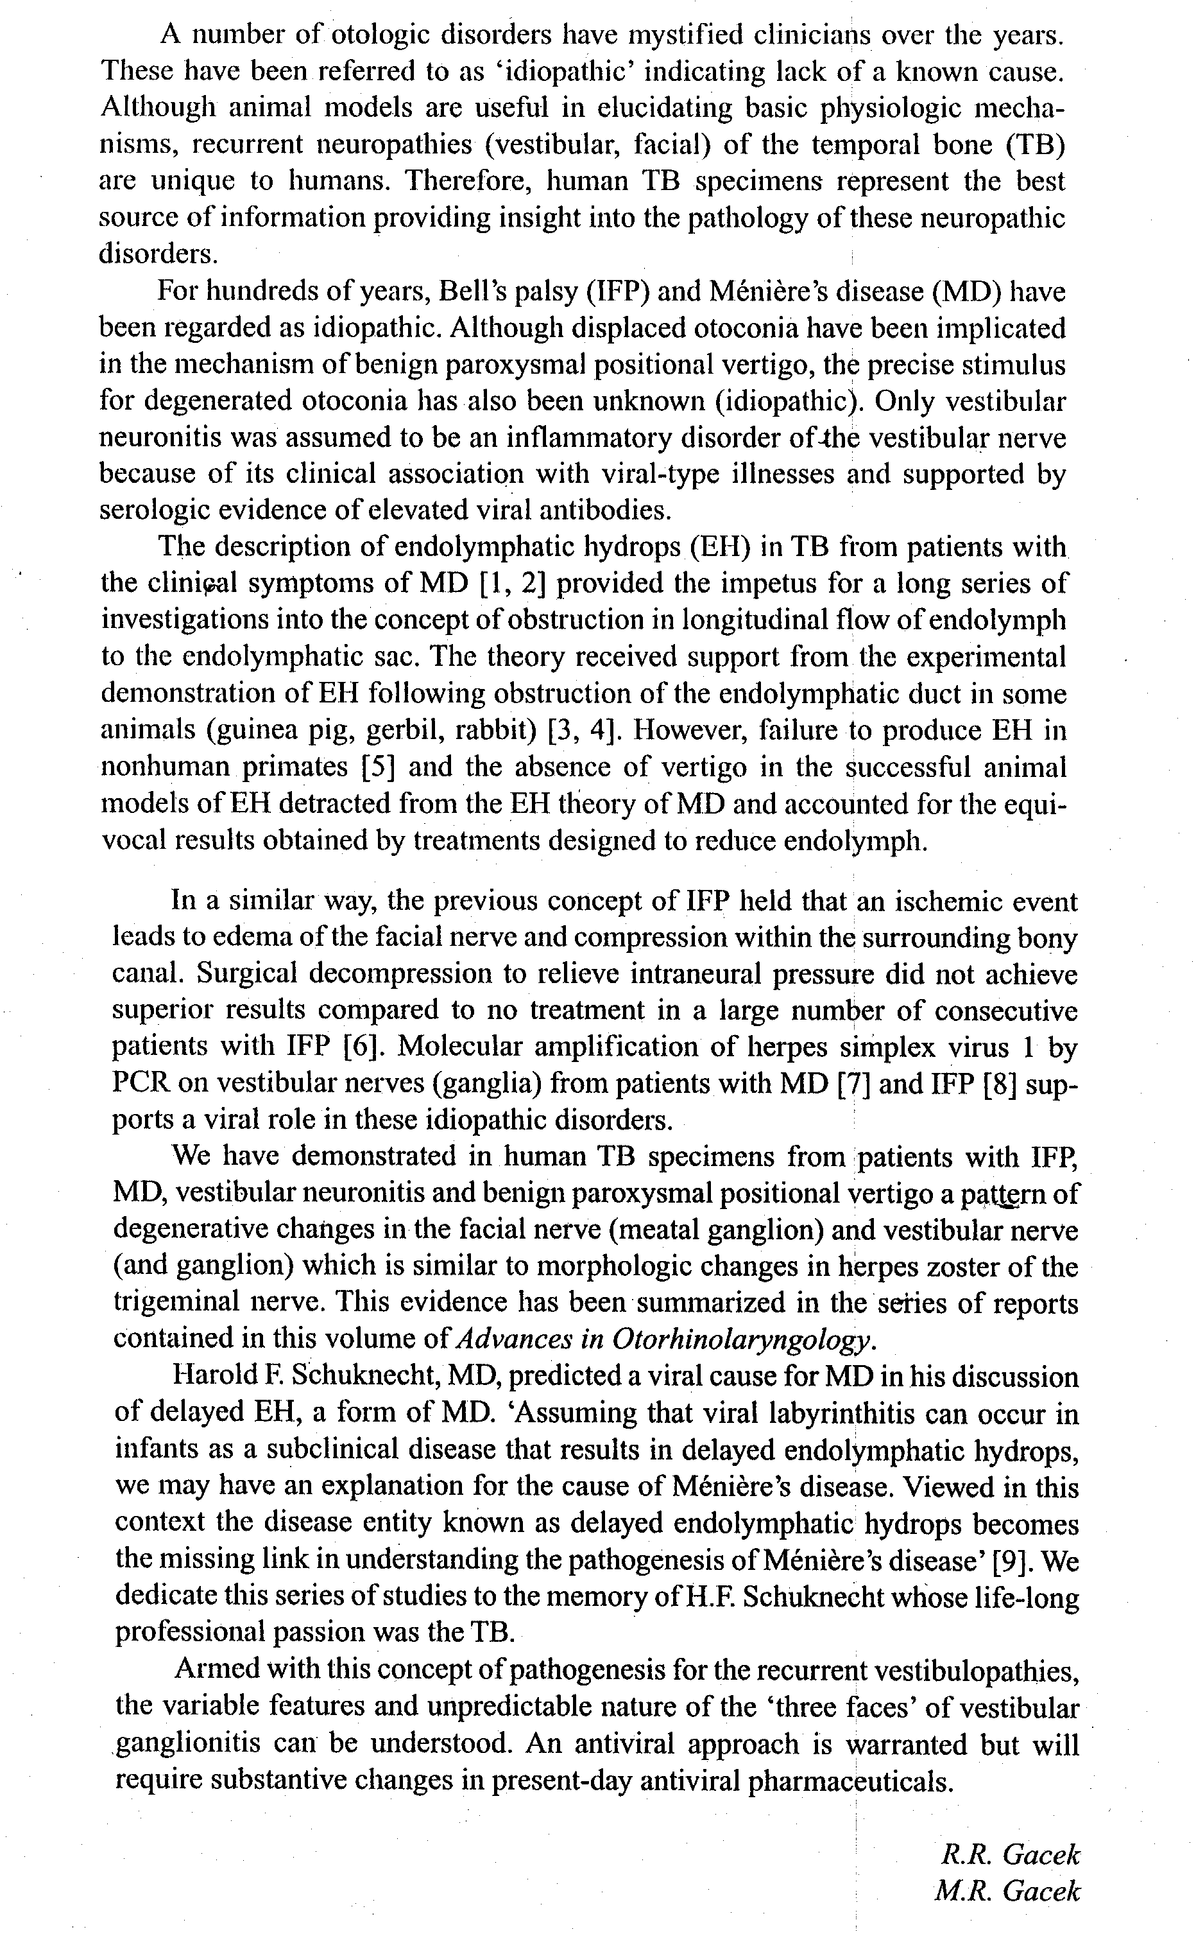
Classification of Recurrent (Viral) Vestibulopathies
(Gacek & Gacek 2002)

The syndromes of Vestibular neuronitis, Benign Positional Vertigo (BPV), and Menière’s disease are clinical expressions of vestibular ganglionitis probably caused by the alpha Herpes virinae family. Several factors may determine the “face” presented in individual patients. These are 1) the amount of virus present (viral load), 2) the virus type and strain, 3) the location and number of affected vestibular ganglion cells, and 4) host resistance. It is possible that other forms of recurrent vertigo are expressions of vestibular ganglionitis.

Gacek & Gacek: Anterograde virus strain (hearing preserved)

Superior vestibular ganglionitis (vestibular neuritis, vestibular Menière disease)
Inferior vestibular ganglionitis (BPV = benign positional vertigo)
Superior and inferior vestibular ganglionitis (vestibular neuritis and BPV)

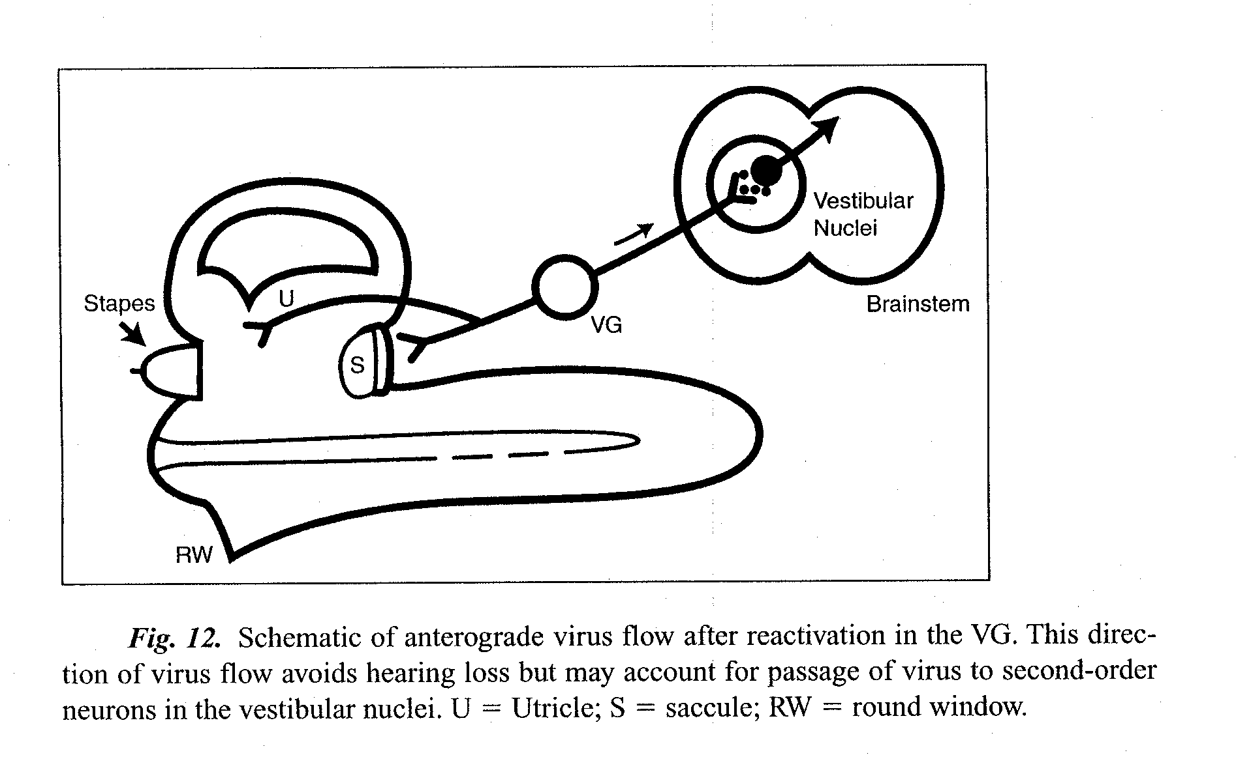

Gacek & Gacek: Retrograde virus strain (hearing affected)
Superior vestibular ganglionitis (Menière disease, neurolabyrinthitis)
Subtype, utricular ganglionitis (Tumarkin’s otolithic crisis)
Superior and inferior vestibular ganglionitis (Menière disease and BPV)

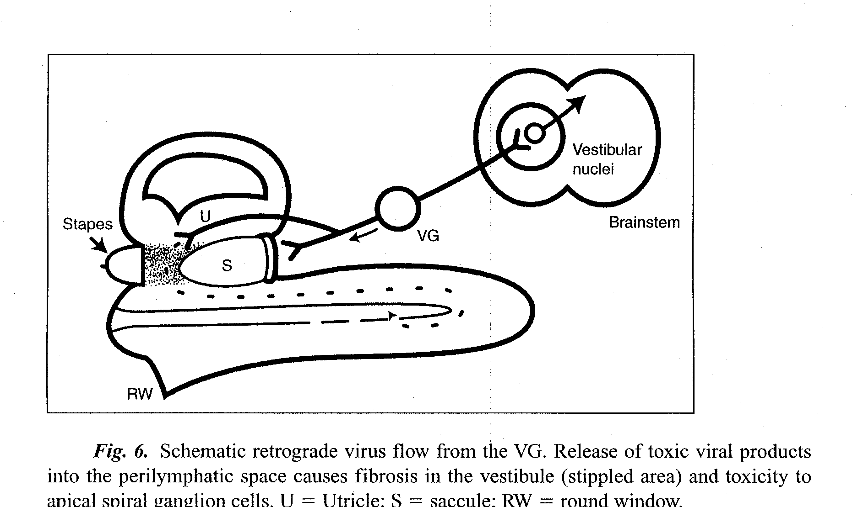

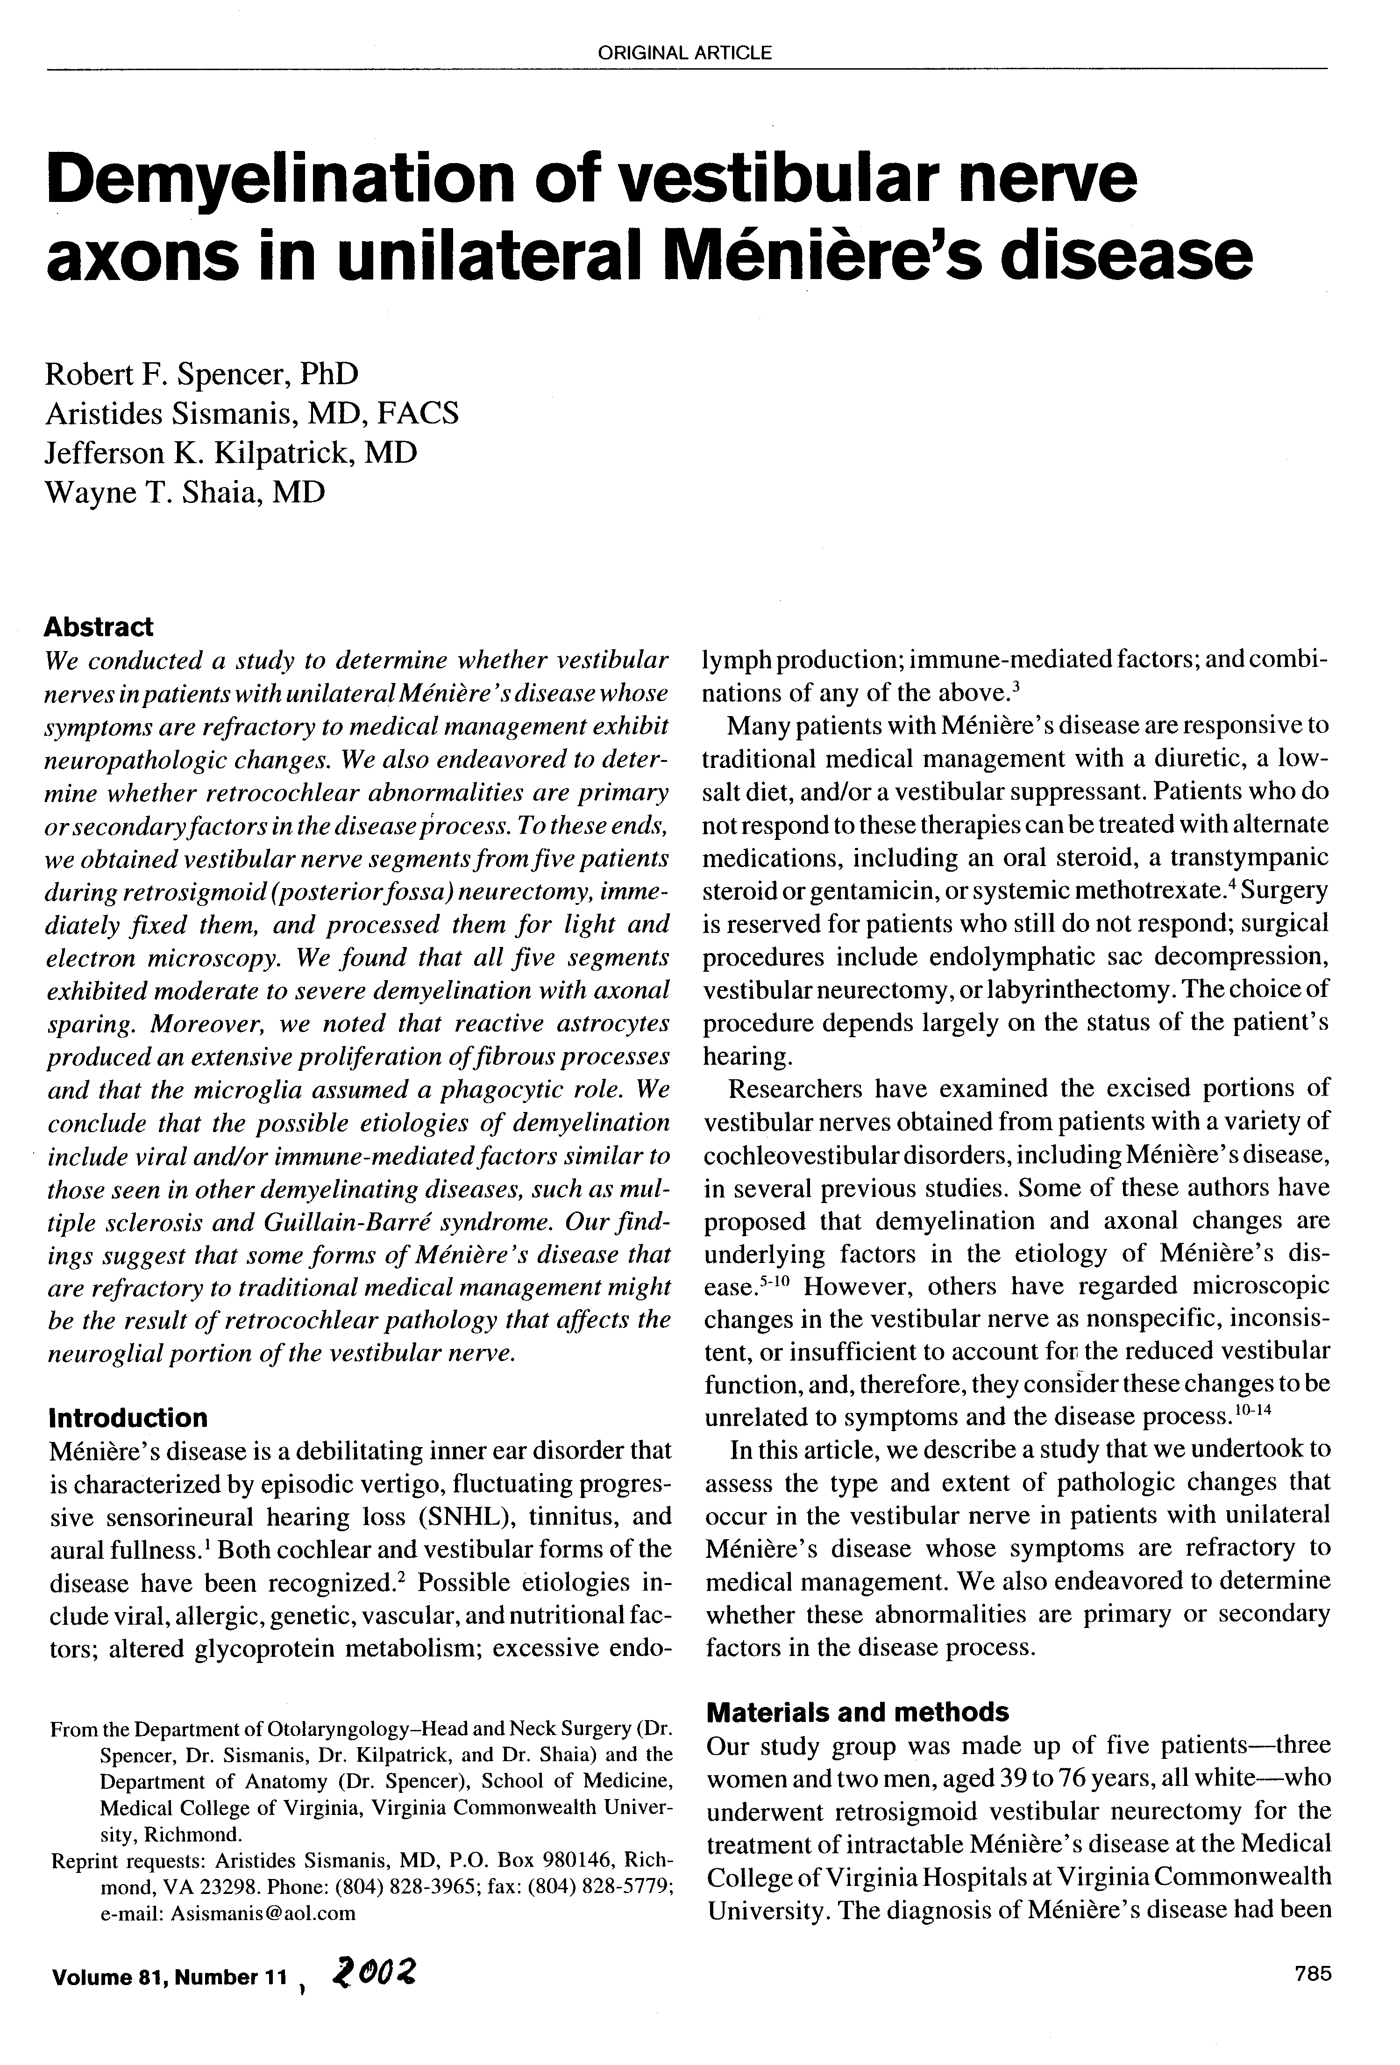
Ear Nose Throat Journal 81:785-89, 2002:
2003:

“Pathology of Benign Paroxysmal Positional Vertigo Revisited”

Prof Richard Gacek
Boston,

Annals of Otology, Rhinology & Laryngology, Volume 112, (7): 574-582,

Abstract:

The pathophysiology of benign paroxysmal positional vertigo (BPPV) is not completely understood. Although the concept of degenerated otoconia transforming the posterior canal (PC) crista into a gravity-sensitive sense organ has gained popular support, several temporal bone (TB) series have revealed similar depositis in normal TBs, suggesting they are a normal change in the aging labyrinth. Furthermore, some TBs from patients with BPPV do not contain particles in the posterior canal. Five TBs from patients with BPPV were studied quantitatively and qualitatively. A small cupular deposit was found in 1 TB, while none was seen in the other 4 TBs. The major pathological changes were

- a 50% loss of ganglion cells in the superior vestibular division of all 5 TBs, and

- a 50% loss of neurons in the inferior division of 3 TBs, and a 30% loss in 2 TBs that contained abnormal saccular ganglion cells.
These observations support a concept in the pathophysiology of BPPV that includes loss of inhibitory efect of otolith organs on canal sense organs.

Conclusion:

Observations in 5 temporal bones from patients with posterior canal BPPV suggest that the pathophyisological mechanism responsible for a position-induced vestibular-ocular response in this disorder is neural, rather than mechanical stimulation of the sense organ. Loss of the inhibitory action of otolith organs on canal activation caused by degeneration of otolith neurons (saccular, utricular) is a possible explanation of the brief canal response induced by the positional stimulus.

- - - - - - - - - - - - - - - - - - - - - - - - - - - - - - - - - - - - - - - - - - - - - - - - - - - - - - - - - - - - - - - -

Menière’s Disease is a Viral Neuropathy

Richard Gacek: ORL 71:78-86 2009

Morphological and clinical evidence supports a viral neuropathy in Menière disease. Quantitative examination of 11 sectioned temporal bones from 8 patients with a history of Men. Disease revealed a significant loss of vestibular ganglion cells in both the endolymph hydropic and non-endolymph hydropic ears. Transmission electron microscopy of vestibular ganglion cells excised from a patient with Menière disease revealed viral particles enclosed in transport vesicles.

Antiviral treatment controlled vertigo in 73 of 86 patients with vestibular neuronitis (85%) and 32 of 35 patients with Menière disease (91%).

The high (90%) rate of vertigo control with orally administered antivirals provide clinical experience

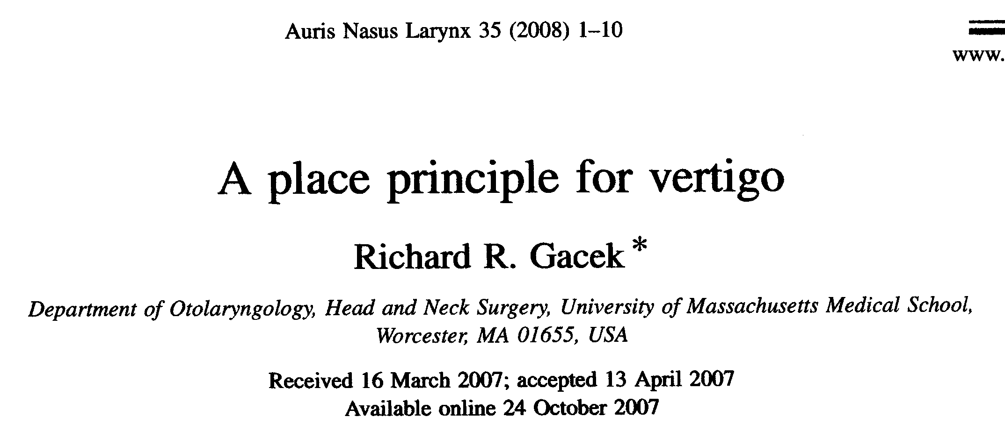

Abstract

Objective: To provide a road map of the vestibular labyrinth and its innervation leading to a place principle for different forms of vertigo.
Method: The literature describing the anatomy and physiology of the vestibular system was reviewed.
Results: Different forms of vertigo may be determined by the type of sense organ, type of ganglion cell and location in the vestibular nerve.
Conclusion: Partial lesions (viral) of the vestibular ganglion are manifested as various forms of vertigo.

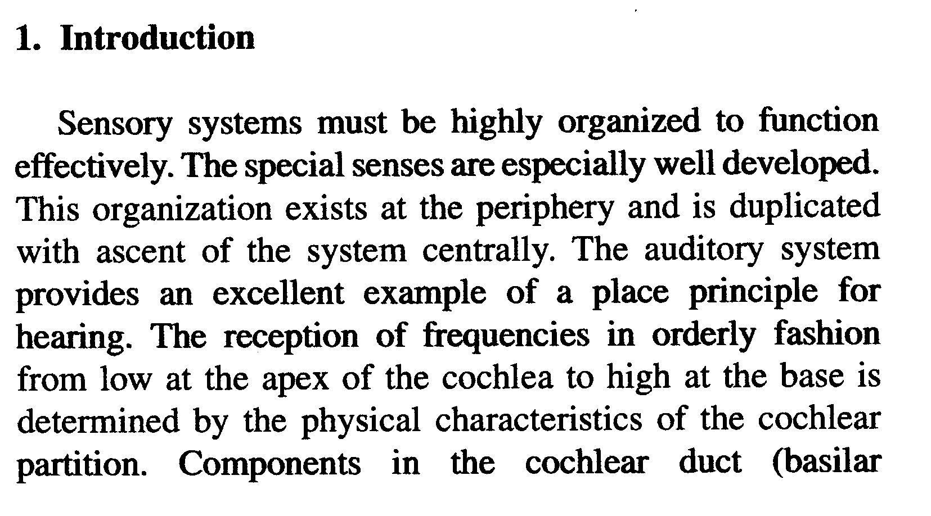

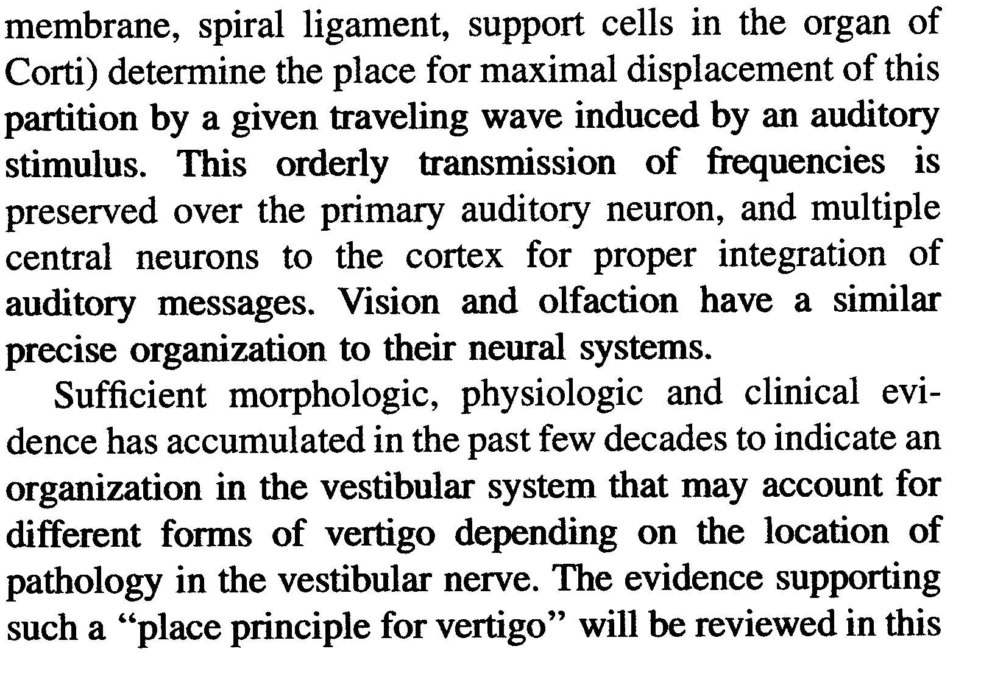

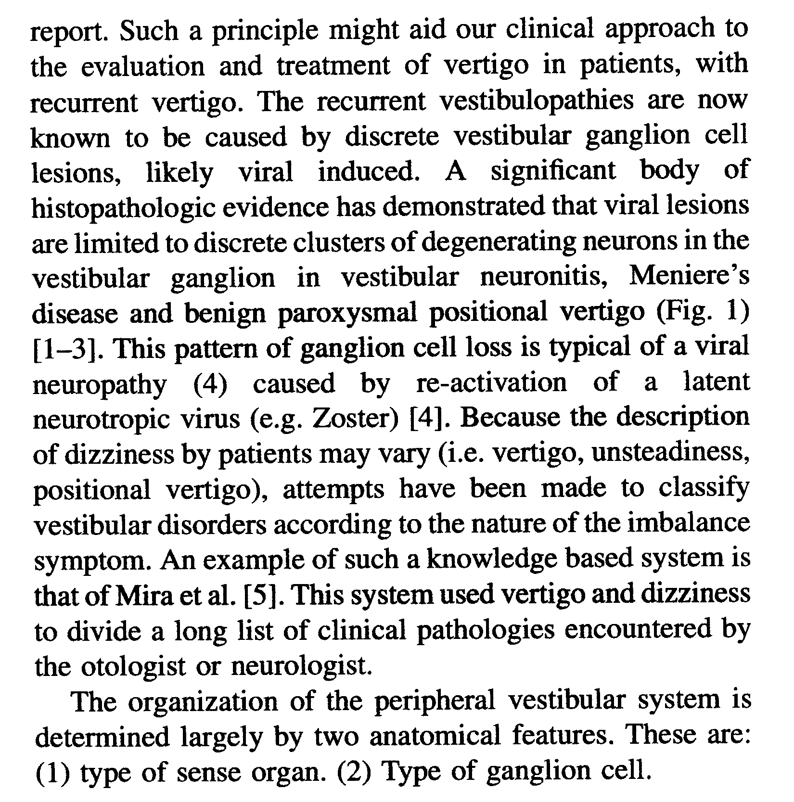
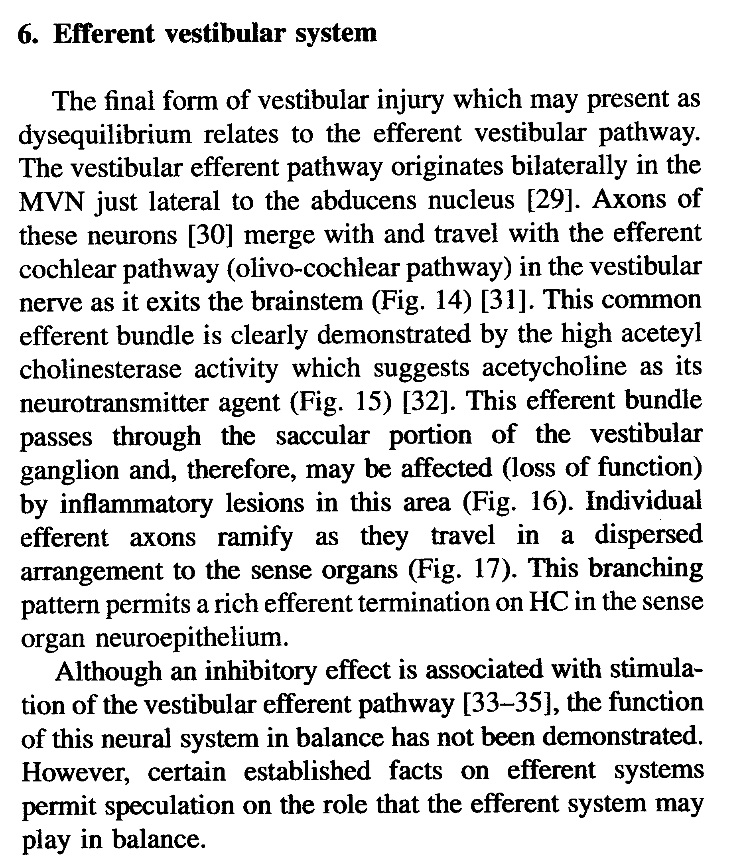

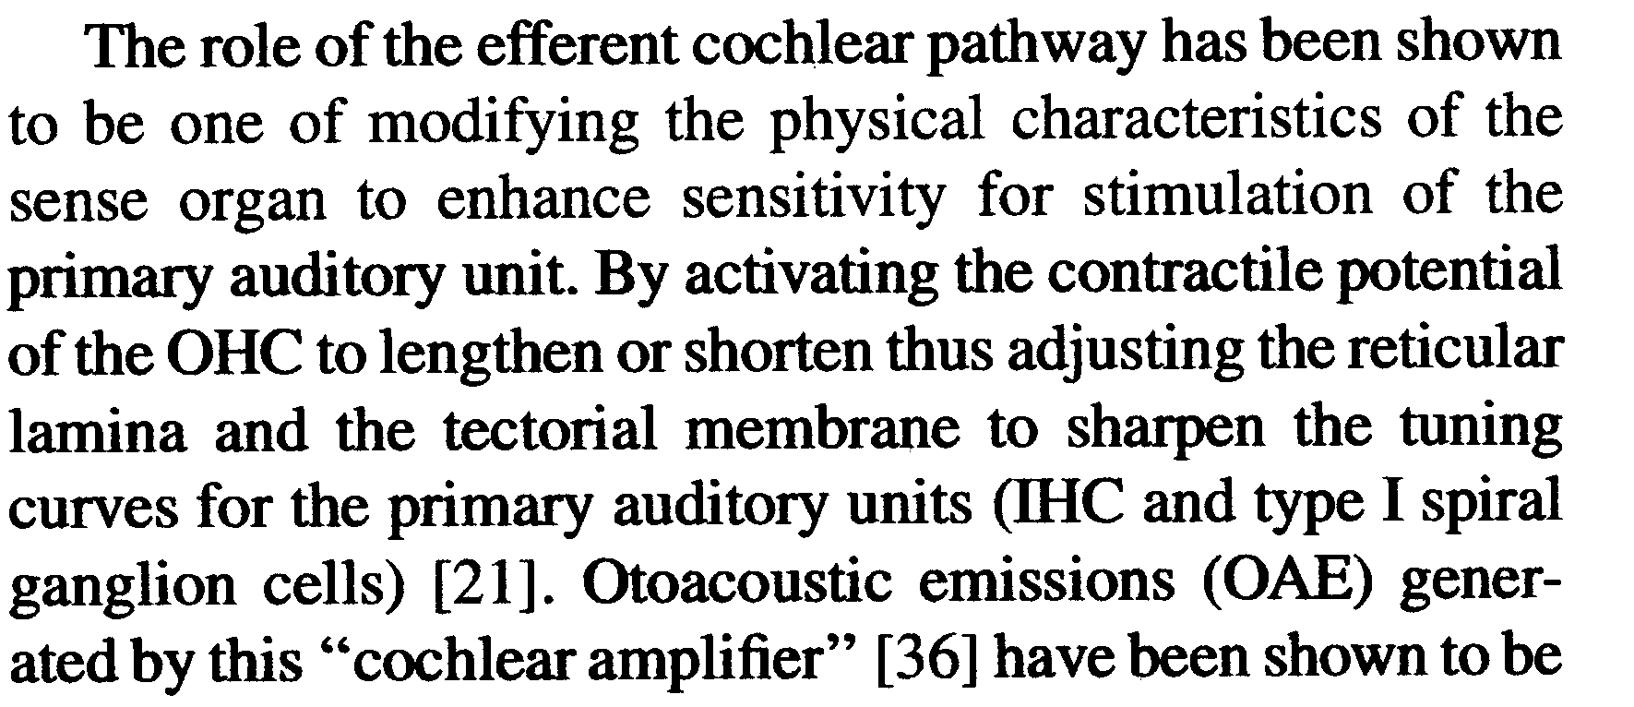

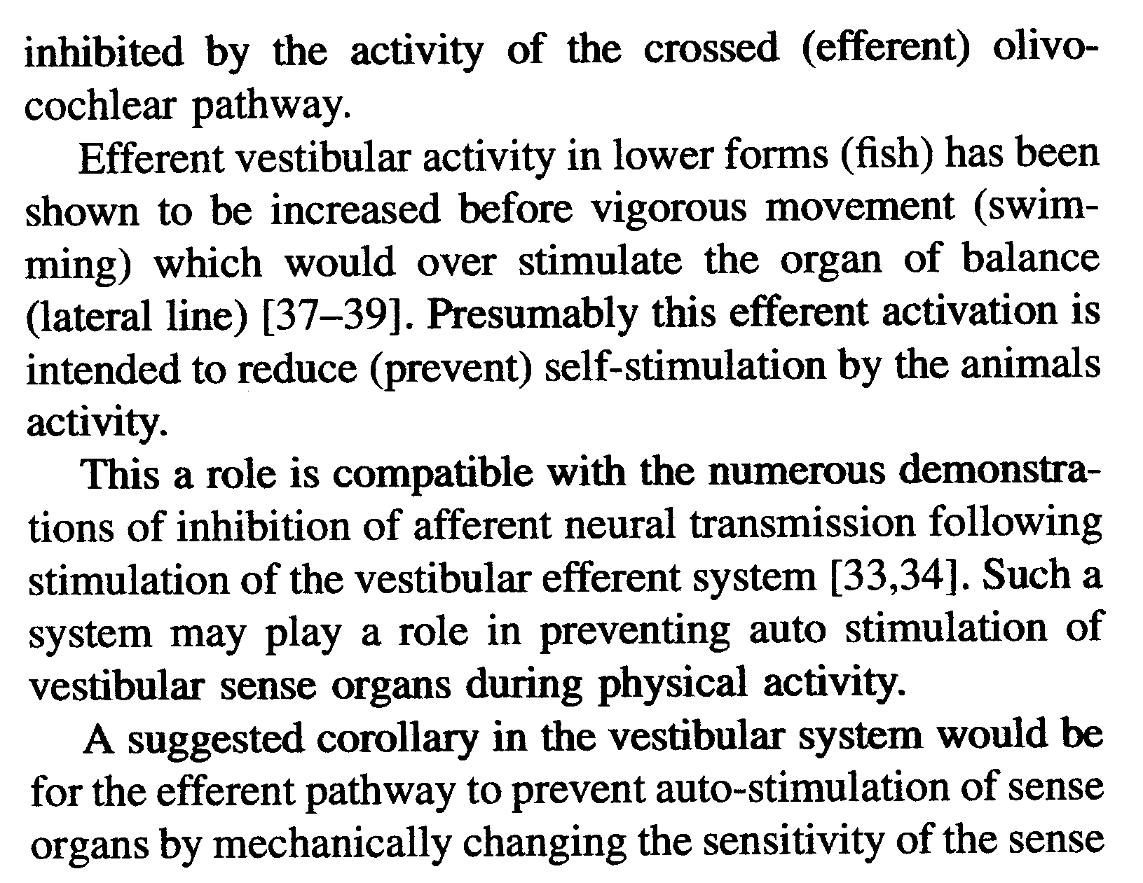

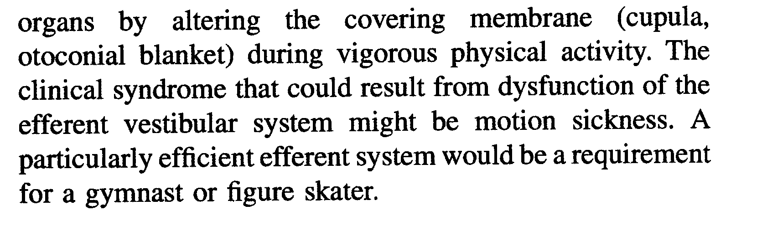

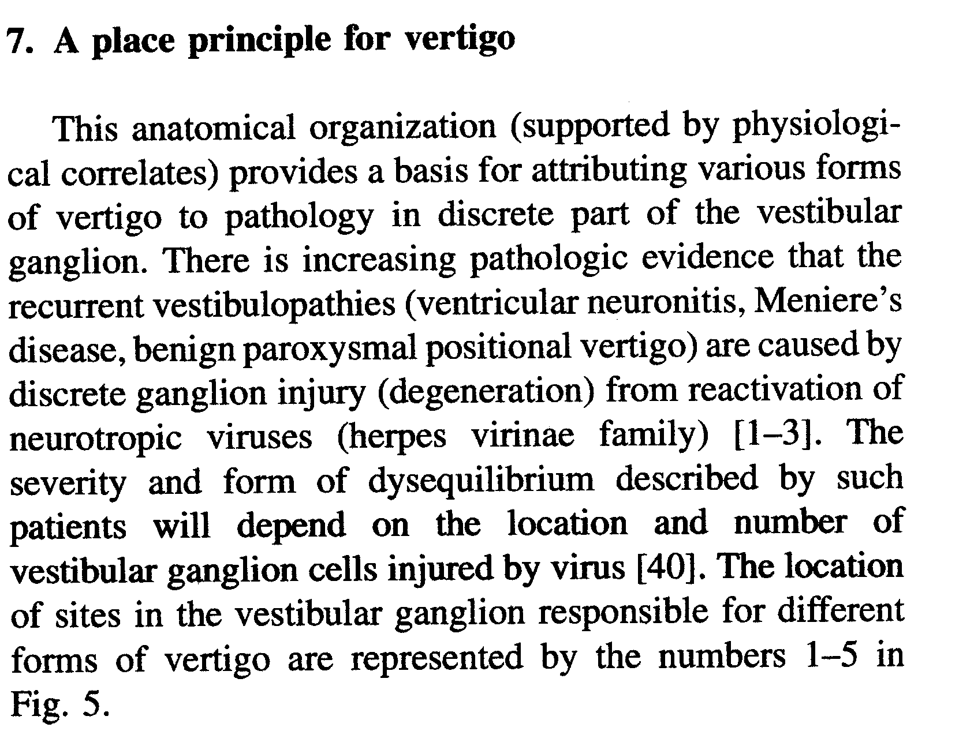

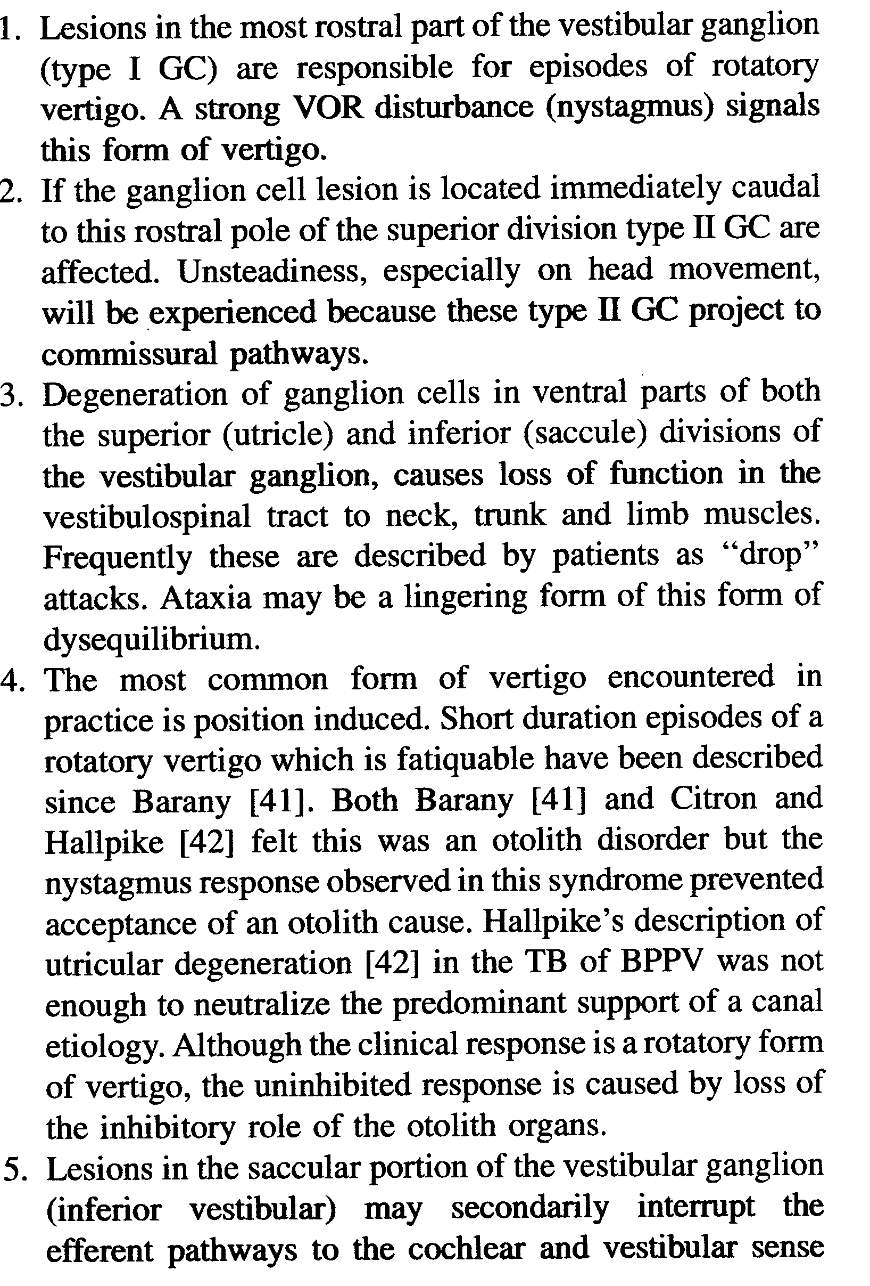

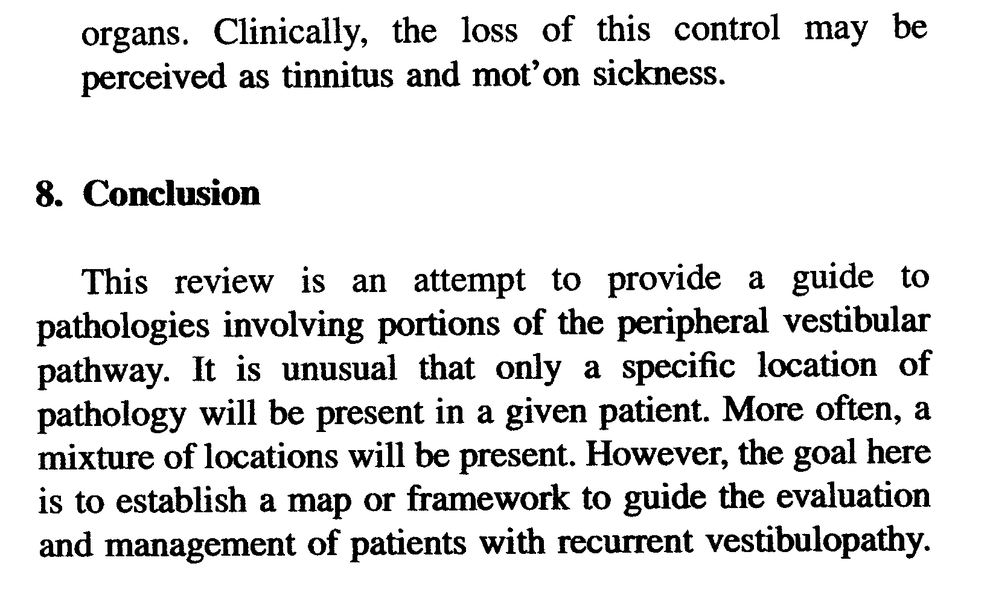

- - - - - - - - - - - - - - - - - - - - - - - - - -

Bloemfontein, South Africa, April 1997

Proposal for a New Classification of Episodic Vertigo based on Symptoms

Dr Adour and Dr Hamersma propose the following new classification for episodic attacks of vertigo which constitute the differential diagnosis of the Syndrome of Menière:

EPISODIC VERTIGO

Episodic Vestibulopathy:

Recurrent attacks of rotational dizziness (vertigo) without any auditory symptoms, not caused by positional factors, which usually last from 5 minutes to 48 hours (also called vestibular Menière) and occasionally for many days (also called vestibular neuronitis) –

1. Caused by replication of the HSV-1 virus, i.e. Polyganglionitis Episodica;
2. Vertige de l’enfance, and
3. Vestibular epilepsy

Episodic Cochleo-Vestibulopathy:

Recurrent attacks of vertigo plus auditory symptoms, which usually last from 5 minutes to 48 hours (also called classic Menière disease), occasionally for many days (protracted attack), including the very severe form also called viral labyrinthitis, and those which develop in previously traumatised and deafened ears (also called secondary endolymphatic hydrops) -

1. Caused by replication of the HSV-1 virus, i.e.Polyganglionitis Episodica;
2. Autoimmune inner ear disease, and
3. Cogan’s disease.

- - - - - - - - - - - - - - - - - - - - - - - - -

Menière’s Disease is a Viral Neuropathy

Gacek R.R.
Department of otolaryngology-Head and Neck Surgery,
UMass Memorial Medical Center, Worcester, MA.

Presented at the Bárány Society Meeting in Kyoto, Japan on March 31, 2008.

Objective:

To present evidence which supports a viral vestibular neuropathy as
the cause of Meniėre’s Disease (MD)

Methods:

Evidence from three sources was reviewed.

- Quantitative and qualitative examination of eleven (11) sectioned
temporal bones (TB) from eight patients with a history of MD.
- Transmission electron microscopic (TEM) examination of the
Vestibular ganglion excised from a patient with MD.
- Clinical results of antiviral therapy in 121 patients with recurrent
vertigo. Eighty-six patients with vestibular neuronitis (VN) and
thirty-five with MD were treated with oral acyclovir over
a 34 month period.

Results:

1. TB series:

Endolymphatic hydrops (EB) was present in 9 out of 11 TB. Vestibular cistern
fibrosis was observed in 6 out of the 11 TB. Focal axonal degeneration in the
vestibular nerve and degenerated meatal ganglion cells was present in all TB.

One TB contained epithelial cells with a large intranuclear inclusion body in
the vestibular cistern. These epithelial cells were mixed with microcystic
structures characteristic for cytomegalo virus (CMV) labyrinthitis.

All eleven vestibular ganglion cell counts revealed a significant loss compared
to normal values.

2. The vestibular ganglion:

The vestibular ganglion excised to control vertigo in a 45 year old female with MD was examined by TEM. Viral capsids enclosed in transport vesicles were observed in the cytoplasm of ganglion cells (Fig. 1). Margination of nuclear chromatin was consistent with viral reactivation.

3. Antiviral therapy:
One hundred forty-seven (147) consecutive patients with MD and VN were
treated with oral acyclovir from April 2004 to February 2007. There were 94
females and 53 males. Ages ranged from 23 to 87 years (avg. 53 years).
Twenty-six patients were lost to follow-up. Vertigo was controlled in 73 of
86 patients with VN (85%), vertigo control was achieved in 32 of 35 patients
with MD (91%).

Conclusion:

Morphological changes in the vestibular nerve and results following antiviral therapy supports the concept of a viral vestibular neuropathy in MD.

Fig. 1: Transmission electron microscopy of vestibular ganglion cell in MD.
There are several viral capsids enclosed in transport vesicles from the
Golgi network. (arrows).

Discussion following presentation:

The author answered a question on antiviral therapy and stated that oral acyclovir 800 mg t.i.d. for 3 weeks was given, then 800 mg b.i.d. for 4 weeks, and then 800 mg daily

