ology & Neurotology = 2010= 31:313-318

Evidence of a Gustatory-Vestibular Pathway
For Protein Transport**

*Richard Gacek and Ť Michael J. Lyon

*Department of Otolaryngology, Head and Neck Surgery , University of Massachusetts Medical School, Worcester, Massachusetts, and

ŤDepartment of Otolaryngology, Research Lab, SUNY Upstate University, Syracuse,
New York, U.S.A.

Objective: To demonstrate anatomically a pathway for protein transport from the palate to the vestibular system.

Method: The vestibulofacial anastomosis and associated ganglion cells were identified in a collection of 160 horizontally sectioned human temporal bones that had been stained with hematoxylin and eosin. Wheat germ agglutinin-horseradish peroxidise (HRP) was applied to the greater superficial petrosal nerve in 4 Spraque-Dawlwy rats. After 30 hours, the rats were killed by intracardia perfusion, and the seventh and eigth nerves with adjacent brainstem removed. Frozen sectioned cut at 30 ųm through this block were then reacted for HRP, counterstained with neutral red, and mounted on slides for examination in the light microscope.

Results: Thirty-two of the human 160 tempoiral bones contained sections through the vestibulofacial anastomosis and its ganglion. In allcases, the ganglion was incorporated into the vestibular ganglion (VG) adjacent to the nervus intermedius. In all 4 3xperimental rats, HRP reaction product labelled a small number of ganglion cells in the VG adjacent to the nervus intermedius and facial nerve.

Conclusion: These observations support the presence of a pathway from receptors in the palate to the VG. Key words: Nervus intermedius – Vestibular ganglion – Vestibulofacial anastomosis.

________________________________________________________

** Transcription by Herman Hamersma, MB ChB (Pretoria) PhD (Amsterdam) Roodepoort, South Africa. www.entinstitute.co.za Hamersma@global.co.za
Conclusion

The current report presents evidence that some ganglion cells in the vestibular ganglion (VG) belong to a part of the nervus intermedius (NI) that carries input from taste receptors supplied by the greater superficial petrosal nerve. Uptake of foreign proteins (i.e., viruses) by such taste receptors early in life may manifest itself as a vestibulopathy later in life.

___________________________________________________________________

As the name implies, the nervus intermedius (NI) travels between the facial nerve (FN) and vestibular nerve (VN). Although a major part of the IN is located in the FN or between the FN and VN, a small variable component travels within the superior division of the VN (1, 2). This VN component leaves the VN at the distal end of the internal auditory canal (IAC)to join the FN as the vestibulofacial anastomosis (VFA).
Functional components of the NI are both efferent and afferent (3). \general visceral efferents are preganglionic parasympathetic neurons in the superior salivatory nucleus, which extend their axons via the chorda tympani (CT) nerve and the grater superficial petrosal (GSP) nerve to the submaxillary and sphenopalatine ganglia where they synapse with postganglionic neurons, which innervate the submaxillary and lacrimal glands, respectively. Special sensory afferent neurons in the NI convey responses from taste receptors in the anterior tongue and the palate. Taste reception in the anterior tongue is carried over sensory neurons in the geniculate ganglion (GG) via the CT nerve and terminates centrally in the nucleus solitaries. Palate taste reception is carried over the GSP nerve and the NI to the nucleus solitaries also. The location of the ganglion cells responsible for taste reception from the palate is not completely known. In the rat, they have been described in the Geniculate Ganglion (GG) (4, 5). However, a human temporal bone (TB) described a meatal ganglion (MG) in the IAC segment of the FN. \this may represent ganglion cells, which receive afferent inpuy ftom the GSP nerve (6).
6 = Gacek R = 1998 = On the duality of the facial nerve ganglion =
Laryngoscope 108:1077 – 86/
This suggestion is supported via the finding of a human TB where the GG was absent and a large MG connected to the GSP nerve remained the sole sensory input in the NI (5).
5 = Hamilton RB, Norgren R = 1984. “Central projections of gustatory nerves in the
rat. J. Comp Neurol.

The development of the facial nerve is important to an understanding of the presence and significance of the VFA and its associated ganglion cells (7).
7 = Gasser RF = 1967. “The development of the facial nerve in man.”
Yhe seventh and eigth nerves begin to develop from a column of neural crest cells, the acoustic-facial primodium, which extends from the brainstem to the epibranchial placode of the second branchial arch. Whereas cells from this column will eventually form the vestibular and spiral ganglia, the lateral extension of yhe column will form the sensory components of the FN (Fig. 1). Responding to neurotrophic signals from the periphery (tongue and palate), the CT and GSP nerves are the first are the first branches of the FN to form (7). The GG is formed by the cells of the epibranchial placode and the distal end of the acoustic-facial primordium (neural crest. The MG results from the neural crest cells of the primordium stimulated by input over the GSP nerve. The remaining cells of the primordium will undergo apoptosis, depending on the amount of neurotrophic factors available. Both of these ganglia are dependent on neurotrophic factors to represent the sensory system responsible for taste (8,9).

8 = Jones KR et al = 1994 = “Targeted disruption of the BDNF gene perturbs brain and
sensory neuron development but not motor neuron development.

9 = Farinas I et al = 1994 = “Severe sensory and sympathetic deficits in mice lacking
Neurotrophin-3.”
Therefore the development of taste buds in the tongue and palate is the determinant of the form and size of the ganglion in the seventh nerve. In the human FN, 2 ganglia result from this process (Fig. 2). These ganglia have formed as a result of neurotrophic factors in taste buds of the anterior two-thirds of the tongue (geniculate) and the palate (meatal). The MG is associated with the NI, near the vestibular ganglion (VN). A small portion of the MG is located within the VG. It is this part of the NI that leaves the VN to join the FN as the VFA. The present study was designed to demonstrate ganglion cells associated with the NI that travels within the VN. Such ganglion cells receiving input from taste receptors would not represent a neural connection with the vestibular system but could allow infectious proteins (i. e., virus) residing in these ganglion cells to spread to adjacent VG cells.
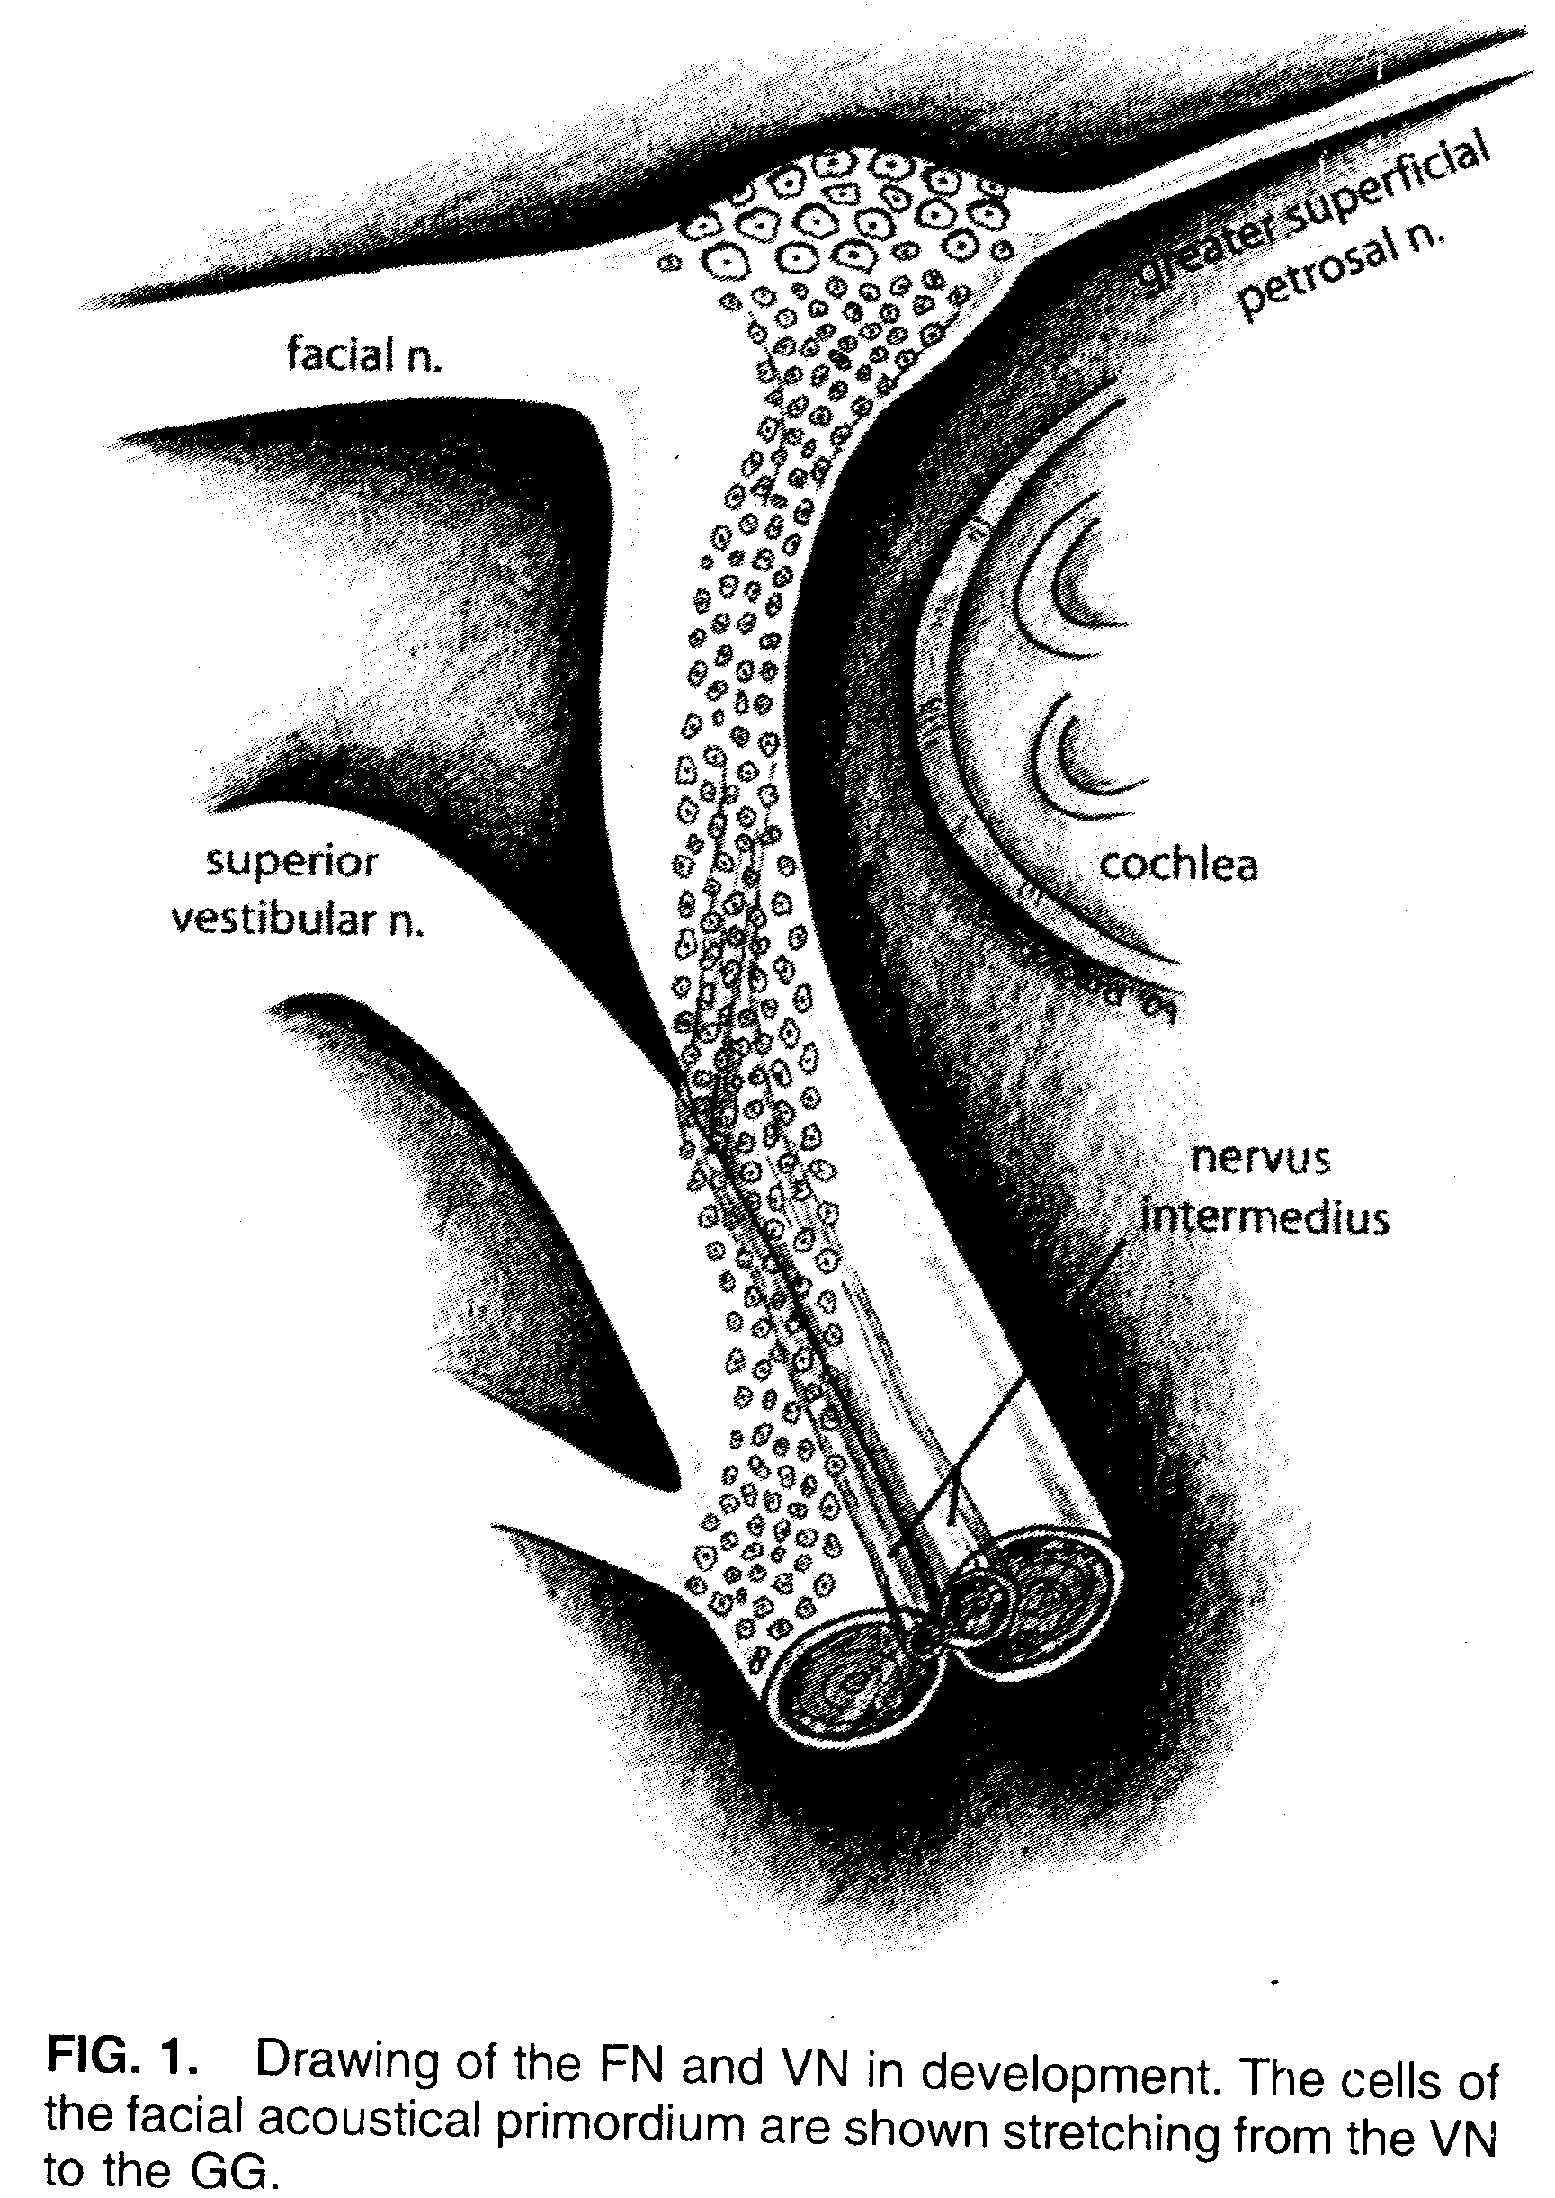

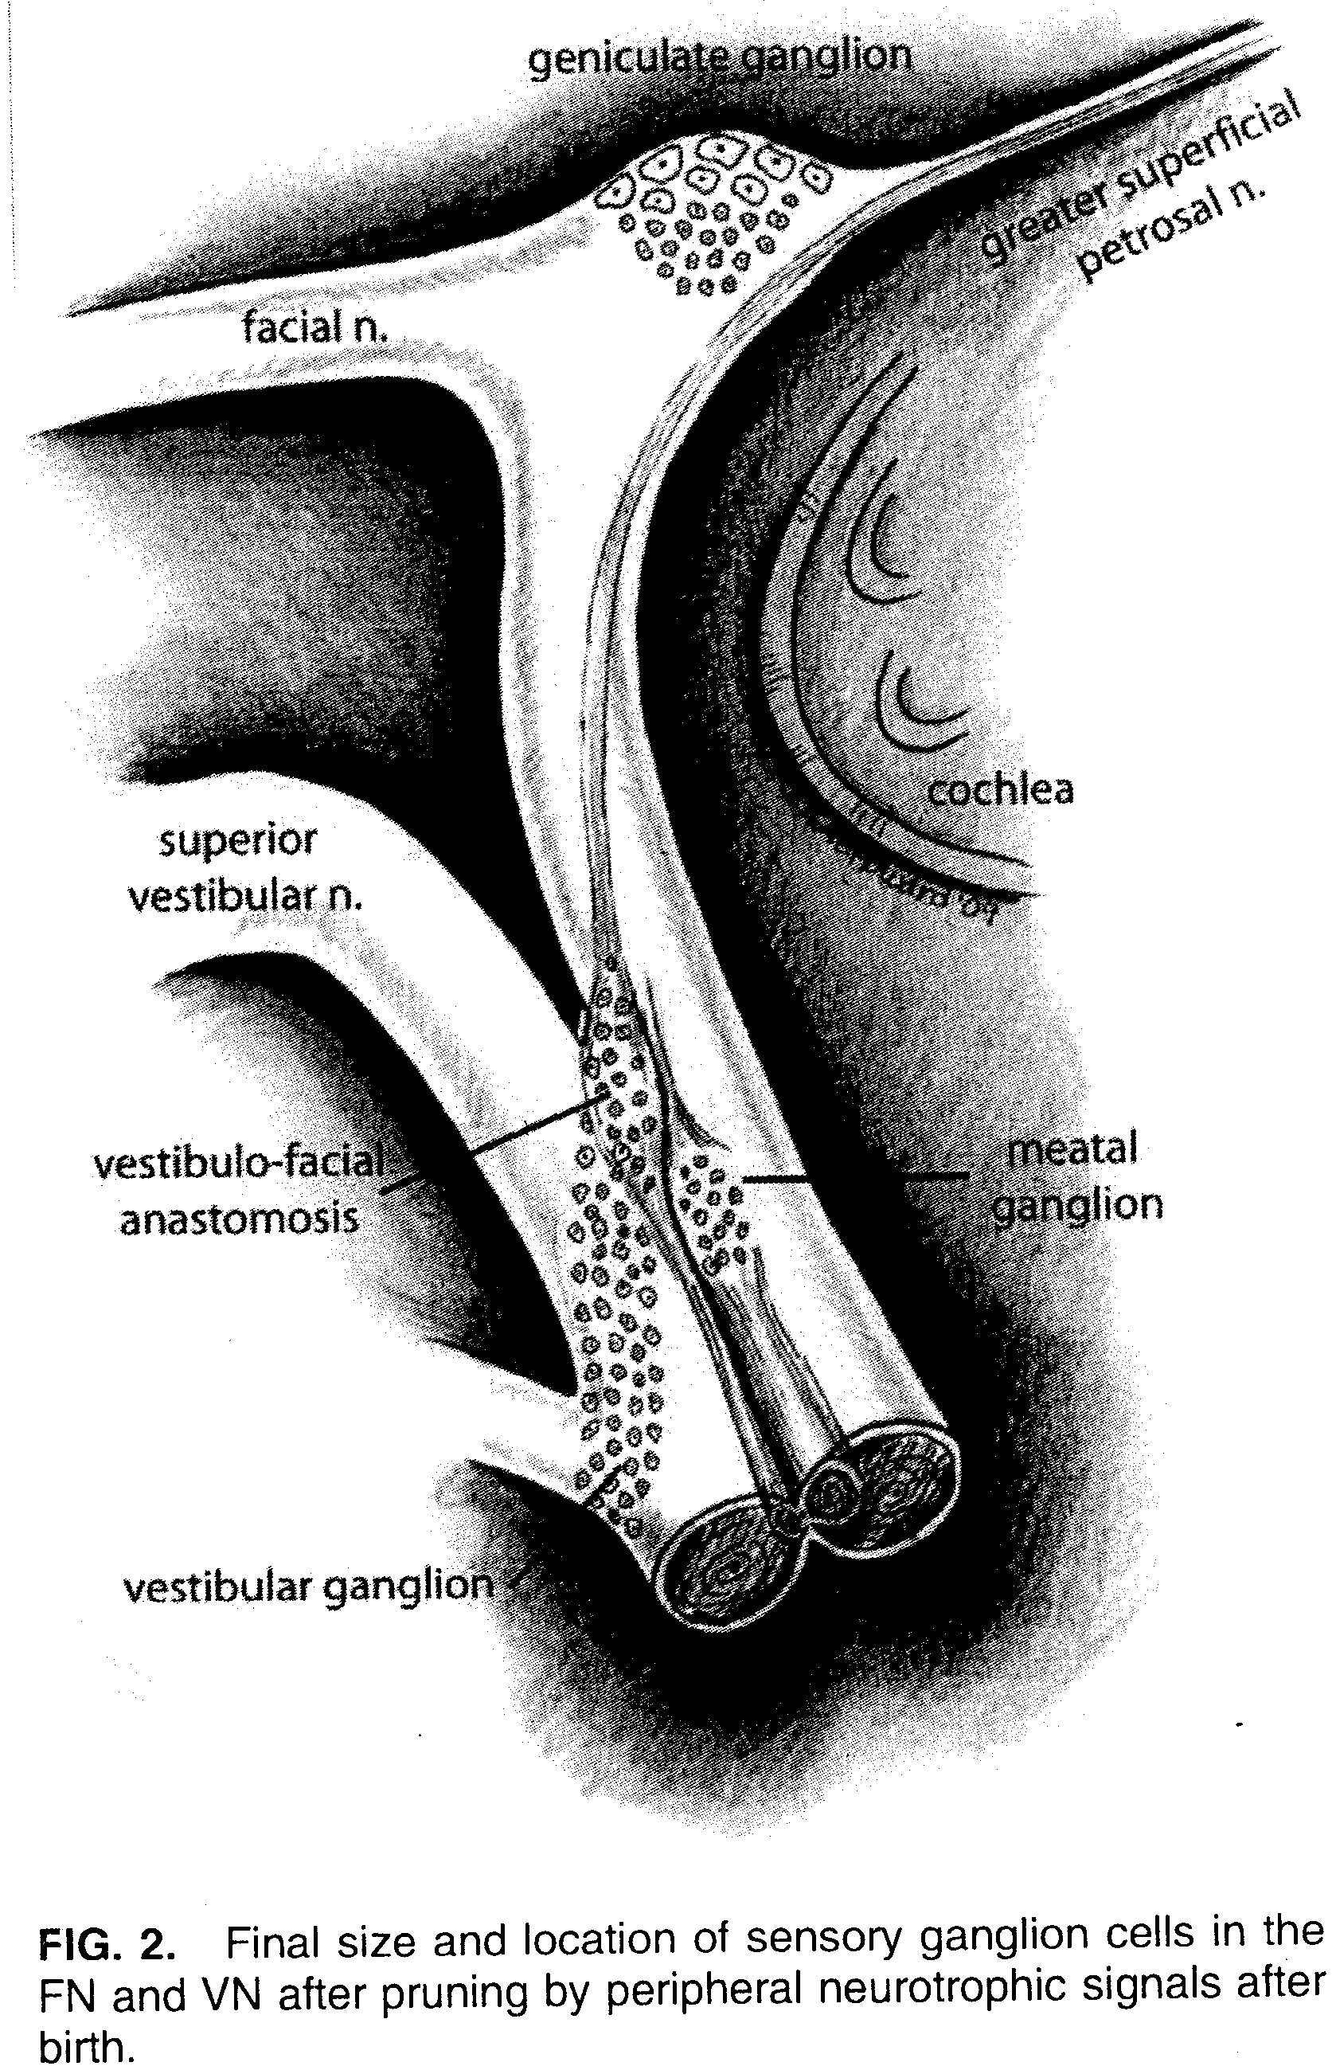

MATERIALS AND METHODS

Human TBs (n = 195) were prepared in a standard fashion. After formalin fixation, they were decalcified, embedded in celloin, and horizontally sectioned at 20 ųm. Every tenth sectioned was stained with hematoxyllin and eosin and mounted for light microscopic examination ffor the presence of the VFA. Thirty-five TBs were excluded because of artifact or pathologic abnormality in in the IAC, which precluded study of the FN and VN. Of the 160 TBs examined, 32 contained sections through the VFA.
Female Spraque-Dawley rats were used in this study (weight, 200 – 240 g, n = 4). All animal procedures were done in accordance with National Institutes of Health guidelines for humane handling of animals, and all protocols were approved by the Committee for the Humane Use of Animals at the SUNY Upstate Medical University, Syracuse, New York.
Animals were anesthetized using isoflurane (3% - 5%), and aseptic techniques used for surgery. The left ventral surface of the neck was shaved and washed with surgical scrub. The temporal bulla was exposed and opened to expose the tensor tympani muscle within the middle ear. Its tendon to the malleus was cut, and the muscle was removed to expose the bony suture line, within its niche, containing the GSP nerve. The GSP nerve was gently elevated and transacted, and crystalline wheat germ agglutinin-horseradish peroxidise (HRP) (~ 50-100 ųg) was applied to its proximal end. The niche was filled with a gelatine sponge (Gelfoam; Upjohn Co., Kalamazoo, MI, USA). Muscles were approximated, and the skin was closed with interrupted sutures. Postoperatively the animals received buprenorphine (0.o5 mg/kg per 12 hours). After 30 hours the animals were anesthetized and killed by intracardiac perfusion with phosphate-buffered saline (PBS; 100mL, pH 7.4) followed by 5% glutaraldehyde in 0.1 mol//: PBS. The seventh and eighth nerves with adjacent brainstem were dissected out of yhe undecalcified TBs and placed overnight in 15% sucrose in PBS at 4°C. The specimens were then embedded in glutaldehyde-hardened egg yolk. Serial horizontal frozen sections were cut at 30 ųm collected in PBS. Sections were reacted for HRP using tetramethylbenzidine, mounted on glass slides, air dried, counterstained with 1% neutral red, dehydrated, and cover slipped. The sections were then examined fir the presence of blue HRP reaction product by light microscopy.

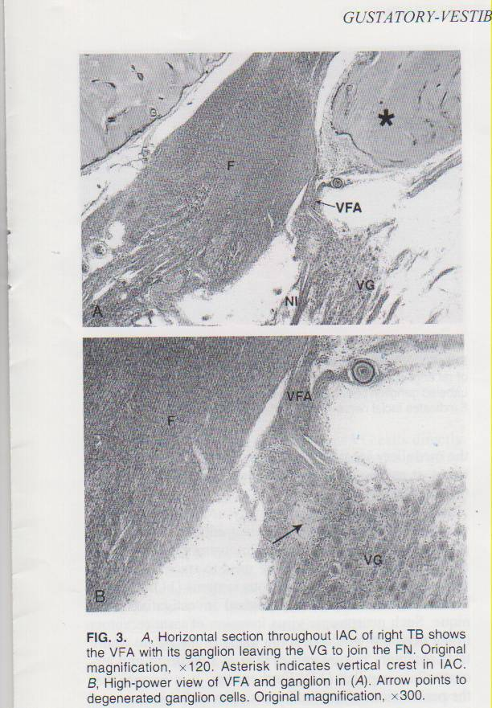

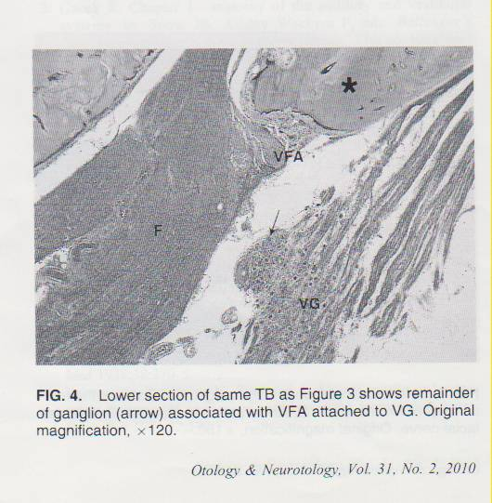

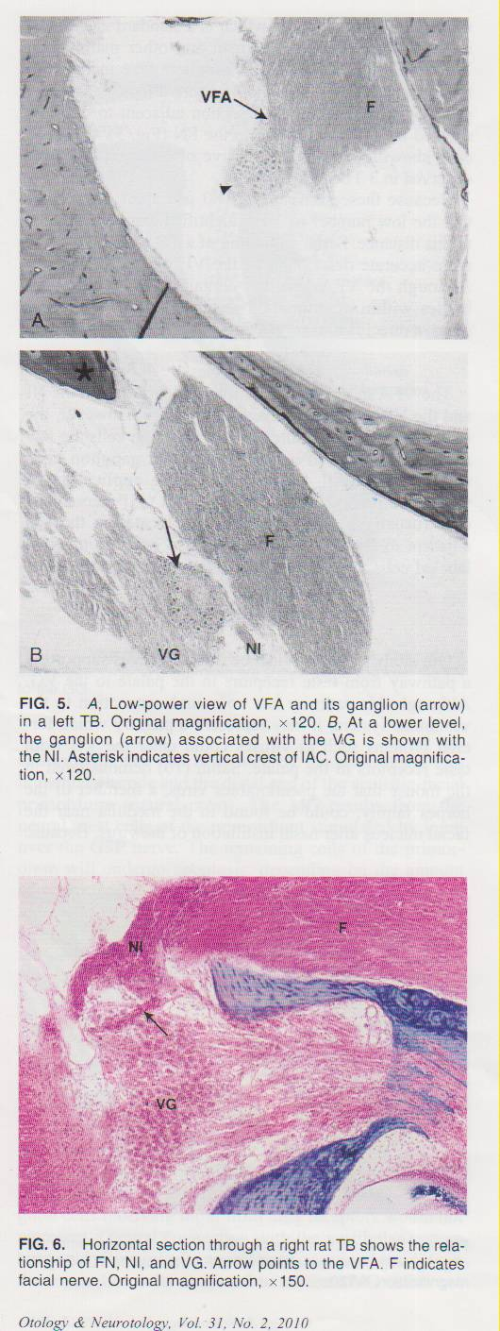
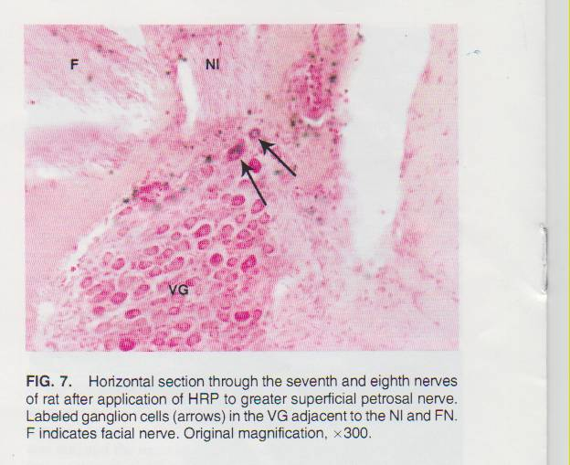

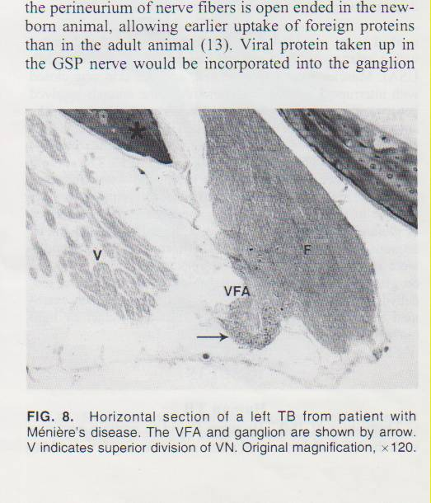

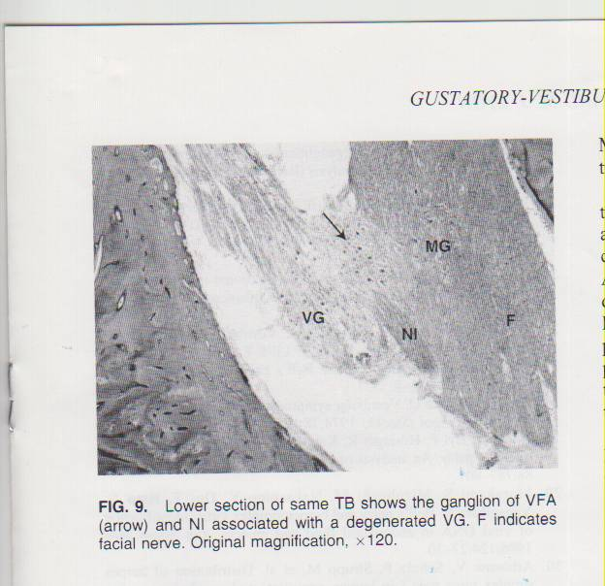

RESULTS

Human TB
Thirty-two of 160 TBs werw found to contain sections with the VFA. A horizontal plane of sectioning favours identification opf this structure, which is standard anatomical neural connection in the human and other mammalian TB. In 13 TGs, the VFA and ganglion were included in the same sections. (Figs. 3 and 4). More often (n =19), the ganglion was observed in a section adjacent to one that showed the VFA connected to the FA (Fig. 5). Ganglion cells showing changes suggestive of degeneration were observed in 3 TBs (Fig.).
Because these sections are 180 ųm apart, it is likely that the low number of VFA identified can be attributed to this distance. Serial sectioning of a TB would provide a more accurate description of the VFA and its ganglion. Although the VFA ganglion contained a cluster of cell bodies within or intimately attached to the VG, in all cases, a direct neural connection to the VG was not found.
Animal series

he VFA in the rat has a similar relationship to the NI and the VG as in the human TBs (Fig. 6). However, the size of the VFA is smaller, and its ganglion cells are few in number. A small number of labeled ganglion cells were found in all 4 animals after the application of wheat germ agglutinin-HRP to the cut GSP nerve. The cells (usually 1- 3 per section) were located in the VG adjacent to the FN and NI (Fig. 7). A small number of labelled cells were also found in the GG in 2 animals.

DISCUSSION

Our study presents evidence from 2 sources supporting a pathway from taste receptors in the palate to the VG. Although this patway has no neural connection to the vestibular system,it may represent a path by which foreign proteins such as viruses could enter the VG from taste receptors in the palate. Sabin (10) demonstrated in the mouse that the pseudorabies, a member of the herpes family, could be found in the medulla near the facial nucleus after nasal instillation of the virus. Because the medullar location likely represents the nucleus solitaries, it can be assumed that the virus travelled via the GSP nerve and NI.

10 = Sabin A = 1938 = “Progression of different nasally insyilled viruses
along different nervous pathways in the same host”
Proc Soc Exp Biol Med 38:270-5.
11 = Kristensson et al = 1971 = “Axonal uptake and retrograde transport of
Exogenous proteins in the hypoglossal nerve.”
Brain Res 1971; 32:399.
It was in search of the pathway used by neurotropic viruses (i.e, herpes family) to gain entrance to the ganglion cell body that led to the demonstration that protein protein markers such as HRP could be used to trace neurons in the central and peripheral nervous systems (11). This has become a standard neurobiological investigative technique. Such neurotropic virus invasion of taste receptors in the newborn would be more likely in the palate where taste receptors mature earlier than in fungiform and circumvallate papillae (12). Furthermore, it is known that the perineurium of nerve fibers is open ended in the newborn animal allowing earlier uptake of foreign proteins than in the adult animal (13). Viral protein taken up in the GSP nerve would be incorporated into the ganglion cells of the VFAand spread to adjacent VG cells directly or indirectly via satellite cells that encircle the ganglion cells (14). Such satellite cells have been shown to have metabolic activity linked to that of the ganglion cells (15, 16). This viral spread may occur by several mechanisms(17):
- The virus may simply leave the infected and attach to membrane receptors on nearby cells with subsequent invasion.
- The virus may move across junctions where cells are closely attached (tight junctions).
- The virus may be carried by satellite cells of the infected cell to nearby ganglion cells.
Recent reports present molecular (18, 19), light (20), and electron nmicroscopic (21) evidence of viral presence in the VG of patients with Meniere;s disease and vestibular neuronitis. This raises the question of how viral entry to the VG occurs. Typically such patients are adults with no history of ear symptoms preceding their vertigo.
18 = Pitvoski, Robinson, Garcia-Ibanez et al = 1999 = “Presence of HSV-1
Gene products characteristic of active infection in the vestibular ganglia
Of patients diagnosed with acute Meniere’s disease”.
19 = Vrabec JT = 2003 = “Herpes simplex virus and Meniere’s disease.”
Laryngoscope 2003; 113:1431 – 28.
20 = Gacek R, Gacek M = 2002 = “The three faces of vestibular ganglionitis”
Ann Otol Rhino Laryngol 2002;11:103-14.
21 = Gacek R = 2009 = “Meniere;s disease is a viral neuropathy”
ORL J Otorhinolaryngol Relat Spec 71:78-86.
Temporal bone studies have documented degenerated ganglion cells in the MG (22) of the FN in idiopathic facial paralysis (IFP) as well as recurrent vestibulopathies, Meniere’s disease, and vestibular neuronitis (19). degeneration of neurons in the GG, alyhough evidence of herpes simplex virus DNA in the GG has been reportedin association with IFP with polymerase chain reaction (23). The MG has not been studied in a similar fashion, despite many magnetic resonance imaging studies tyhat indicate that the earliest enhancement in IFP is at the fundus of the IAC where the MG is located (24).
22 – Gacek R, Gacek M – 1999 = “Meatal ganglionitis. Clinical pathologic
Correlation in idiopathic facial paralysis (Bell’s palsy”.
Otorhinolaryngol Noiva 9:229-38.
The reported observation of vestibular symptoms and deficits in a significant number of patients with IFP (25 – 27) has been assumed to be on the basis of the intimate anatomical relationship of the FN and VN in the IAC. There have been reports of recurrent vestibulopathies after resolution of IFP (20). These clinical associations deserve a thorough consideration of an anatomical basis for FN and VN idiopathic pathologic findings. Much evidence has been reported to support a neurotropic viral cause in the disorders (28-31).

23 - = Burgess RC et al – 19994 = “Polymerase chain reaction amplification of
herpes simplex viral DNA from the geniculate ganglion of a patient
with Bell’s palsy. Ann Otol Rhinol Laryngol 105: 75-9.
24 = Anderson R, Laskofl J = 1990 = “Ramsay Hunt syndrome mimicking
Intracanalicular acoustic neuroma contrast-enhanced MR.
Am J Neuroradiol 11;409.
25 = Rauchbach E et al = 1978 = “Vestibular involvement in Bell’s palsy.
Laryngoscope 85:1396-8.
26 = Philipszoon AJ = 1962 = “Nystagmus and Bell’s palsy”.
Pract Otorhinolaryngol 24;233-8.
27 = Lammil K, Fisch U = 1974 = “Vestibular symptoms in idiopathic
facial palsy. Acta Otolaryngol (Stockh) 78:15-8.
28 = Adour K et al = 1978 = “The true nature of Bell’s palsy. An analysis of
1000 cases. Arch Otolaryngol 88:787-801.
29 = Murakami S et al = 1996 = “Bell’s palsy and herpes simplex virus
Identification of viral DNA in in endoneural fluid and muscle.’
Ann Intern Med 124:27-30.
30 = Arbusow V, Schulz P, Strupp M, et al = 1999 = “Distribution of herpes
simplex virus type 1 In human geniculate and vestibular ganglia:
implication for vestibular neuritis.” Ann Neurol 46:416-9.
31 = Davis LE = 1993 = “\viruses and vestibular neuritis: Review of human
and animal studies.” Acta Otolaryngol Suppl (Stockh) 503:700-33.

The high incidence of ganglion cell lesions in the meatal and vestibular ganglia of TB with Meniere’s disease and vestibular neuronitis points to a neural basis for the close anatomical relationship of the 2 ganglionic entities. As demonstrated in the present report, these 2 ganglia are derived from the same primordium, and a portion, and a portion of the MG included in the VG at the VFA. The axonal transport of HRP in neurons supplying taste receptors in the palate mixed mixed with VG neurons is evidence of the path that neurotropic viruses could follow to the VG and and eventually reactivate to cause vestibulopathies in later life.

An example of this histopathologic correlate in Meniere’s disease is shown in Figure 8. This TB from a patient with documented Meniere’s disease shows degeneration of ganglion cells associated with the VFA as well as the VG (Fig. 9). The degeneration of ganglion cells in the VG occurred in clusters separated by fibrous tissue. Such clustering is characteristic of closely arranged cell bodies affected by a neurotropic virus. Bundles of degenerated axons in the VN trunk reflect this pattern of ganglion cell loss.

CONCLUSION
The current report presents evidence that some ganglion cells in the VG belong to a part of the NI that carries input from taste receptors supplied by the greater superficial petrosal nerve. Uptake of foreign proteins (i.e., viruses) by such taste receptors early in life may manifest itself as a vestibulopathy later in life.

