PHC Chapter 12: Sexually transmitted infections

  - Vaginal discharge syndrome (VDS)
    - Sexually non-active women
    - Sexually active women
  - Lower abdominal pain (LAP)
  - Male urethritis syndrome (MUS)
  - Scrotal swelling (SSW)
  - Genital ulcer syndrome (GUS)
  - Bubo
  - Balanitis/balanoposthitis (BAL)
  - Syphilis serology and treatment
  - Treatment of more than one STI syndrome
  - Treatment of partners
  - Genital molluscum contagiosum (MC)
  - Genital warts (GW) Condylomata Accuminata
  - Pubic lice (PL)

The syndromic approach to Sexually Transmitted Infections(STI) diagnosis and management is to treat the signs or symptoms (syndrome) of a group of diseases rather than treating a specific disease. This allows for the treatment of one or more conditions that often occur at the same time and has been accepted as the management of choice.

Causative organisms and medicine management for STI syndromes:

ORGANISM | SYDROME/S | MEDICINE MANAGEMENT
Neisseria gonorrhoeae | VDS, MUS, LAP | ceftriaxone + azithromycin
Chlamydia trachomatis | VDS, MUS, LAP | azithromycin
Trichomonasvaginalis | VDS, LAP | metronidazole
Bacterial vaginosis (overgrowth of Gardnerellavaginalis, lactobacillus, anaerobes etc) | VDS | metronidazole
Candida albicans | VDS | clotrimazole
Treponemapallidum | GUS | doxycycline/ benzathine penicillin
Herpes simplex | GUS | aciclovir
Haemophilusducreyi | GUS, Bubo | azithromycin
Lymphogranulomavenereum | GUS, Bubo | azithromycin

It is important to take a good sexual history and undertake a thorough ano-genital examination in order to perform a proper clinical assessment. The history should include questions concerning symptoms, recent sexual history, sexual orientation, type of sexual activity (oral, vaginal, anal sex), the possibility of pregnancy (females), use of contraceptives including condoms, recent antibiotic history, antibiotic allergy, recent overseas travel and domestic violence. Refer to a social worker, as required.

Note: Standard referral letter for treatment failure must include the following:
reason for referral: presumptive diagnosis (e.g. persistent cervicitis with suspected resistant gonorrhoea)
clinical findings including speculum examination for vaginal discharge
treatment history (including all medicines with dose and duration)
details of notification and treatment history of partner(s)

Suspected STI in children should be referred to hospital for further investigation and management.

GENERAL MEASURES
Counselling and education, including HIV testing.
Condom promotion, provision and demonstration to reduce the risk of STIs.
Compliance/ adherence with treatment.
Contact treatment/ partner management.
Circumcision promotion (counselling to continue condom use).
Cervical cancer screening.
Promote HIV counselling and testing.
For negative test results repeat test after6 weeks, because of the window period.

Benzathine benzylpenicillin
Benzathine benzylpenicillin remains the recommended treatment for syphilis. However, due to global shortage of benzathine benzylpenicllin (limited global supply of the active pharmaceutical ingredient) the algorithms now recommend doxycyline, oral except in pregnant women and children. Azithromycin is not recommended for the treatment of syphilis in pregnancy as azithromycin does not effectively treat syphilis in the fetus, and resistance develops rapidly to macrolides. Therefore, the limited stock of benzathine benzylpenicllin must be reserved for use in pregnant women and children.

12.1 VAGINAL DISCHARGE SYNDROME (VDS)
B37.3/N76.0/N89.8

12.1.1 SEXUALLY NON- ACTIVE WOMEN
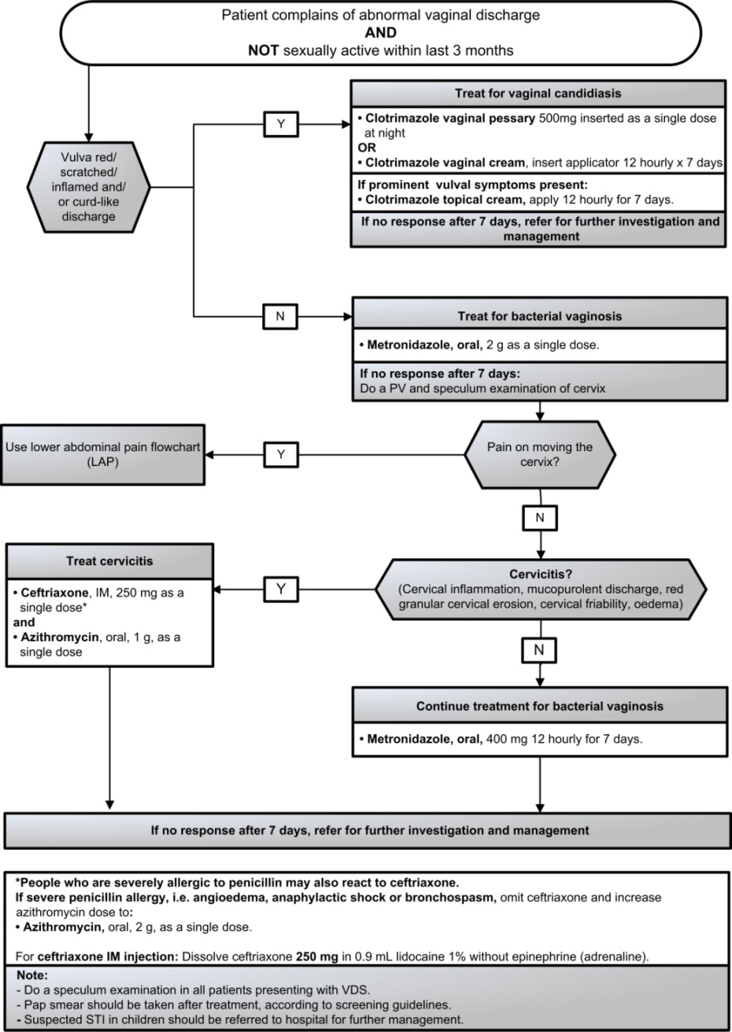

12.1.2 SEXUALLY ACTIVE WOMEN

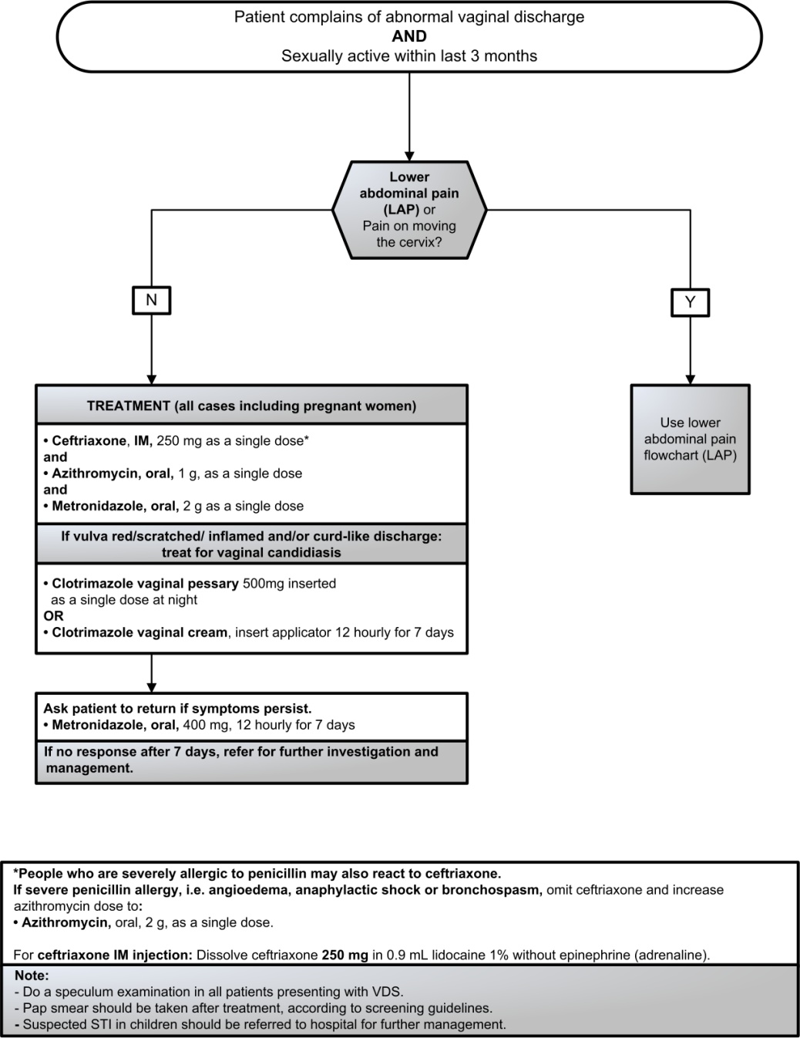

12.2 LOWER ABDOMINAL PAIN (LAP)
N73.9
LoE:II^{vii}

12.3 MALE URETHRITIS SYNDROME (MUS)
A64 + N34.1

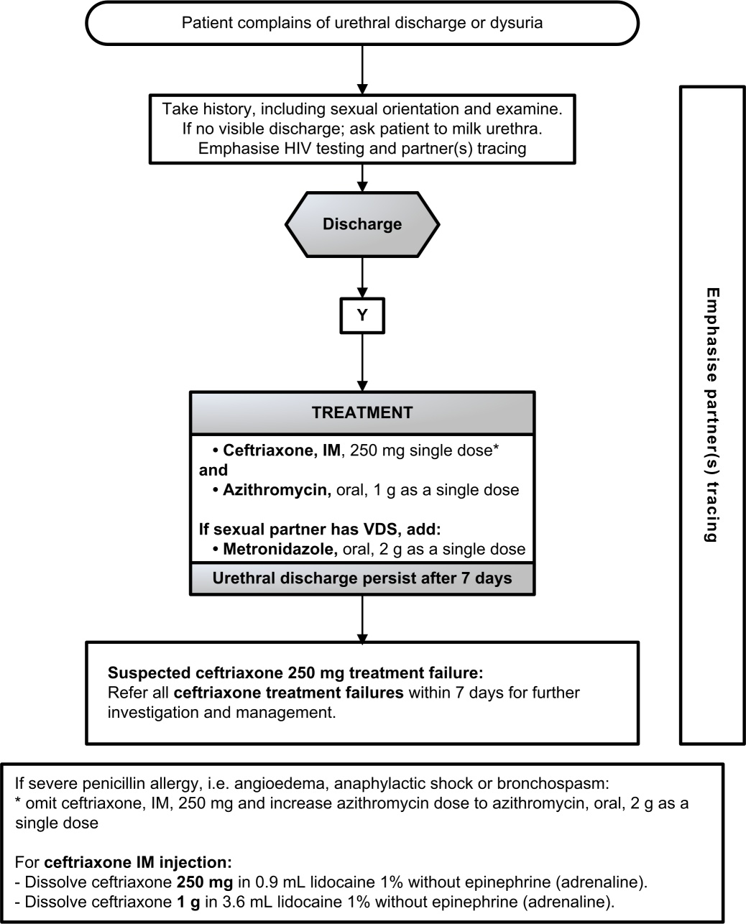

12.4 SCROTAL SWELLING (SSW)
N45.1

12.5 GENITAL ULCER SYNDROME (GUS)
A60.9/A51.0
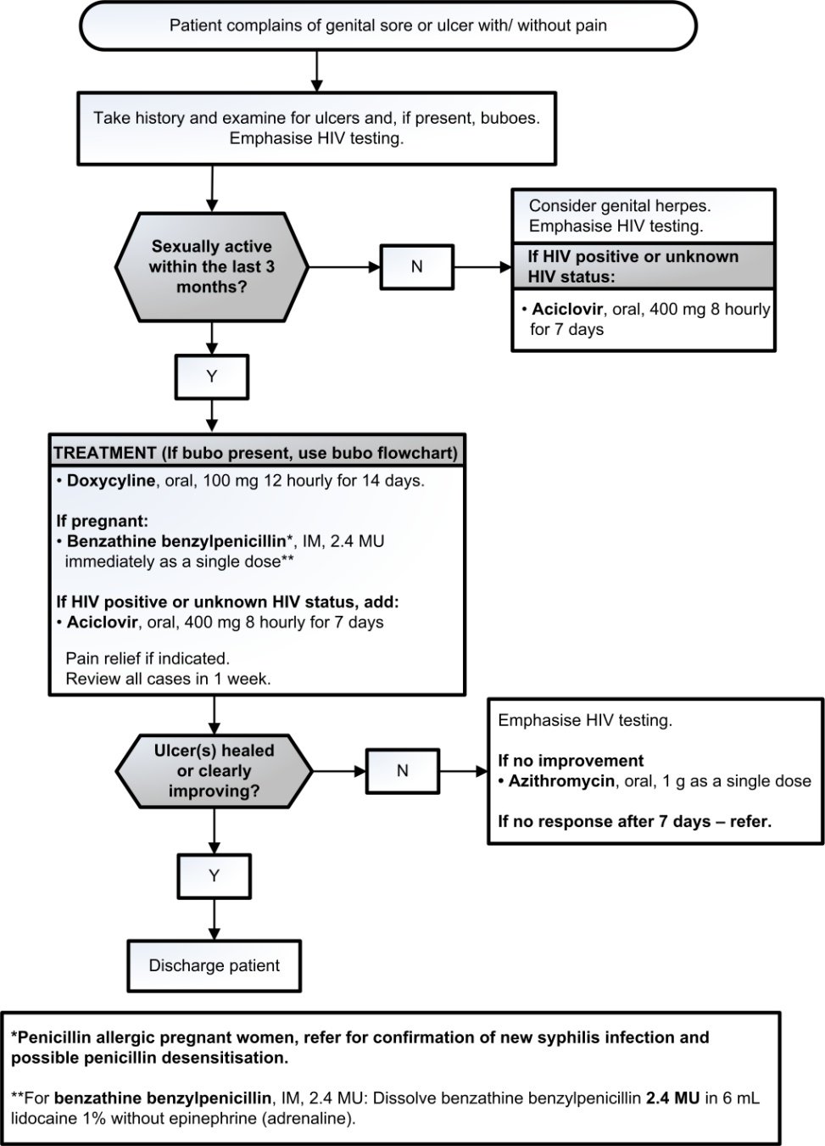

12.6 BUBO
A58

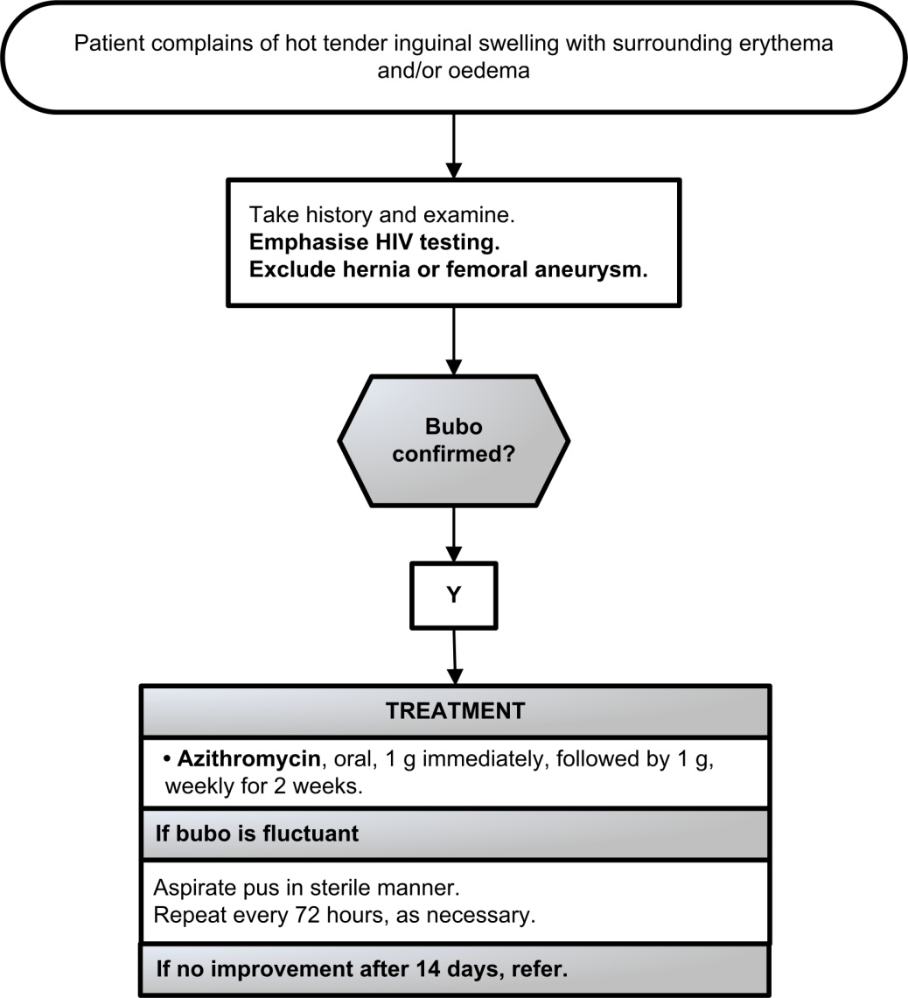

12.7 BALANITIS/BALANOPOSTHITIS (BAL)
N48.1

12.8 SYPHILIS SEROLOGY AND TREATMENT
A53.9

Syphilis serology
The Rapid Plasmin Reagin (RPR) measures disease activity, but is not specific for syphilis. False RPR-positive reactions may occur, notably in patients with connective tissue disorders (false positive reactions are usually low titre <1:8). For this reason, positive RPR results should be confirmed as due to syphilis by further testing of the serum with a specific treponemal test, e.g.:
Treponema pallidum haemagglutination (TPHA) assay.
Treponema pallidum particle agglutination (TPPA) assay.
Fluorescent Treponemal Antibody (FTA) assay.
Treponema pallidum ELISA.
Rapid treponemal antibody test (TPAb)

Screening can also be done the other way around starting with a specific treponemal test followed by a RPR in patients who have a positive specific treponemal test. This is sometimes referred to as the “reverse algorithm”.

- Once positive, specific treponemal tests generally remain positive for lifeand therefore the presence of specific treponemal antibodies cannot differentiate between current and past infections
- A person with previously successfully treated syphilis will retain lifelong positive specific treponemal test results.

The RPR can be used:
To determine if the patient’s syphilis disease is active or not,
To measure a successful response to therapy (at least a fourfold reduction in titre, e.g. 1:256 improving to 1:64), or
To determine a new re-infection.
Some patients, even with successful treatment for syphilis, may retain life-long positive RPR results at low titres (≤1:8), which do not change by more than one dilution difference (up or down) over time (so-called serofast patients).

Note:
Up to 30% of early primary syphilis cases, i.e. those with genital ulcers may have a negative RPR.
The RPR is always positive in the secondary syphilis stage and remains high during the first two (infectious) years of syphilis.

For syphilis treatment in pregnancy, see Section 6.2.4 Syphilis in pregnancy.

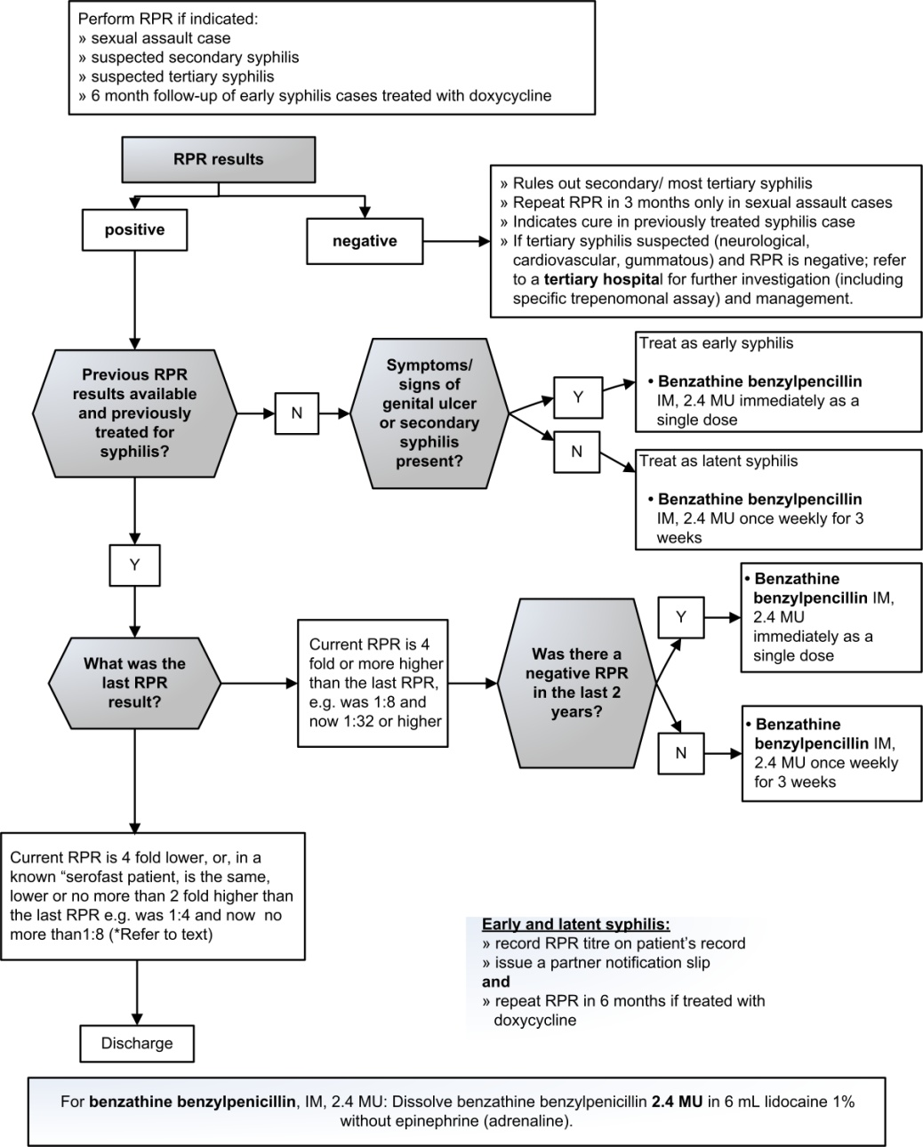

MEDICINE TREATMENT
Early syphilis treatment
Check if treated at initial visit.
- Benzathine benzylpenicillin, IM, 2.4 MU immediately as a single dose.
  - Dissolve benzathine benzylpenicillin, IM, 2.4 MU in 6 mL lidocaine 1% without epinephrine (adrenaline).

In penicillin-allergic patients or if benzathine benzylpenicillin is unavailable:
- Doxycycline, oral, 100 mg twice daily for 14 days.
LoE:III

If penicillin-allergic and pregnant: Refer for penicillin desensitisation.

Late latent syphilis treatment
Check if treatment was commenced at initial visit.
- Benzathine benzylpenicillin, IM, 2.4 MU once weekly for 3 weeks.
  - Dissolve benzathine benzylpenicillin, IM, 2.4 MU in 6 mL lidocaine 1% without epinephrine (adrenaline).

In penicillin-allergic patients or if benzathine benzylpenicillin is unavailable:
- Doxycycline, oral, 100 mg twice daily for 30 days.
LoE:III

If penicillin-allergic and pregnant: Refer for penicillin desensitisation.

REFERRAL
Tertiary syphilis: Neurosyphilis, cardiovascular syphilis; gummatous syphilis.
Clinical congenital syphilis.

12.9 TREATMENT OF MORE THAN ONE STI SYNDROME

STI syndromes | Treatment (new episode)
MUS + SSW | Treat according to SSW flow chart.
MUS + BAL | Treat according to MUS flow chart.  AND  - Clotrimazole cream, 12 hourly for 7 days.
MUS + GUS | - Ceftriaxone, IM, 250 mg immediately as a single dose.  AND  - Azithromycin, oral, 1 g as a single dose.  AND  - Aciclovir, oral, 400 mg 8 hourly for 7 days*.
VDS + LAP | Treat according to LAP flow chart.  AND  Treat for candidiasis, if required (see VDS flow chart).
VDS + GUS | - Ceftriaxone, IM, 250 mg immediately as a single dose.  AND  - Metronidazole, oral, 2 g immediately as a single dose.  AND  - Azithromycin, oral, 1 g as a single dose.  AND  - Aciclovir, oral, 400 mg 8 hourly for 7 days*.  AND  Treat for candidiasis, if required (see VDS flow chart).
LAP+ GUS | - Ceftriaxone, IM, 250 mg immediately as a single dose.  AND  - Metronidazole, oral, 400 mg 12 hourly for 7days.  AND  - Aciclovir, oral, 400 mg 8 hourly for 7 days*.  AND  - Azithromycin, oral, 1 g as a single dose.
SSW+ GUS | - Ceftriaxone, IM, 250 mg immediately as a single dose.  AND  - Aciclovir, oral, 400 mg 8 hourly for 7 days*.  AND  - Azithromycin, oral, 1 g as a single dose.
*Treat with aciclovir only if HIV status is positive or unknown.

**Penicillin allergic men and non-pregnant women avoid ceftriaxone and refer to relevant algorithms.

Penicillin allergic pregnant/breastfeeding women, refer for penicillin desensitisation.

12.10 TREATMENT OF PARTNERS

Syndrome | Asymptomatic partner | Symptomatic partner
VDS | - Ceftriaxone, IM, 250 mg immediately as a single dose.  AND  - Metronidazole, oral, 2 g immediately as a single dose.  AND  - Azithromycin, oral, 1 g as a single dose. | - Ceftriaxone, IM, 250 mg immediately as a single dose.  AND  - Metronidazole, oral, 2 g immediately as a single dose.  AND  - Azithromycin, oral, 1 g as a single dose.  PLUS treatment for syndrome present if not included in the above.
LAP | - Ceftriaxone, IM, 250 mg immediately as a single dose.  AND  - Metronidazole, oral, 2 g immediately as a single dose.  AND  - Azithromycin, oral, 1 g as a single dose. | - Ceftriaxone, IM, 250 mg immediately as a single dose.  AND  - Metronidazole, oral, 2 g immediately as a single dose.  AND  - Azithromycin, oral, 1 g as a single dose.  PLUS treatment for syndrome present if not included in the above.
MUS | - Ceftriaxone, IM, 250 mg immediately as a single dose.  AND  - Azithromycin, oral, 1 g as a single dose. | - Ceftriaxone, IM, 250 mg immediately as a single dose.  AND  - Azithromycin, oral, 1 g as a single dose.  PLUS treatment for syndrome present if not included in the above.
Scrotal swelling | - Ceftriaxone, IM, 250 mg immediately as a single dose.  AND  - Azithromycin, oral, 1 g as a single dose. | - Ceftriaxone, IM, 250 mg immediately as a single dose.  AND  - Azithromycin, oral, 1 g as a single dose.  PLUS treatment for syndrome present if not included in the above.
GUS | - Doxycyline, oral, 100 mg 12 hourly for 14 days.  Except pregnant women:  - Benzathine benzylpenicillin, IM, 2.4 MU immediately as a single dose.  - Dissolve benzathine benzylpenicillin, IM, 2.4 MU in 6 mL lidocaine 1% without epinephrine (adrenaline). | - Doxycyline, oral, 100 mg 12 hourly for 14 days.  Except pregnant women:  - Benzathine benzylpenicillin, IM, 2.4 MU immediately as a single dose.  - Dissolve benzathinebenzylpenicillin, IM, 2.4 MU in 6 mL lidocaine 1% without epinephrine (adrenaline).  PLUS treatment for syndrome present if not included in the above.
Bubo | - Azithromycin, oral, 1 g as a single dose. | - Azithromycin, oral, 1 g as a single dose.  PLUS treatment for syndrome present if not included in the above.

LoE:III

12.10 GENITAL MOLLUSCUM CONTAGIOSUM (MC)
B08.1

DESCRIPTION
This is a viral infection which can be transmitted sexually and non-sexually. It is usually self-limiting but can be progressive in an advanced stage of immunodeficiency.
Clinical signs include papules at the genitals or other parts of the body.
The papules usually have a central dent (umbilicated papules).

MEDICINE TREATMENT
- Tincture of iodine BP.
  - Apply with an applicator to the core of the lesions.
12.11 GENITAL WARTS (GW): CONDYLOMATA ACCUMINATA
A63.0

DESCRIPTION
The clinical signs include:
Warts on the ano-genital areas, vagina, cervix, meatus or urethra.
Warts can be soft or hard.
In most cases, warts resolve without treatment after 2 years in non-immunosuppressed patients.

GENERAL MEASURES
If warts do not look typical or are fleshy or wet, perform a RPR test to exclude secondary syphilis, which may present with similar lesions.
Emphasise HIV testing.

REFERRAL
All patients with:
- warts > 10 mm
- inaccessible warts, e.g. intra-vaginal or cervical warts
- numerous warts

12.12 PUBIC LICE (PL)
B85.3

DESCRIPTION
Infestation of lice mostly confined to pubic and peri-anal areas, and occasionally involves eyelashes.
The bites cause intense itching, which often results in scratching with bacterial super-infection.

GENERAL MEASURES
Thoroughly wash clothing and bed linen that may have been contaminated by the patient in the 2 days prior to the start of treatment in hot water and then iron.

MEDICINE TREATMENT
- Benzyl benzoate 25%
  - Apply to affected area.
  - Leave on for 24 hours, then wash thoroughly.
  - Repeat in 7 days.

Pediculosis of the eyelashes or eyebrows
- Yellow petroleum jelly (Note: Do not use white petroleum jelly near the eyes).
  - Apply to the eyelid margins (cover the eyelashes) daily for 10 days to smother lice and nits.
  - Do not apply to eyes.

REFERRAL
All children with lice on pubic, perianal area and eyelashes to exclude sexual abuse.

References:

Doxycycline, oral: Early syphilis treatment - penicillin allergic: World Health Organization. WHO guidelines for the treatment of Treponemapallidum (syphilis), 2016.http://apps.who.int/iris/bitstream/10665/249572/1/9789241549806-eng.pdf
Doxycycline, oral: Late latent syphilis treatment - penicillin allergic: World Health Organization. WHO guidelines for the treatment of Treponemapallidum (syphilis), 2016.http://apps.who.int/iris/bitstream/10665/249572/1/9789241549806-eng.pdf
STI partner treatment: Centers for Disease Control and Prevention. 2015 Sexually Transmitted Diseases Treatment Guidelines.https://www.cdc.gov/std/tg2015/

